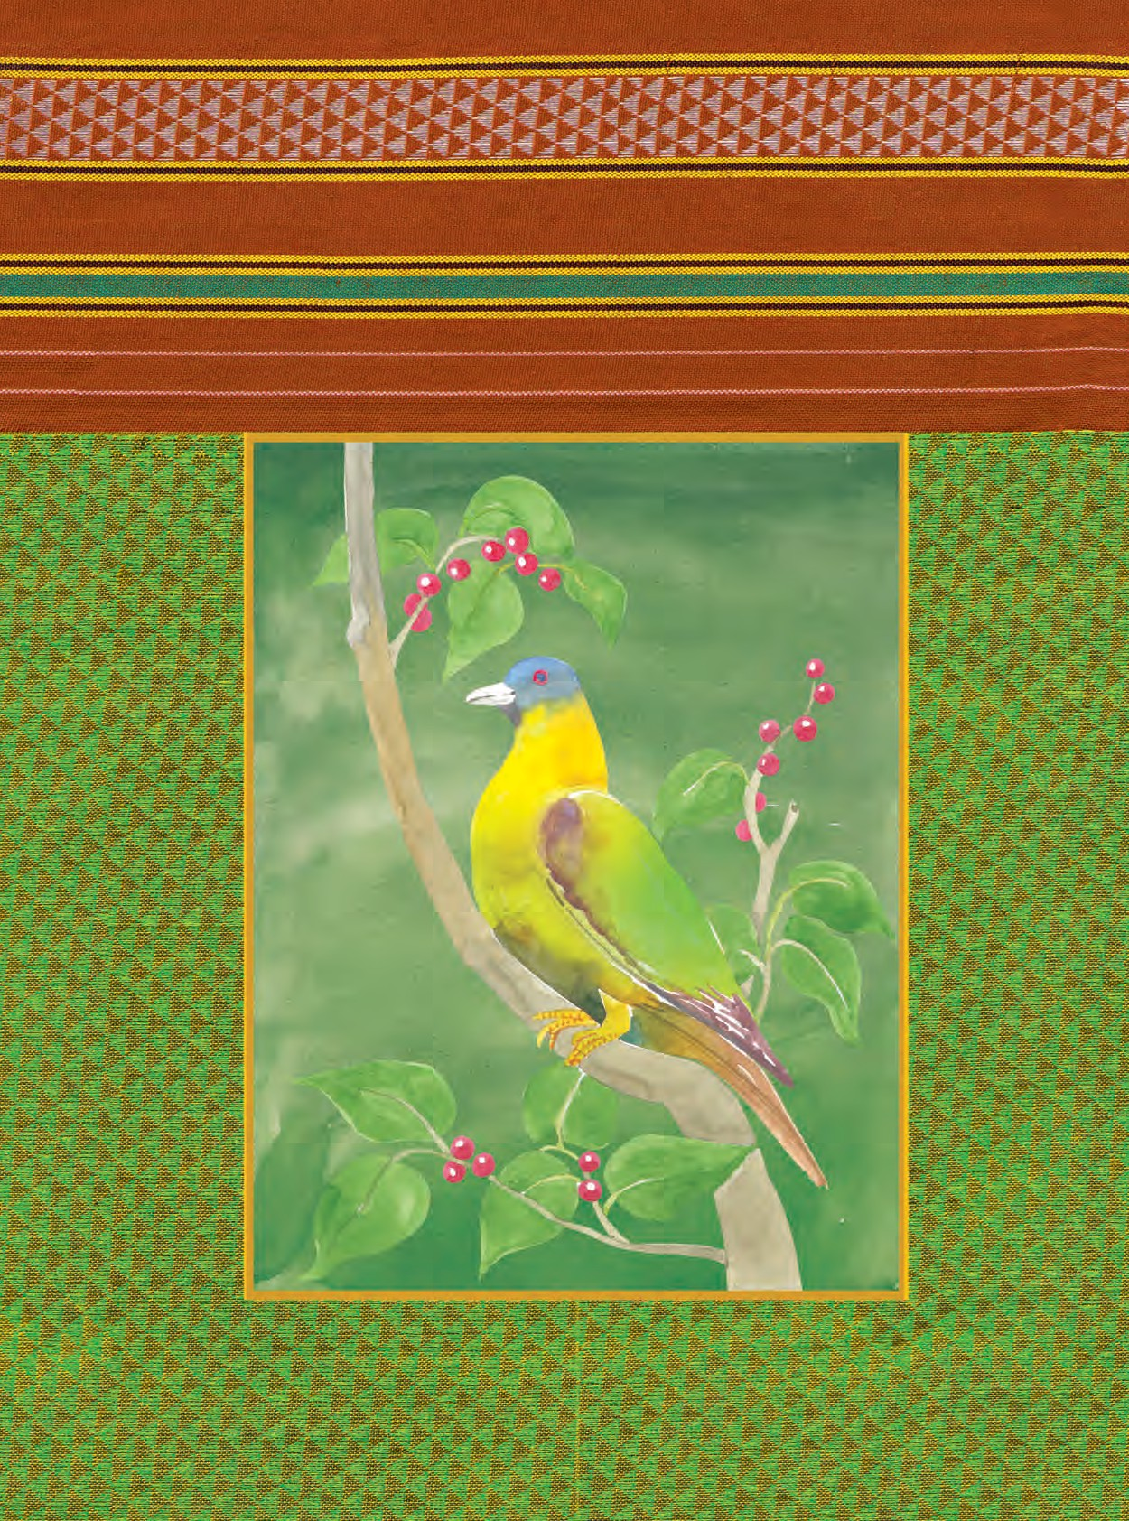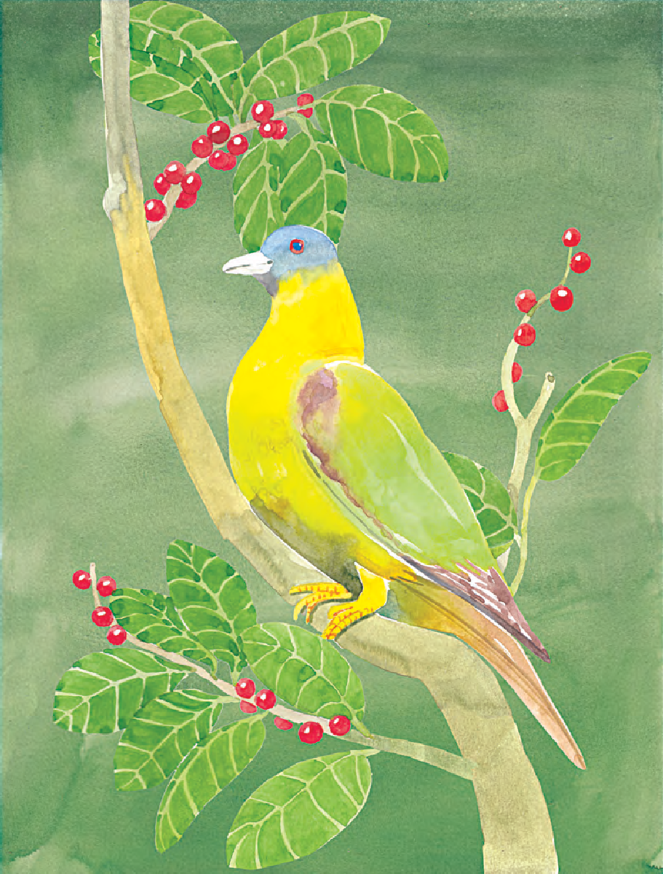

The Constitution of India



Chapter IV A

**Fundamental Duties**

**ARTICLE 51A**

**Fundamental Duties- It shall be the duty of every citizen of India-**

1. to abide by the Constitution and respect its ideals and institutions, the National Flag and the National Anthem;
2. to cherish and follow the noble ideals which inspired our national struggle for freedom;
3. to uphold and protect the sovereignty, unity and integrity of India;
4. to defend the country and render national service when called upon to do so;
5. to promote harmony and the spirit of common brotherhood amongst all the people of India transcending religious, linguistic and regional or sectional diversities, to renounce practices derogatory to the dignity of women;

to value and preserve the rich heritage of our composite culture;

to protect and improve the natural environment including forests, lakes, rivers and wild life and to have compassion for living creatures;

1. to develop the scientific temper, humanism and the spirit of inquiry

and reform;

1. to safeguard public property and to abjure violence;

g) to strive towards excellence in all spheres of individual and collective activity so that the nation constantly rises to higher levels of endeavour and achievement;

(k) who is a parent or guardian to provide opportunities for education to his child or, as the case may be, ward between the age of six and fourteen years.

ǀǎǛcǡiǜǛ Ǜǜ. : ƺǀưƲƿǁƜǎǣiǣiƜǠǝƜƟƝƞƢƚƞƣƜƞƣƤƠ Ʊǎǡǒ Ƨ ƝƣƜƝơƜƟƝƞƣ

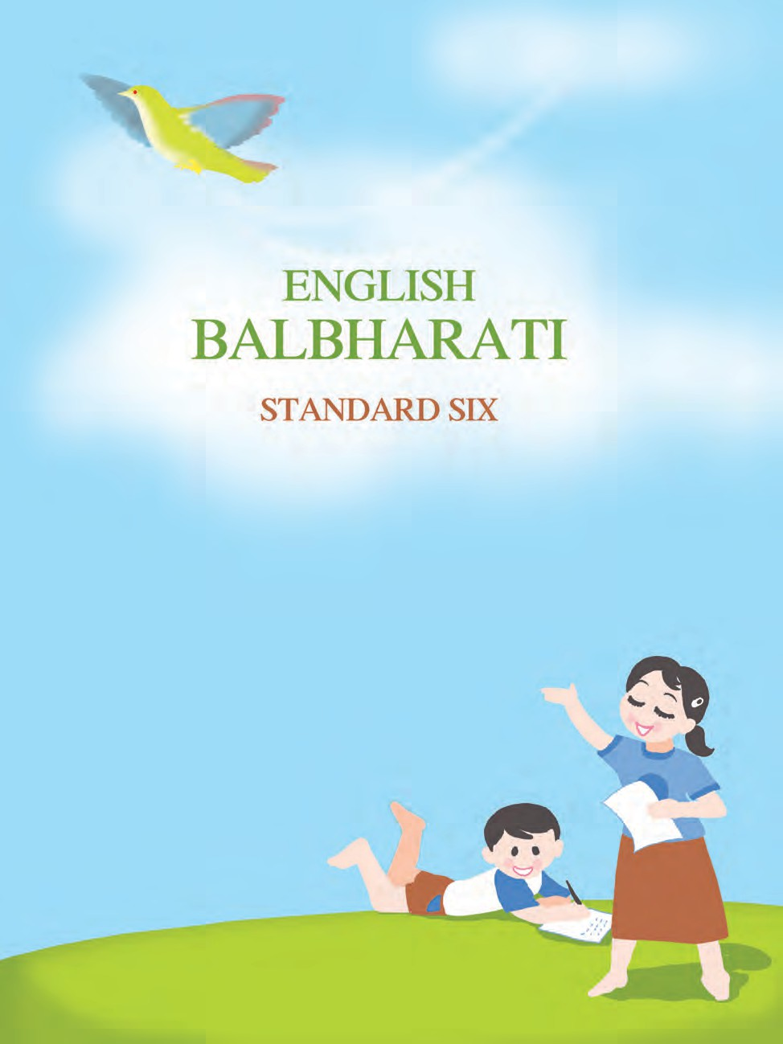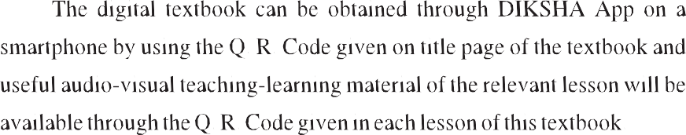

#### Maharashtra State Bureau of Textbook Production and Curriculum Research, Pune.



**First Edition : 2016**

**Sixth Reprint : 2022**

O **Mohoroshtro Stote Bureou of Textbook Production ond Curriculum Reseorch, Pune** - **411 004.**

The Mohoroshtro Stote Bureou of Textbook Production ond Curriculum Reseorch reserves oll rights reloting to the book. No port of this book should be reproduced without the written permission of the Director, Mohoroshtro Stote Bureou of Textbook Production ond Curriculum Reseorch, ‘Bolbhoroti’, Senopoti Bopot Morg, Pune 411004.

**English Longuoge Committee** :

Dr Probho Sompoth, Choirmon

Dr Monjushree Sordeshponde, Member

**English Longuoge Study Group** :

Dr Rohit Kowole, Member

Dr Muktojo Mothkori, Member Dr Shruti Choudhory, Member

Shri. Shridhor Nogorgoje, Member Shri. Nilesh Kedore, Member

Smt. Dhonovonti Hordikor, Member-Secretory

**Cover ond Illustrotions** : Reshmo Borve

**Co-ordinotion** : Dhonovonti Hordikor

Acodemic Secretory for Longuoges Sontosh J. Powor

Assistont Speciol Officer, English

Shri. Akhil Bhosole Dr Jyotimoni Rocque

Smt. Monjusho Sogrolikor Shri. Nilkontheshwor Potil Shri. Pundolik Koviroj Smt. Renu Dhotre

Smt. Soroswothi Surom

Shri. Shorod Pondhore Smt. Smito Pore Shri. Amol Komble Shri. Anil Petkor

Shri. Ashok Goikwod

Shri. Bolkrishno Shinde Shri. Bhuvnesh Kumbhor Shri. Dogdu Gorkor

Shri. Gojendro Mugole Dr Juee Kulkorni

Shri. Mohesh Dudhonkor Shri. Nodeem Khon Shri. Rojiv Songpol

Shri. Roju Korde Shri. Rokesh Jodhov

Shri. Sontosh Goikwod Smt. Yogito Potil

**Production** Sochchitonond Aphole Chief Production Officer



Sochin Mehto Production Officer

Nitin Woni

Asst. Production Officer

**Poper** :

70 GSM Creomwove

**Typesetting** :

DTP Section (Longuoges) Textbook Bureou, Pune.

**Printer** :

N/PB/2022-23/35,000

Print Order No. :

M/S. SHRI ASTHAVINAYAK PRINTING PRESS , KOLHAPUR

**Publisher**

Vivek Uttom Gosovi **Controller** Mohoroshtro Stote Textbook Bureou, Probhodevi,

Mumboi - 400 025.



**The Constitution of India**

**Preamble**

WE, THE PEOPLE OF INDIA, having

solemnly resolved to constitute SOVEREIGN SOCIALIST

DEMOCRATIC REPUBLIC and

all its citizens:

India into a SECULAR

to secure to

JUSTICE, social, economic and political;

LIBERTY of thought, expression, belief, faith and worship;

EQUALITY of status and of opportunity; and to promote among them all

FRATERNITY assuring the dignity of the individual and the unity and integrity of the Nation;

IN OUR CONSTITUENT ASSEMBLY this

twenty-sixth day of November, 1949, do HEREBY ADOPT, ENACT AND GIVE TO OURSELVES THIS CONSTITUTION.

NATIONAL ANTHEM

Jana-gana-mana-adhinäyaka jaya hé Bhärata-bhägya-vidhätä,

Panjäba-Sindhu-Gujaräta-Maräthä Drävida-Utkala-Banga

Vindhya-Himächala-Yamunä-Gangä uchchala-jaladhi-taranga

Tava subha nämê jäge, tava subha äsisa mägë, gähê tava jaya-gäthä,

Jana-gana-mangala-däyaka jaya hê Bhärata-bhägya-vidhätä,

Jaya hê, Jaya hê, Jaya hë, Jaya jaya jaya, jaya hë.

PLEDGE

Indio is my country. All Indions ore my brothers ond sisters.

I love my country, ond I om proud of its rich ond voried heritoge. I sholl olwoys strive to be worthy of it.

I sholl give my porents, teochers ond oil elders respect, ond treot everyone with courtesy.

To my country ond my people, I pledge my devotion. In their well-being ond prosperity olone lies my hoppiness.

#### Preface

The **Right of Children to Free and Compulsory Education Act, 2009** and **National Curriculum Framework 2005** are two important events that have influenced primary education in our country. In the State of Maharashtra, too, the revised **Primary Education Curriculum 2012** reflects their guidelines and expectations. We are happy to place this **English Balbharati** for Standard Six based on the revised curriculum in your hands.

The RTE Act emphasizes all-round development of the child, as also learning through activities, discovery and exploration in a child-friendly and child-centred manner; making the child free of fear, trauma and anxiety and helping the child to express views freely. We have tried to design this textbook so that these principles become an integral part of the teaching-learning process. For the convenience of teachers and parents, we have also specified the various competencies that should be developed by the end of Std VI.

**Balbharati Six** is meant for use in English medium schools. It aims at a balanced development of all the four language skills of listening, speaking, reading and writing. In addition, some activities have been included to improve the children’s study skills. Some of the content is designed to create an awareness about the structure and function of language. The main focus, however, is on making the process of education engaging and joyful.

The textbook has been prepared in a big size with plenty of colourful illustrations to enhance its visual appeal for children. We hope that children will enjoy handling this textbook throughout the year.

This book was scrutinized by teachers and experts from various parts of the State to make it flawless and more useful. The English Language Committee, Study Group and the artist have taken great pains to prepare this textbook. The Bureau is grateful to all of them.

We hope that the textbook will receive a warm welcome from students, parents and teachers.

**Pune**

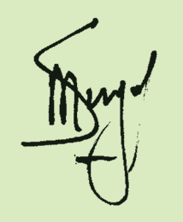

**Date :** 9 May 2016,

Akshay Tritiya, Indian Solar Year : Vaishakh 19, 1938

**(Dr Sunil Magar) Director**

Maharashtra State Bureau of Textbook Production and Curriculum Research, Pune.

**Learning Outcomes : English Balbharati : Standard Six**

|  |  |
| --- | --- |
| **Suggested Pedagogical Processes** | **Learning Outcomes** |
| **The learner may be provided opportunities in pairs/ groups/ individually and encouraged to–**   * become familiar with songs/poems/prose in English through input-rich environment, interaction, classroom activities, discussion etc. * listen to English news(TV, Radio) as a resource to develop listening comprehension * watch/ listen to English movies, serials, educational channels with sub-titles, audio-video materials, talking books, teacher reading out from materials and to understand and respond * participate in individual talk viz. introducing oneself and other persons; participate in role play / make a speech, reproduce speeches of great speakers * summarise orally the stories, poems and events that he/ she has read or heard * locate sequence of ideas, events and identify main idea of a story/poem through various types of comprehension questions * read different kinds of texts such as prose, poetry, play for understanding and appreciation and write answers for comprehension and inferential questions * raise questions based on their reading * interpret tables, charts, diagrams and maps and write a short paragraph * think critically and try to provide suggestion/solutions to the problems raised * read/ discuss the ideas of the text for critical thinking * use dictionary as a reference book for finding multiple meanings of a word in a variety of contexts * take dictation of words, phrases, simple sentences and short paragraphs * understand the use of antonym (impolite/polite) synonym (big/large) and homonym (tail/tale) * understand the grammatical forms in context/ through reading, for example, noun, pronoun, verb, adverb, determiners, etc. * understand the context for various types of writing such as messages, notices, letters, report, biography, diary entry, travelogue etc. * draft, revise and write in English with punctuation and with focus on appropriate beginning, middle and end * use ICT (Net, mobile, website, Youtube, TED talks etc) to browse for information, for projects/PPT etc. | **The learner–** |

#### For Teachers ...

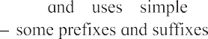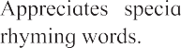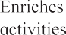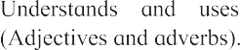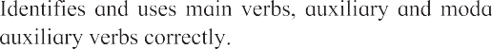

* look at cartoons/ pictures/comic strips with or without words, and talk/write about them
* visit a language laboratory
* read/write a book review.

1. Please take into account the various learning outcomes specified on the page alongside. They indicate the areas of language developments and the stages which a child is expected to reach by the end of Std VI. You can plan your classroom interaction and assessment of pupils in the light of these specific goals.
2. Use the textbook in three ways –
   1. **Learning language:** Learning to communicate one’s own ideas, thoughts, feelings, etc. in English.
   2. **Learning through language:** Using English to seek knowledge in other areas of study like science, geography, environmental studies and even art and craft; learning to properly organize and present the information or knowledge one gets through English; learning to identify the difficulties in one’s understanding and then to make efforts to overcome them; ‘personalise’ learning by making notes for reference and so on. Many activities in the textbook focus on these ‘study skills’. They will enable the students to use English throughout their life as an effective medium of learning.
   3. **Learning about language:** After getting acquainted with the English language for several from an early age, children may now be ready to consciously observe how it works. The ‘Language Study’ activities in the book acquaint the students with a few grammatical terms. The aim here, is only to build an awareness of the language system. Such an awareness will help them to rectify their own errors and to refine their own expression. The teacher should not use this content for mechanical drilling.
3. Please go through the entire book before you start teaching it. Also, because the activities and games are graded in order of difficulty, do use them in the given order. However, once an activity or game is introduced, feel free to use it again from time to time, according to the needs and interests of your class.
4. Many of the games and activities in the book involve open-ended questions. Please give the children enough time and opportunity to respond to these using their own ideas. Do not use readymade (or ‘teacher made’) answers.
5. Watch over the classroom participation and development of each child in the classroom and provide opportunities of growth to all of them.
6. An innovative teacher may come up with many parallel or extension activities but do take care to see that all tasks and activities given in the textbook are carried out first.

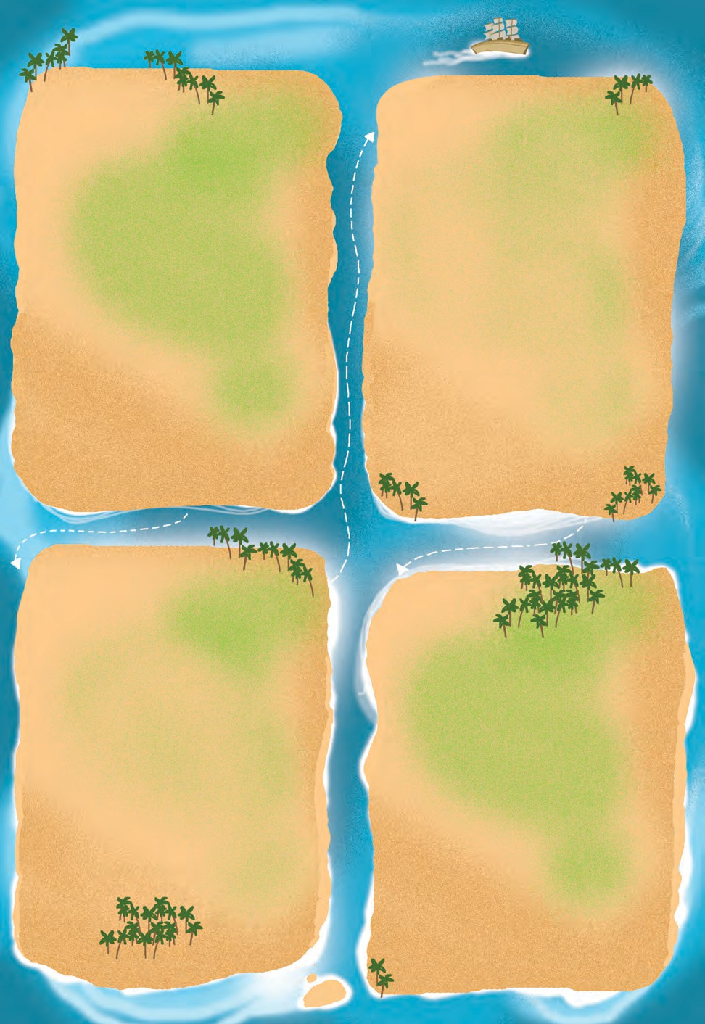**Contents**

**Voyage One Page**

* 1. Don’t Give Up ! 1
  2. Who’s the Greatest ? 2
  3. Autobiography of a 6

Great Indian Bustard

* 1. Children are going 10

to school ...

* 1. A Kabaddi Match 12
  2. The Peacock and 18

the Crane

* 1. Param Vir Chakra : 20

Our Heroes

**Voyage Two Page**

* 1. The Clothesline 23
  2. The Worth of a Fabric 25
  3. A Wall Magazine for 29

your Class !

* 1. Anak Krakatoa 34
  2. The Silver House 38
  3. Ad‘wise’ Customers 40
  4. Yonamine and Bushi 44

Voyage Three Page

* 1. It Can Be Done 49
  2. Seven Sisters 51
  3. Stone Soup 58
  4. Sushruta 64

(A Peep into the Past)

* 1. The Donkey 68

3.6. The Merchant 70

of Venice

3.7 At the Science Fair 75

**Voyage Four Page**

* 1. Sleep, My Treasure 81
  2. The Story of 83

Gautama’s Quest

* 1. Mr Nobody 86
  2. A Mad Tea Party 88
  3. If I can stop one 93

heart from breaking ...

* 1. The Phantom Tollbooth 94

(A Book Review)

* 1. The Sword in the Stone 98
  2. An Autumn Greeting 104

# Don’t Give Up !

If you’ve tried and have not won, Never stop for crying;

All’s that’s great and good is done Just by patient trying.

Though young birds, in flying, fall, Still their wings grow stronger; And the next time they can keep Up a little longer.

Though the sturdy oak has known Many a blast that bowed her,

She has risen again, and grown Loftier and prouder.

If by easy work you beat, Who the more will prize you? Gaining victory from defeat - That’s the test that tries you!

*- Phoebe Cary*

* + - **give up :** Here, it means lose heart and stop trying.
    - **sturdy :** strong

**POINTERS**

* + - **has known many a blast :** has survived many blows of stormy winds
    - **Loftier :** taller and stronger
    - **you beat :** Here, it means ‘you win’.
      1. Have you ever given up on something good ? Share your story with your friend.

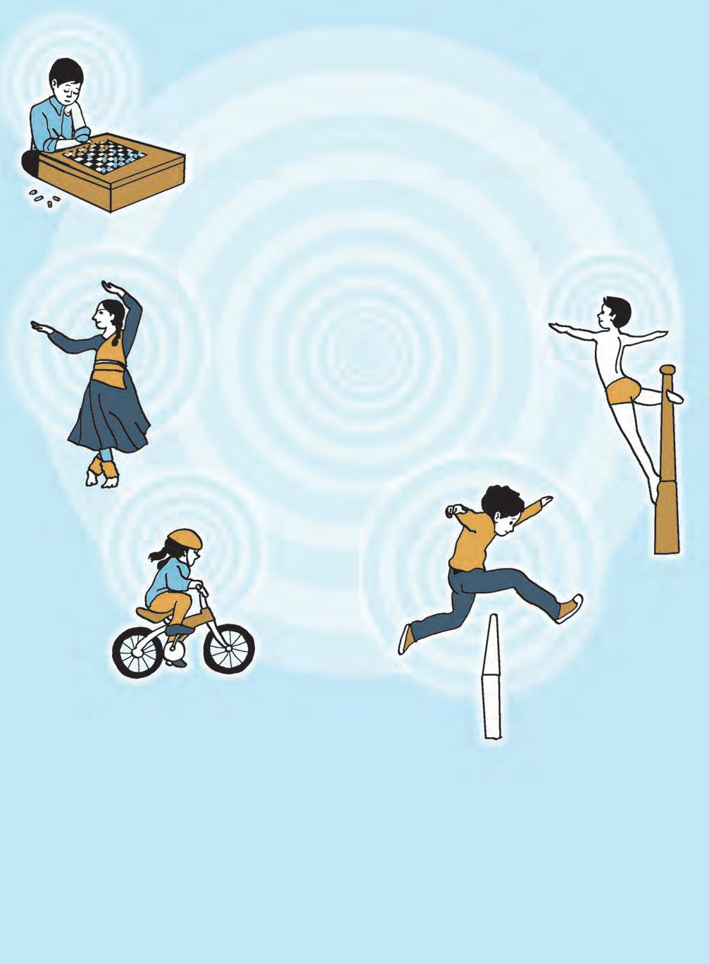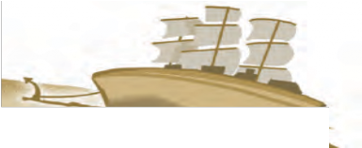

* + - 1. Your friend fell down learning to ride a bicycle, and now has given it up altogether. What do you think will be the poet’s advice ? Write it down.

1

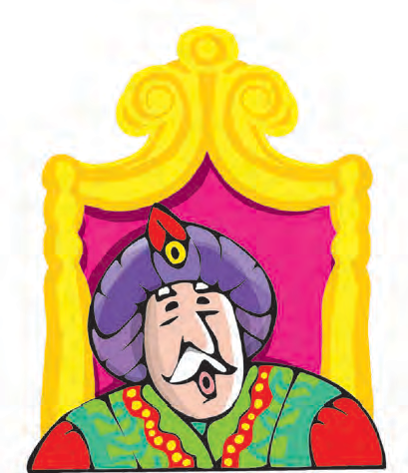

# Who’s the Greatest ?

E mperor Akbar or Akbar the Great is known as one of the greatest rulers in the world - not just because he had a vast empire, a very strong army, untold wealth, but because he was a good human being. He cared for his subjects. He had great respect for scholars, writers, poets and artists belonging to different religions. He was a patron of art and culture. The nine gems or ‘nav-ratnas’ in his court were famous. Many people believe that of these nine gems, Birbal was the closest to the Emperor’s heart. Akbar loved to pose interesting questions or problems in his court, and Birbal never failed to come up with an equally interesting answer.

We don’t know whether all the Akbar and Birbal stories that we hear today have any basis in history. They have been handed down over generations mainly by word of mouth. Here are two of them :

One day, the Emperor entered the court with a very serious expression on his face. As soon as he was seated, he said, “I have a question for all of you. What should be the punishment for someone who pulls my moustache ?’’

The court was stunned ! Pull the Emperor’s moustache ! It was unheard of !

“Flog him ! Give him fifty lashes of the whip !’’ exclaimed one nobleman.

“That’s not enough. Put him in jail without food and water,’’ said another.

2

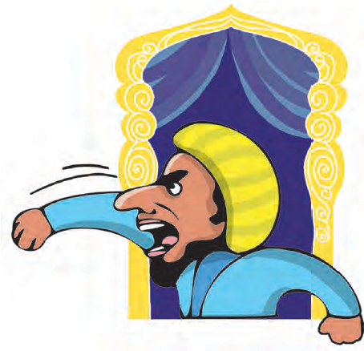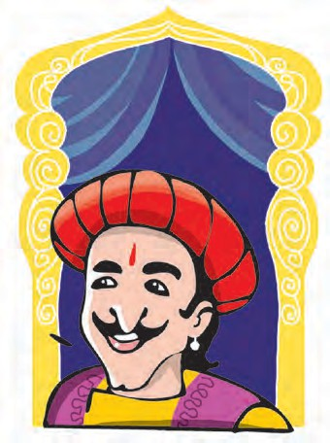

“Whip him ’’ “Beat him up ’ “Hang hi “Cut off his offending hands.’’ The agitated courtiers began to cry out. Only Birbal was silent. He was even smiling a little.

“Whip him

!’’

“Beat him up

!’

’ “Hang

him

!’

’ “Cut off his

offending hands.’’ The

agitated courtiers began

to cry out. Only Birbal

was silent. He was even

smiling a little.

“What do you say, Birbal ? What is your opinion ?’

“What do you say,

Birbal

? What

is your

opinion

?’’

“In my opinion, O Giver of Peace to the World, the offender should be given his favourite sweetmeats.’’

“In my opinion, O Giver of Peace to the World, the

offender should be given his favourite sweetmeats.’’

“Raja Birbal, are you out of your mind ? Give sweetmeats for such a grave offence ?’ The courtiers began to say. Birbal smiled and offered an explanation: “Yes, who would be so bold as to pull the Emperor’s moustach ? Only his own grandson ’

“Raja Birbal, are you

out of your mind

?

Give

sweetmeats for such a grave

offence

?’

’ The courtiers

began to say. Birbal smiled

and offered an explanation:

“Yes, who would be so bold

as to pull the Emperor’s

moustache

? Only his own

grandson

!’’

When Akbar heard this he burst out laughing because

When Akbar heard this,

he burst out laughing because

that is exactly what had happened in the morning!

that is exactly what had happened in the morning

!

On another occasion, Akbar was relaxing with some of his courtiers. A few of them thought this was a good opportunity to shower praise on the Emperor and get some favours from him. They began to compete with each other in praising Akbar.

On another occasion, Akbar was relaxing with some

of his courtiers. A few of them thought this was a good

opportunity to shower praise on the Emperor and get some

favours from him. They began to compete with each other

in praising Akbar.

“You are the greatest of the kings ’

“You are the greatest of the kings

!’

“You are the greatest of the kings or emperors that ever lived on the earth !’’

“You are the greatest of the kings or emperors that

ever lived on the earth

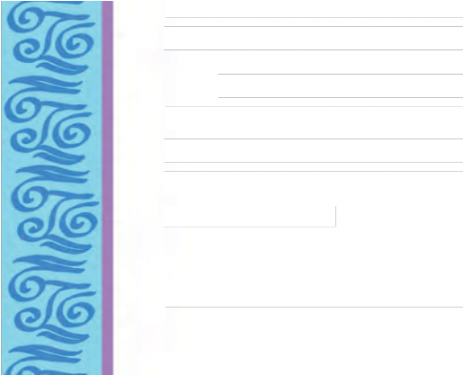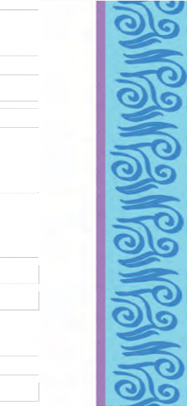

“You are the greatest of all the people in heaven or earth ’’

“You are the greatest of all the people in heaven or

earth

!’’

“You are as great as God Almighty ’’ “You are greater than the God Almighty ’

“You are as great as God Almighty

!’’

“You are greater than the God Almighty

!’’

Now, Akbar was no fool. He did not care for false praise. He stopped the courtiers and asked, “Do you all believe so?’’

Now, Akbar was no fool. He did not care for false praise.

He stopped the courtiers and asked, “Do you all believe so?’’

“Yes !’’ they answered in one voice.

“Yes

!’’ they answered in one voice.

“All right, then, prove it to me. Tell me at least one thing that I can do but God Almighty will not be able to do. Otherwise, you will all incur our royal displeasure You have till tomorrow morning to prove it ’’

“All right, then, prove it to me. Tell me at least one

thing that I can do but God Almighty will not be able to

do. Otherwise, you will all incur our royal displeasure

! You

have till tomorrow morning to prove it

!’’

Akbar then left the place without another look at the courtiers. They were in a proper fix. They thought and thought but couldn’t think of any such thing. In the end, they went to Birbal. When Birbal heard their story, he told them not to worry

Akbar then left the place without another look at the

courtiers. They were in a proper fix. They thought and

thought but couldn’t think of any such thing. In the end, they

went to Birbal. When Birbal heard their story, he told them

not to worry.

The next morning, the court was full. Everyone was curious to see what would happen next.

The next morning, the court was full. Everyone was

curious to see what would happen next.

“Well,’’ said the Emperor, “Have you found a good answer to my question ? Or are you ready to leave the court forever ?’

“Well,’’ said the Emperor, “Have you found a good

answer to my question

? Or are you ready to leave the court

forever

?’’

Just then Birbal stepped forward and bowed low. “Please don’t be angry with those who think you are the greatest. There’s certainly at least one thing that you can do, but the God Almighty cannot ’

Just then Birbal stepped forward and bowed low. “Please

don’t be angry with those who think you are the greatest.

There’s certainly at least one thing that you can do, but the

God Almighty cannot

!’’

Akbar looked at Birbal thoughtfully, “And what is that one thing ?’’

Akbar looked at Birbal thoughtfully, “And what is that

one thing

?’’

“When you want to punish someone, you can banish that person you can throw him out of your kingdom. But God’s kingdom extends everywhere. The Almighty cannot banish anyone from his kingdom.’’

“When you want

that person - you ca God’s kingdom exten

to punish someone, you can banish

n throw him out of your kingdom. But

ds everywhere. The Almighty cannot

banish anyone from his kingdom.’’

Akbar’s face was lit up with a smile, “That was very clever Birbal! While showing how I have an advantage,

Akbar’s face was lit up with a smile, “That was very

clever, Birbal

! While showing how I have an advantage,



you have also shown that God is greater. I believe you.’’

Akbar was so pleased with the answer that he forgave the courtiers for their stupidity.

* **patron of art and culture :** a person who appreciates, supports and encourages art and culture

Akbar was so pleased with the answer that he forgave

the courtiers for their stupidity.

* **flog :** beat someone hard, especially with a whip
* **agitated :** disturbed
* **incur our displeasure :** make me angry
* **in a proper fix :** in a tight corner, in a difficult situation

you have also shown that God is greater. I believe you.’’



**POINTERS**

* 1. Listen to the stories carefully, as your teacher reads them aloud. Note down the new words, ideas or concepts. Discuss them in the class.
  2. Guess the meaning of the following words and phrases :

untold wealth, closest to the Emperor’s heart, grave offence, banish.

* 1. Say with reasons, whether the following statements are true or false.
     1. Akbar wanted to punish the person who pulled his moustache.
     2. Akbar thought he was greater than God.
     3. Birbal thought Akbar was greater than God.
  2. Write a sentence each about three of your friends. Each time you should say what your friend cannot do, and yet, pay a compliment to your friend.
  3. Write a short note on Emperor Akbar.
  4. Convert the stories into dialogues and read the dialogues aloud in the class.
  5. Form pairs and make a ‘pair presentation’ of any one of the two stories. To do so, each person presents only one sentence at a time, and the next one is immediately presented by the partner. Thus, each person in the pair presents alternate sentences without breaking the flow of the narration.
  6. Find at least five other Akbar and Birbal stories and share them with your friends. Make a list of the stories collected by the entire class. Put your list in alphabetical order.
  7. Visit a library : Find the stories of  Mulla Nasiruddin  Gopal Bhand and  Tenali Raman. Share them in the class.

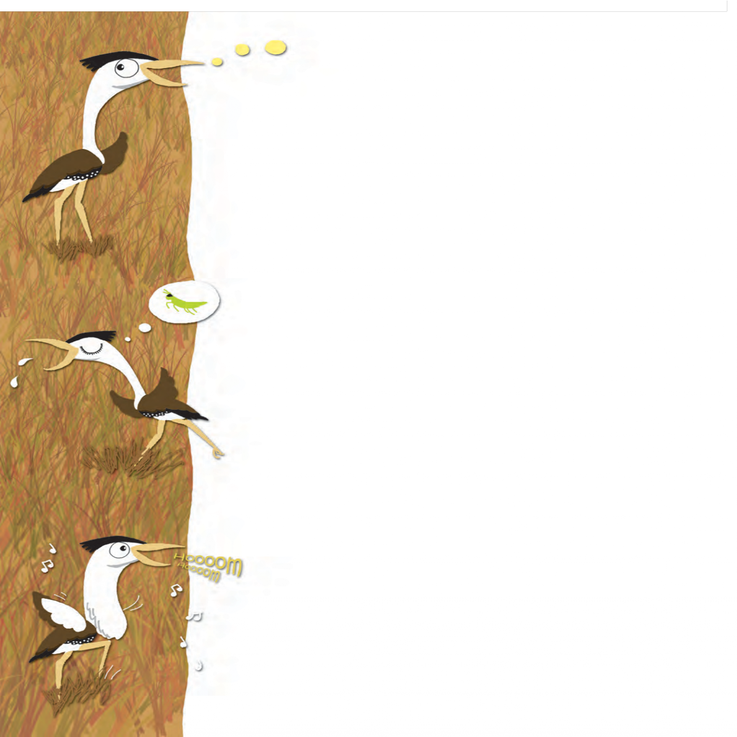

# Autobiography of a Great Indian Bustard

Which is the heaviest flying bird in India? Well, friends, it’s me – The Great Indian Bustard. I feel proud to be known as the ‘Great Indian’ Bustard. I have more than 30 different names in various Indian languages. In Marathi, I am known as ‘*Maldhok*’ or ‘*Hoom*’. I can weigh up to 18 kilos and can stand up to four feet in height

- reaching up to your shoulders or even higher ! I have got a long white neck; brown wings, tall yellow legs and a black cap on my head. My wife - Mrs Bustard is smaller and slimmer than I am and her neck is not white. But I have heard humans say that we both look impressive!

I live on grasslands and deserts along with my other friends including *chinkara*, blackbuck and larks. I eat everything including snakes, lizards, small fruits and berries and all sorts of insects. That’s a very healthy habit! But grasshoppers and beetles are my favourite food items.

When it starts raining, we all gather at our favourite grasslands where there are no people to disturb us. I perform a wonderful dance by gulping air in the special feathery pouch attached below my neck. This pouch helps me to produce a resonating sound similar to the one produced by the cow - ‘*Hoooooom*’. I dance in joy with puffed out feathers and cocked up tail and dropped down wings. It helps me to impress my soul mate.

You know that we birds lay eggs and our young ones hatch out of eggs. Mother GIB lays just one egg directly on the ground. We don’t believe in building nests - but

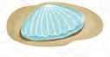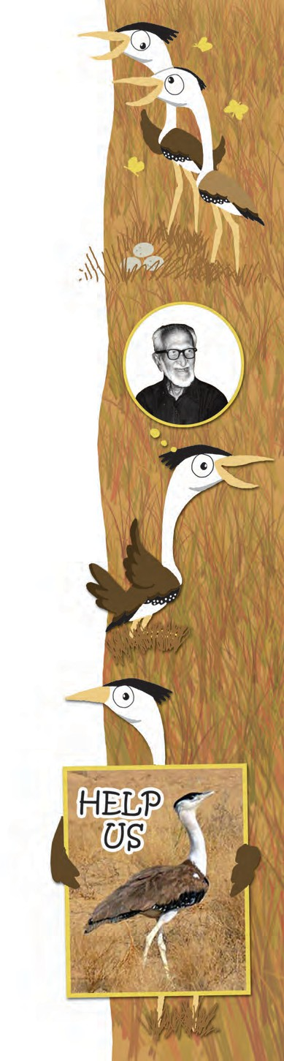

we have a special trick to protect our eggs from predators. The egg looks like a stone. Monitor lizards, foxes, dogs, pigs, snakes and eagles are enemies of my egg and chick, but my wife protects the egg from all of them. By the time our young one hatches out of the egg, rains arrive. There’s plenty of grass, swarming with insects - fresh food for my family. Young ones of other birds soon fly away from the nest, but a Great Indian Bustard mother and chick stay together for nearly one year. The chick learns many good habits from the mother.

You may have heard about a great human friend of ours – Dr Salim Ali. He had even suggested that we should be given the status of the ‘National Bird’ of our country but the honour went to our beautiful relative - the peacock. I am happy to tell you that I am the State bird of Rajasthan. We have got ten sanctuaries for our protection but sadly, our number is still going down. We used to live in all parts of India. But slowly the growing population of man pushed us away from more than 90 percent of our home regions. We are afraid of hunters that kill us for fun. We also die due to electric power-lines that we can’t see while flying. We are losing our homes. Today, only the last 200 of us are left in the world. We need your support and love in order to survive. Can you help us?

You can write letters to your leaders and make an appeal to help us. You can make my drawing and submit it to your teacher. You can discuss this with your parents. Come to see us at a sanctuary, because now you will not see us in other places. And who knows, if humans don’t help us, none of us will be left on the earth. You will only see us in pictures.

*- Dr Pramod Patil*

7

* **pouch :** Here, it means a pocketlike space.
* **resonating :** producing a loud, clear and deep sound
* **predators :** animals that hunt, kill and eat other animals



**POINTERS**

* 1. Read the passage aloud.
  2. You are going to meet a Great Indian Bustard very soon. Prepare at least 10 questions to interview him.
  3. Play the roles of an interviewer and a Great Indian Bustard and present the interview in the classroom.
  4. Write a letter to your friend about the Great Indian Bustard. You may use the following points :
     + Why we need to protect the bird.
     + What you plan to do to help the bird.
  5. Form pairs and decide whether the following statements are those of a Great Indian Bustard or not.

|  |  |  |
| --- | --- | --- |
| **Statements** | **Great Indian Bustard** | **Some Other Bird** |
| (a) I am the heaviest flying bird in India. |  |  |
| (b) I am known as *Maldhok* or *Hoom* in Marathi. |  |  |
| (c) I live in mountainous regions. |  |  |
| (d) I don’t like grasshoppers or beetles. |  |  |
| (e) We don’t believe in building nests. |  |  |
| (f) Our chick stays with the mother for a period of nearly one year. |  |  |
| (g) I am the State bird of Maharashtra. |  |  |
| (h) We have been pushed away from more than 90 percent of our home regions. |  |  |

* 1. With the help of the internet and other sources, obtain more information about the critically endangered birds and animals in India. Find the names of their sanctuaries.

bird

healthy

wonderful

friends gather

helps

directly

humans

protect

together away happy slowly afraid you

we

arrive us

I

grasslands

Some critically endangered birds and animals in India :

‘CR’ or critically endangered birds or animals are those that are likely to become extinct in the wild. We may never see them again.

* Forest Owlet
* Indian Vulture  Siberian Crane
* Deolali Minnow (fish)  Asiatic Cheetah  Himalayan Wolf
* Amboli Toad
  1. Prepare a poster on the need for the conservation of the Great Indian Bustard.
  2. Write a short autobiography of any bird or animal of your choice.
  3. Make a list of the channels available on your TV under the following categories : News, entertainment, sports, movies, music, etc.

Which are the channels on which you can watch programmes on animals, wild life, conservation of environment, etc.?

* 1. Ask your parents to show you TV programmes on animals, wild life and conservation on channels like the following :

DD National, National Geographic, Discovery and Animal Planet.

* 1. You have won a prize to visit a wild life sanctuary or National Park in Africa or Australia. Choose a location, read about it. Imagine that you are visiting it and write a letter to your friend about it.
  2. Language Study : Identify the following from the list given in the box below : 4 nouns, 4 verbs, 4 adjectives, 4 adverbs, 4 pronouns.

***

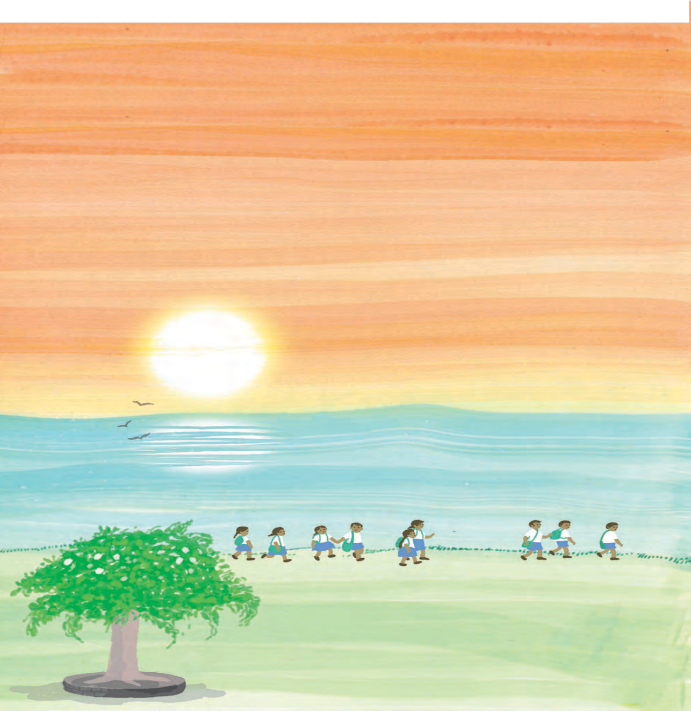

# Children are going to school ...

Morning light spreads over the earth.

Once again, the Sky bows his head in respect, For children are going to school.

The Sun, after his morning dip in the river dressed up in his golden muslin turban waits and smiles on one side of the road,

For children are going to school.

Through the green-topped branches, Breezes sing their songs of blessings.

Fragrant flowers awaken the sleepy roads with their melodies.

At the corner of the lane,

the Peepal in his lush deep foliage waves his hands

For children are going to school.

Angels of light have set out ... Every road is a-gleam.

At this hour,

every particle of the earth throbs like a mother’s heart.

Time, sitting on an old roof, flies pigeons in the sky.

For children are going to school.

*- Translated from ‘Bachche school ja rahe hain’*

*By Nida Fazli*

* + - **muslin :** a kind of soft cotton fabric
    - **foliage :** greenery; leafy cover
    - **a-gleam :** shining bright



**POINTERS**

1. Read the poem aloud.
2. Find at least two things from the poem that show the following :
   1. It is early morning.
   2. The atmosphere is pleasant.
3. Apart from the children, no other human beings are mentioned in the poem. However, many natural elements are shown to act like persons. Name them and also write what they do.
4. Draw a picture of the scene described in the poem.
5. The whole world is happy because children are going to school. Why is it so ? Discuss it in the classroom.
6. Write about how your family supports you to go to school.
7. What would happen if children didn’t go to school ?

Discuss the question in groups of 5-8 and prepare a short composition on it.

1. Write in short about what your parents/guardians feel when they send you to school.
2. List five of your favourite Hindi or Marathi poems or songs. Try to translate any one of them into English.
3. Visit a library. Find a school poem. Recite it to your parents.



A Project : ‘Sources of Light’

1. List all possible sources of light which enable you to see. Try to list at least 10 to 15. You may add the following to your list : Different kinds of lamps in your house, different sources you see in nature, different sources used by man in the past, etc.
2. Collect as many pictures as you can, or draw diagrams of all the sources you have listed above. Make a scrapbook using them.
3. Think of different ways of classifying them, for example, electric and non-electric, day-time sources and night-time sources.
4. What is your favourite source of light ? Write its autobiography. (10 - 15 lines)

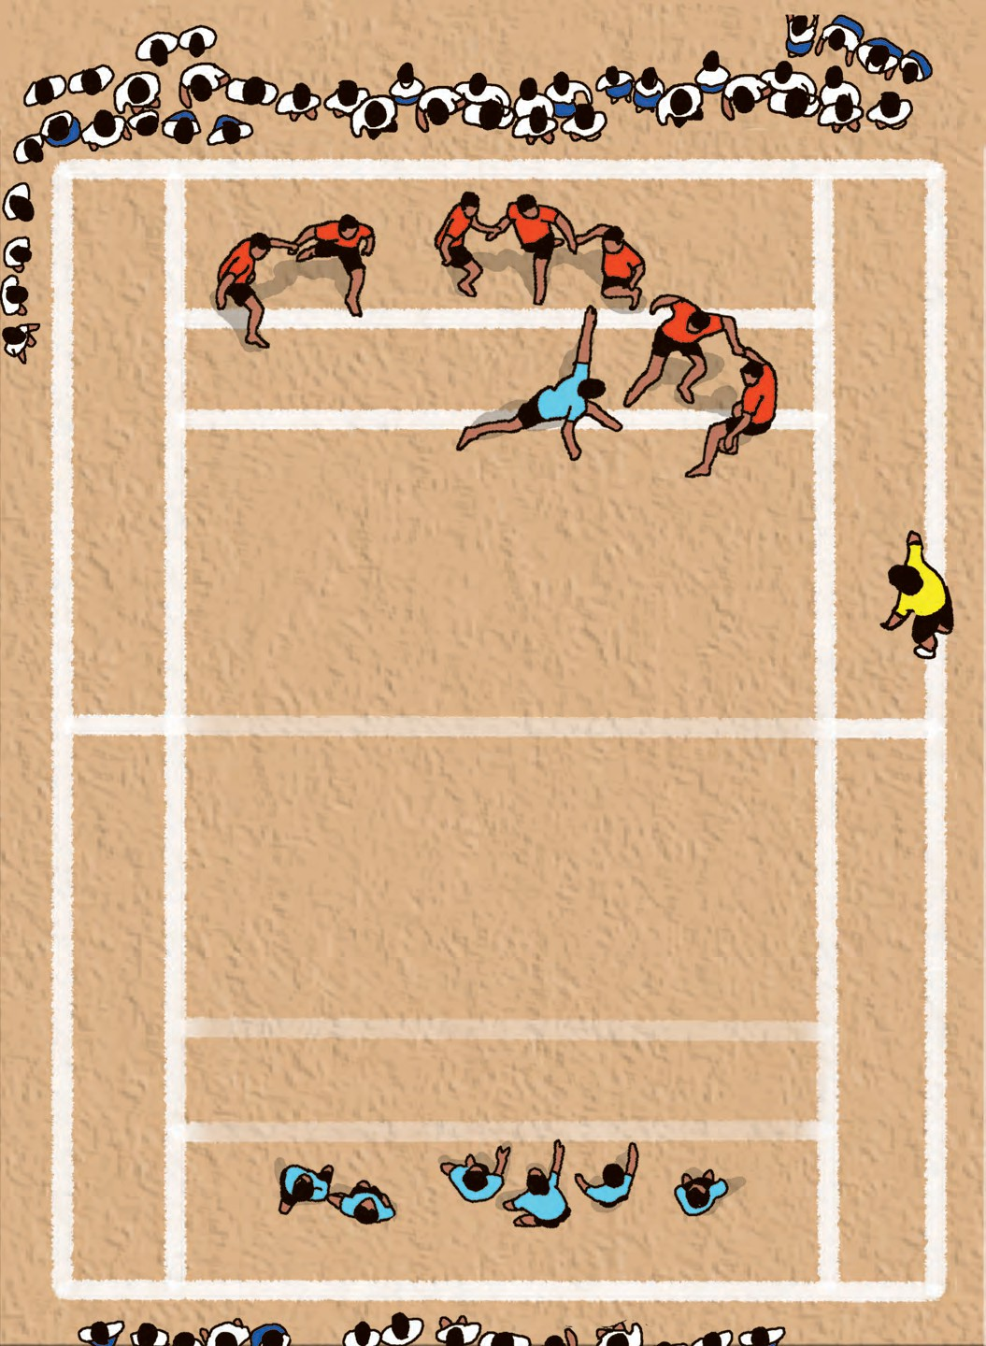

# A Kabaddi Match

The school sports meet was scheduled next month. The practice matches had already begun. 9 B were the favourites as they had strong players in their team. The Kabaddi trials were on. This year there were three new students in class 9 A. To everyone’s surprise, they proved to be outstanding players. 9 A’s hopes soared.

When the match started, all the spectators clapped and boosted the morale of both the teams. 9 A won the toss and sent their raider Govind. He was so swift that before the opponents realized it, he had touched Suresh from 9 B, and was already heading home. A point was scored.

Ravi from 9 B was a very strong player. He alone was sufficient to catch hold of any player so tightly in between his legs twisted like scissors that releasing oneself from his grip was next to

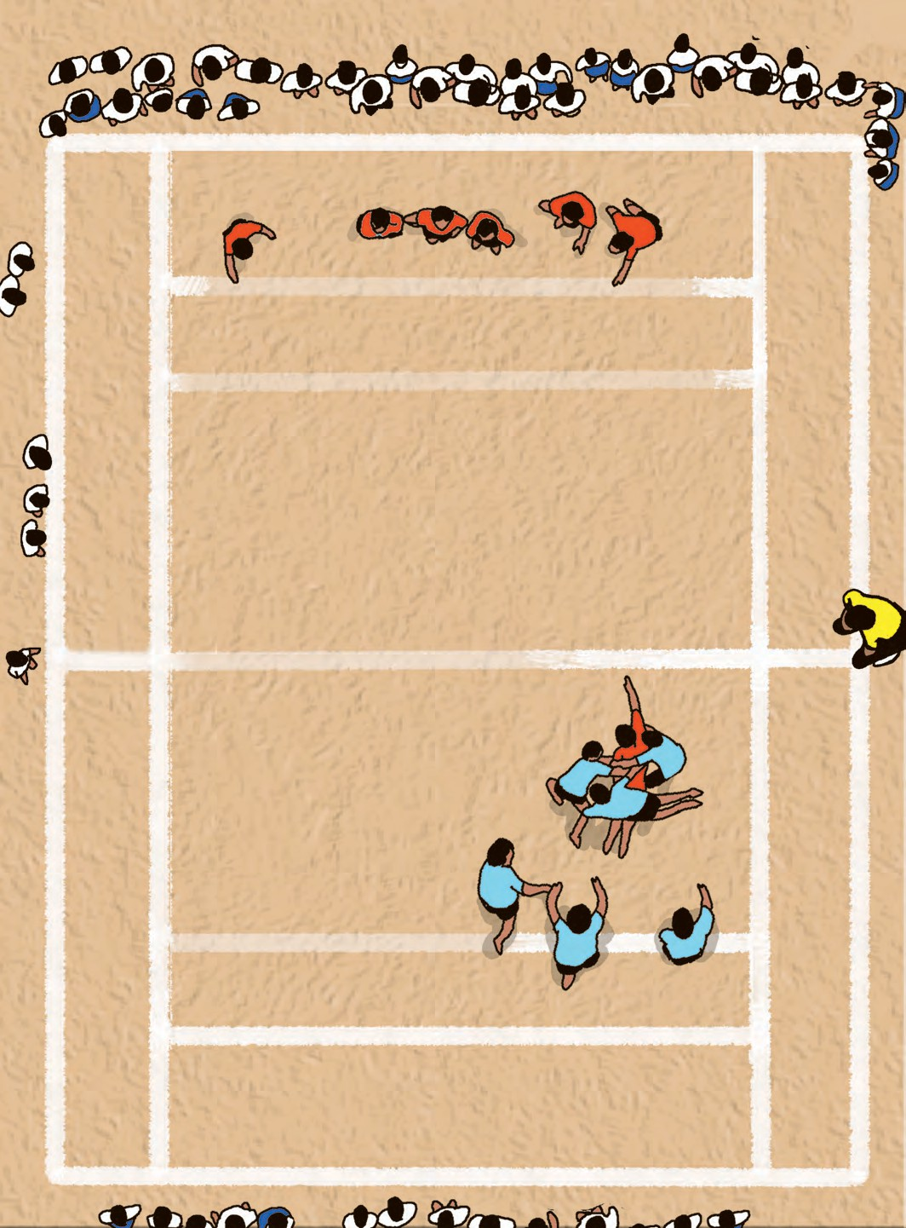

impossible. All the players were literally afraid of him. This ace player had won many matches for 9 B. With the support of Mohan and Vinod, 9 B were unbeatable.

Mangesh from 9 A was also strong. He was a good match for Ravi. Ravi was relaxed as he had never dreamt of any strong opposition from any team. When Mangesh was wrestled down by Ravi and his friends, everyone in the spectators thought that 9 A would lose Mangesh. But Mangesh proved his mettle. He was on the ground with the anti-raiders catching hold of his waist and legs.

Slowly, he inched towards his court. All the anti-raiders with all their might were trying their best to pull him back. But with great determination, and without losing his breath, Mangesh successfully touched the midline. There were cheers in the air.

He had not only saved himself but was also able to score three points for his team as Ravi, Mohan and Ajinkya who were holding him were also declared out.

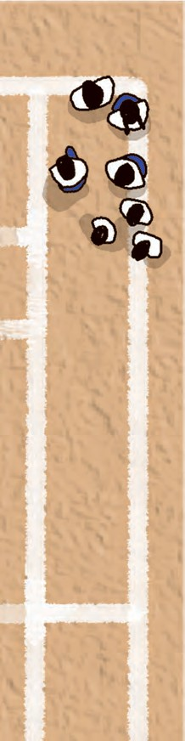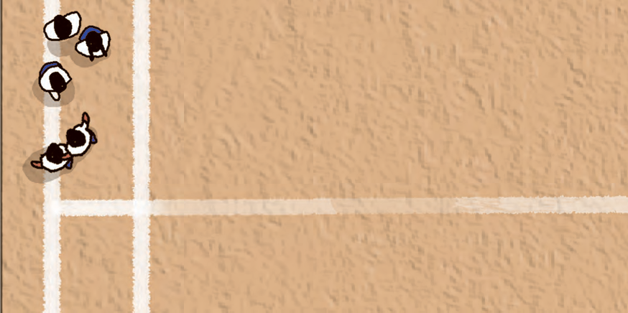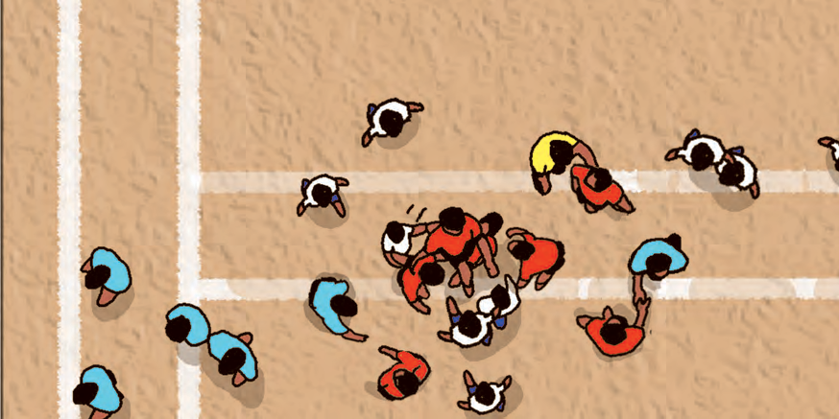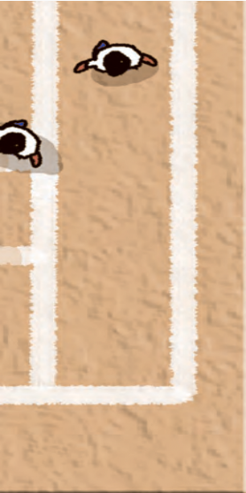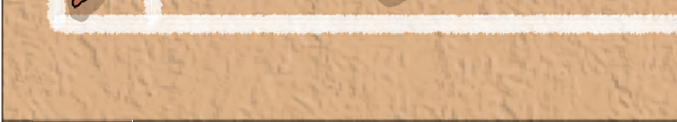

Now, 9 B began to play cautiously. Mihir, one of their raiders, even managed to tag Sohan in 9 A. Nothing much happened in the next few raids. Now it was Vivek’s raid. He always played with strategies and they worked fine. The remaining three players from 9 B trapped Vivek. He slowly moved back towards his court, the three anti-raiders also moved with him. When they caught his arm and were trying to pull him back, Vivek slipped his leg beyond the midline with the anti-raiders still hanging on to his arm. Oh ! The whole of the 9 B team was declared out.

9 A had actually managed to get three more bonus points of *lona*. It was an icing on the cake ! What an enviable score! It set the heads of 9 B reeling.

After the half time break, the star players of 9 A were full of confidence. Once again, they managed to catch hold of the ace raiders Mohan, Ajinkya and Ravi ! 9 A outplayed 9 B in all the areas of Kabaddi. Their team spirit, their confidence, their strategies, their swiftness, suppleness helped them to beat 9 B who had never tasted defeat earlier.

14

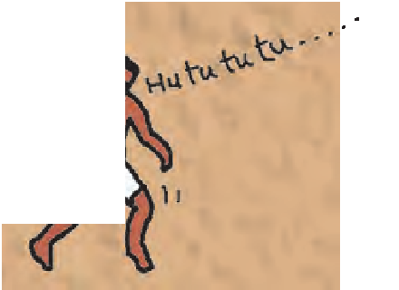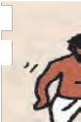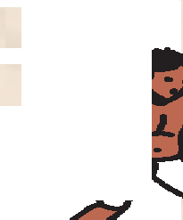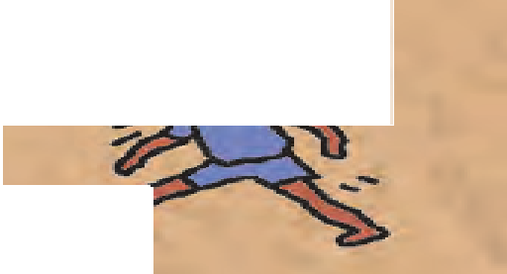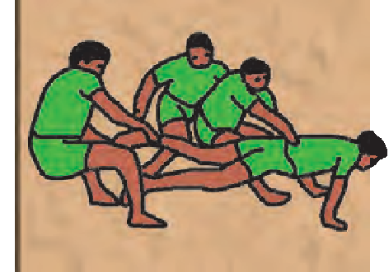

**Kabaddi** is an ancient sport. It originated in India and has now become popular in many countries, so that many international events are organized. In these events, international rules are followed, but several other Kabaddi styles such a

s

Sanjeevani, Gaminee, Amar, etc. are followed in differe t parts of India.

nt

In Kabaddi, two teams of seven members each face each other in a flat rectangular court, divided by a midline. The game is usually played in two halves with a halftime break in between. After the break, the teams exchange their sides in the court.

To play the game, each team sends ‘raiders’ across the midline to the other team. The raider tries to ‘tag’ the opponents and run back to his side, all in one breath. To show that he hasn’t inhaled again, he has to chant ‘Kabaddi-Kabaddi’ all the time. If he has to inhale again, he is ‘out’. The opponents try to catch the raider and stop him going back to his half till he loses his breath, and has to inhale again. If the raider manages to go back successfully, all the persons he has tagged and all those who have touched him are declared out. For each player declared out, the opposite team scores a point. If all the seven players in a team are ‘out’, the opposite team gets bonus points - a *lona*. The team with the maximum points wins the ma .

atch.

The game of Kabaddi requires good health, muscular strengt strategic skills, a lot of practice and above all, great determination. Indian girls and boys have always excelled at Kabaddi. Would you like to be an ace Kabaddi player when you are a little older ? Who knows, if you make a resolve now, one day you may help win glory for your school, district, or even the State and the Country.

h,



**POINTERS**

1. Form pairs. Make a list of as many games as you can. (At least 25) Then classify the games using the following criteria :
   * Indoor and outdoor games.
   * Games played with and without any equipment.
   * Games which have one-to-one matches and those in which teams play against each other (Single player or team)
   * Games played mostly by children and games played by adult players.
   * Shape and size of the court or field.

Use the following figures to show your classification.

1. Read the description of the Kabaddi match and do the following :
2. Note down the names of the players and say whether each one belongs to 9 A or 9 B.
3. Describe, in your own words, the important events in the first half.
4. Write, in your own words, what happened in the second half.
5. Choose any one event and draw a diagram to show what happened.
6. List all the words specially used in the game of Kabaddi.
7. From the internet or other sources, find the other names by which Kabaddi is known in different parts of our country and the world.
8. What characteristics are needed to be a good player of Kabaddi ? What should you do to develop each ? Discuss this in groups of 5 and write a composition on it.

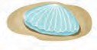

16

1. Read the following note from a school girl’s diary :



Write diary entries for the interesting or important events that take place in your school. Write at least 3 entries.

1. Language Study : Degrees of comparison.

We use different forms of adjectives and adverbs to show comparison. They are known as degrees of comparison.

Positive : Mangesh was *as strong as* Ravi.

She is *as tall as* her sister.

Comparative : Mangesh was *stronger than* other players.

She is *taller than* her sister.

Superlative : Mangesh was *the strongest* player in the team.

Their sister is *the tallest* amongst the three.

1. Complete the following sentences using your own ideas.

* The princess was as ................... as ................... . (Positive)
* The princess was ................... than ................... . (Comparative)
* The princess was the ................... amongst all (Superlative)

Note that we usually add ‘-*er*’, ‘-*est*’ to short adjectives and use ‘*more*’ or ‘*most*’ with longer adjectives.

Examples :

* high - higher - highest  attractive - more attractive - most attractive
* nice - nicer - nicest  interesting - more interesting - most interesting

1. Read the following words and name the degree of comparison shown by each.

good - better - best

bad - worse - worst

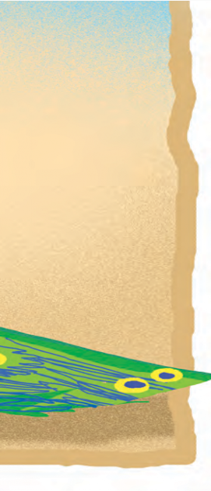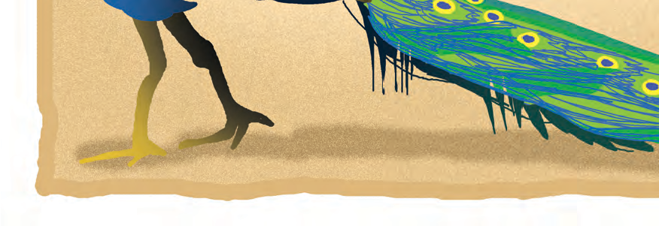

# The Peacock and the Crane

There was once a very conceited Peacock who had a gorgeous tail like no other bird. So, when he met a Crane one day, the Peacock scoffed at the Crane’s colourless and dull feathers, and immediately spread his own colourful tail for the Crane to see and admire.

“Look at my feathers,” he boasted, “how they shine in all the colours of the rainbow, while yours are so pale! I am dressed like a king!”

“That’s true,” the Crane answered, “but I can fly high above, among the clouds and the stars and I can see all the beauty of the earth in all its glory, while you live down here just like any other cock.”

Fine feathers don’t make fine birds.

8

18

* + - **conceited :** very proud, vain, arrogant
    - **gorgeous :** beautiful, magnificent, stunning
    - **scoffed at :** laughed at (the crane) rudely and scornfully



**POINTERS**

* **Fine feathers don’t make fine birds :** The saying ‘Fine feathers make fine birds !’ is used in a negative sense, to indicate that looks or flashy clothes may not be very important after all.
  1. Read the following sentences carefully and choose the correct meaning.
     1. The Peacock had a gorgeous tail like no other bird.  No other bird had a tail.

 The Peacock’s tail was more beautiful than any other bird’s.

 All birds had gorgeous tails.

* + 1. Fine feathers don’t make fine birds.

 You cannot use feathers to make birds.

 You can judge something by its outward beauty.

 Something that looks beautiful may not really be useful.

* 1. Read the story aloud (or present it) in groups of three - the narrator, the peacock and the crane.
  2. Imagine you are the Crane. What actions and words of the Peacock would you not like ? Write about it in short.
  3. Discuss what a friendly and good-natured peacock would say to a crane. Write his speech. (5-8 lines.)
  4. Find one more example which shows that a beautiful appearance is not enough.
  5. List 5 adjectives and 5 nouns from the story.
  6. Find five adjectives that end with (a) ‘-ful’ and (b) ‘-less’. Then write the antonym of each.
  7. Start a collection of proverbs. A proverb is a short, well-known sentence or phrase that gives advice or tells you what is generally true. For example, ‘A stitch in time saves nine’ means ‘If one does something in time or immediately, it saves a lot of work later’. A proverb is also known as a saying. Here are some proverbs for your collection.
* Appearances can be deceptive.
* Do not judge by appearance; a rich heart may be under a poor coat.
* All that glitters is not gold.
* You can’t tell a book by its cover.
* Clothes do not make the man.
  1. Visit a library : This story is a fable. Find two more fables. Share them with your friends.

 **1.7 Param Vir Chakra : Our Heroes** 

You may have heard about legendary heroes of the past and their extra- ordinary acts of bravery. But even today many brave soldiers of our country sacrifice their own lives for our safety. Their brave deeds are honoured by bestowing military decorations on them.

Param Vir Chakra is India's highest military decoration. It is awarded for

the most conspicuous bravery or some daring or pre-eminent act of valour or

rifice, in the presen

self-sac

air.

ific ence of the enemy, whether on land, at sea or in the

The Param Vir Chakra is a very rare honour. So far, it has been awarded only 21 times. Fourteen of these awards were given posthumously.

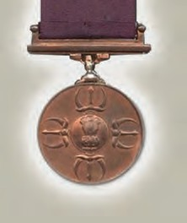

The medal itself is very simple in appearance. It is made of bronze, and is fitted with swivel mounting and has a plain purple ribbon. On the obverse, it has the Indian national emblem at the centre, surrounded by four replicas of ‘Indra’s Vajra’. On the reverse, the words Param Vir Chakra are engraved in Hindi and English, with two lotus flowers in between.

The Param Vir Chakra medal was designed by Savitribai Khanolkar. She was a European lady, who married Vikram Khanolkar, an Indian Army Officer. Savitribai loved India and took Indian citizenship. She spoke Marathi, Sanskrit, Hindi fluently and had studied Indian arts and traditions in depth.

20

20

Indra’s vajra or thunderbolt is supposed to be a matchless weapon. But what makes the weapon invincible is the supreme sacrifice of the sage Dadhichi.

According to legend, thousands of years ago, a demon had stolen all the water in the world. Innocent people were suffering and dying without water. This demon could not be defeated by any ordinary weapon made of ordinary material like wood, metal, etc. Something extra-ordinary was required. It was learnt that the sage Dadhichi had bones of such extra-ordinary power. But how could one ask for the bones of a living man? Sage Dadhichi was a noble person. He himself laid down his life and gave his own bones to help the people. Indra- vajra, Indra's weapon of thunderbolts, was fashioned from these bones and the demon was defeated.

Just as the Indra-vajra derived power from Sage Dadhichi's bones, the Indian military derives its strength and power from the sacrifice of the bravest of the brave -the Param Vir Chakra holders.

**The 21 Bravest of the Brave Param Vir**

* Major Somnath Sharma
* Lance Naik Karam Singh
* 2nd Lieutenant Rama Raghoba Rane
* Naik Jadunath Singh
* Company Havildar Major Piru
* Captain Gurbachan Singh Salaria
* Major Dhan Singh Thapa
* Subedar Joginder Singh
* Major Shaitan Singh
* Company Quarter Master Havildar Abdul Hamid
* Lieutenant-Colonel Ardeshir Burzorji Tarapore
* Lance Naik Albert Ekka
* 2/Lieutenant Arun Khetarpal
* Major Hoshiar Singh
* Naib Subedar Bana Singh
* Major Ramaswamy Parameswaran
* Lieutenant Manoj Kumar Pandey
* Grenadier Yogender Singh Yadav
* Rifleman Sanjay Kumar
* Captain Vikram Batra
* Flying Officer Nirmal Jit

Singh Sekhon

**Flying Officer Nirmal Jit Singh Sekhon**

**10877 F (P), PVC**

**Squadron No 18 : The Flying Bullets**

On the 14th of December 1971, Srinagar Airfield was attacked by a wave of six enemy Sabre aircraft. Flying Officer Nirmal Jit Singh Sekhon was on readiness duty at

that time. He could not take off immediately because of clouds of dust raised by another aircraft. By the time the runway was clear, the enemy aircraft were overhead. They were flying low, firing and attacking the airfield with bombs. Even then Flying Officer Sekhon took off in his Gnat fighter the moment he could. He began to combat the powerful Sabre jet aircraft of the enemy. He damaged two of them. His fight with the attacking aircraft now continued at tree-top height. At last, the enemy aircraft fled from the scene of battle. The airfield and the town of Srinagar were saved. But alas ! Flying Officer Sekhon's aircraft, too, crashed and he was killed.

Flying Officer Sekhon displayed great flying skill and determination in the face of certain death. He showed unmatched heroism above and beyond the call of duty ! Salute to the bravest of the brave - Flying Officer Nirmal Jit Singh Sekhon !

Do read more on the internet at [www.paramvirchakra.com,](http://www.paramvirchakra.com/) about the gallant PVC awardees who laid down their lives in the service of the country. You will see that they belong to various communities and religions. Do find and read the inspiring accounts of how they faced the enemy without any regard for their fatal wounds

and physical pain. 21

21

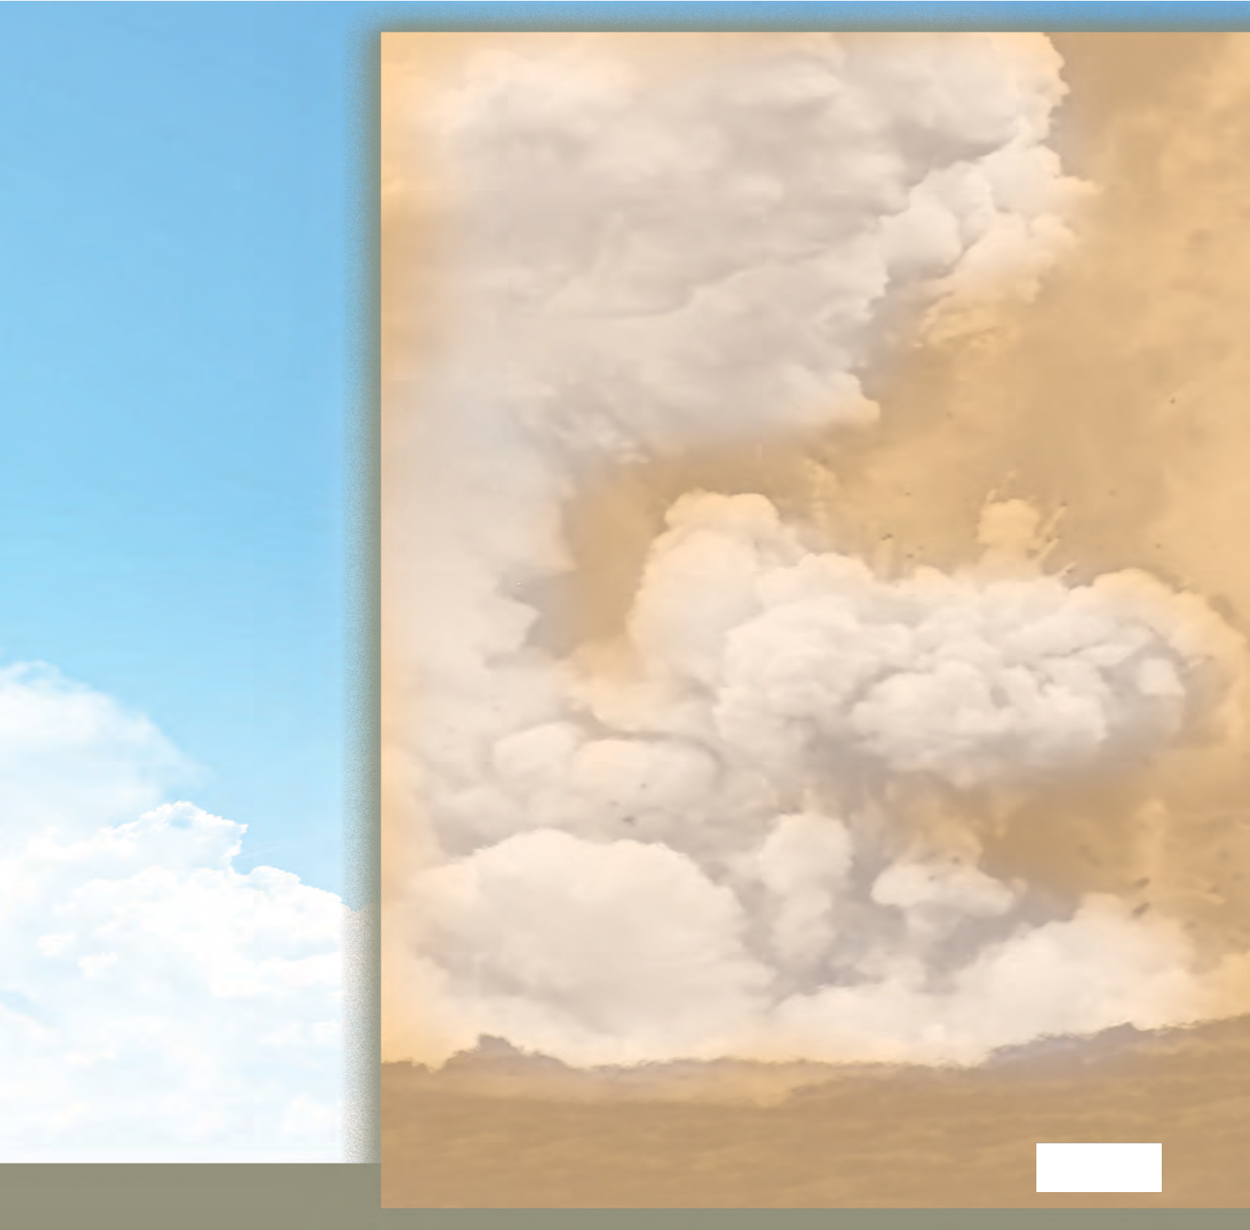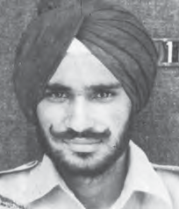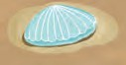

* **legendary :** very famous and admired
* **conspicuous :** outstanding
* **posthumously :** after a person’s death
* **fitted with swivel mounting :** fixed in a way which allows it to move freely
* **obverse and reverse :** the front and back sides (of the medal)
* **emblem :** symbol; an object that represents something
* **thunderbolt :** a flash of lightning with a clap of thunder that strikes at something
* **invincible :** impossible to defeat
* **determination :** strong resolve, perseverance
* **gallant :** brave, courageous
* **inspiring :** motivating
* **account :** a description of an event
* **fatal :** causing death



**POINTERS**

* 1. Read the passage and answer the following questions :
     1. What is ‘Param Vir Chakra’ ?
     2. What is seen on the obverse and reverse of the PVC medal ?
     3. Who designed the PVC medal ?
     4. What makes Indra’s vajra or weapon invincible ?
  2. Write the story of Sage Dadhichi’s sacrifice in your own words.
  3. Read aloud the account of how Flying Officer Nirmal Jit Singh Sekhon sacrificed his life to defend our country.
  4. Find more information about other Param Vir Chakra awardees. Prepare a collage using photographs, pictures and text matter written in beautiful handwriting.
  5. Find more information about the Indian Armed Forces - the Army, the Navy and the Air Force with the help of your teacher.
  6. What can you do to show your love, respect and support to the soldiers who fight for the country ? Discuss this in the classroom. For example, you can send greeting cards to them on various occasions, with the help of your teacher.

***

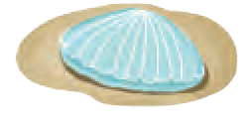

22

Sometimes, we use two or three adjectives together to describe a noun. In such cases, the order in which adjectives are used depends on the meaning. The adjectives that express/show your opinion about something are usually put first. The other adjectives are normally put in the following order :

Examples :  a *nice little* basket  a *brave young* woman,

* a *big red, plastic* bag  a *noisy, old, drilling* machine.

size, age, shape, colour, origin, material, use or purpose.

# The Clothesline

Hand in hand they dance in a row, Hither and thither, and to and fro, Flip! Flap! Flop! and away they go — Flutt’ring creatures as white as snow,

Like restive horses they caper and prance; Like fairy-tale witches they wildly dance; Rounded in front, but hollow behind,

They shiver and skip in the merry March wind.

One I saw dancing excitedly, Struggling so wildly till she was free,

Then, leaving pegs and clothesline behind her, She flew like a bird, and no one can find her.

I saw her gleam, like a sail, in the sun, Flipping and flapping and flopping for fun. Nobody knows where she now can be,

Hid in a ditch, or drowned in the sea.

She was my handkerchief not long ago,

But she’ll never come back to my pocket, I know.

*- Charlotte Druitt Cole*

* **restive :** restless, fidgety, unable to remain still
* **caper :** leap, skip or dance about in a lively, playful manner
* **prance :** walk or move with high, springy steps
* **wildly :** Here, it means very hard, violently.
* **pegs :** pins used to secure something in place, as for example, clothes on a clothesline

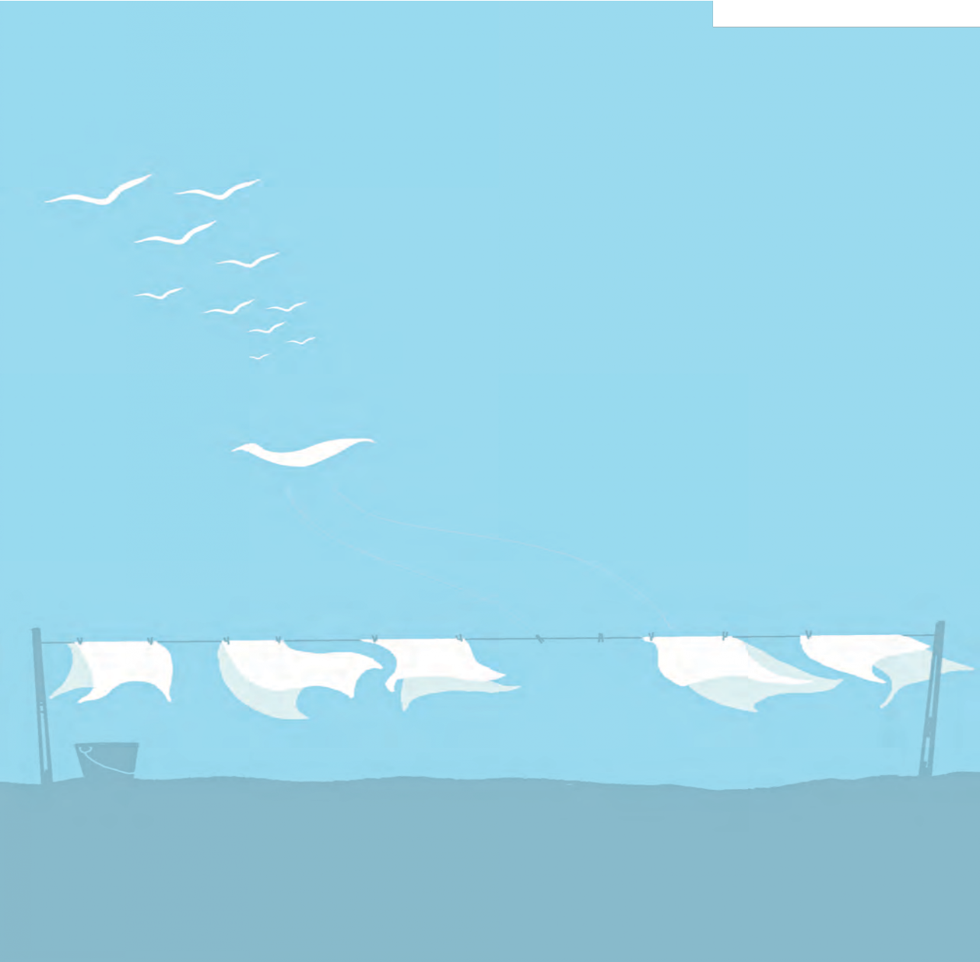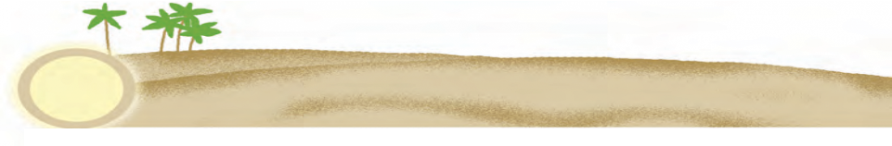

23



**POINTERS**

* 1. Read the poem aloud. Recite any stanza of your choice from memory.
  2. Answer the following questions with reference to the poem.
     1. What is described in the poem ?
     2. What are the clothes compared to? Give two examples.
     3. What do restive horses do ?
     4. What do fairy-tale witches do ?
     5. What did one of the fluttering creatures do ?
     6. What could have happened to the one who flew away ? Who was she ?
  3. Form groups and discuss the following questions :
     1. Why are the clothes compared to living things ?
     2. The events described in the poem take place at a certain place, at a certain period of the year, under specific weather conditions. Describe the place, the time and the weather conditions.
  4. When we say that two or more words rhyme, we mean that they end with the same sound or syllable. For example, ‘ring-sing’. Rhyming words are often used in verse at the end of the lines. List the rhyming words from the poem. Note the words ‘behind’ and ‘wind’. They have similar spellings, that is, they look the same. But they are pronounced differently, that is, they do not ‘sound’ the same. This is known as ‘eye rhyme’. Separate the examples of eye rhymes from the following list.
* cry-try  stronger-longer  laughter-daughter  known-grown
* none-shone  beat-feat  shut-put  won-done  imply-simply
  1. List all the phrases from the poem in which two or more words are joined with ‘and’.
  2. Form groups and discuss what must have happened to the handkerchief. Write the story in your own words.
  3. Wash your handkerchief clean. Hang it with a peg to dry in the wind. Watch how it flutters.
  4. Complete the following comparisons.
* as white as ................  as green as ................  as red as ................
* as blue as ................  as black as ................  as bright as ................
  + 1. Rewrite these comparisons using the comparative degree.

Example : Whiter than snow

* + 1. Find suitable objects for each comparison.

Example : Petals or flowers or feathers whiter than snow.

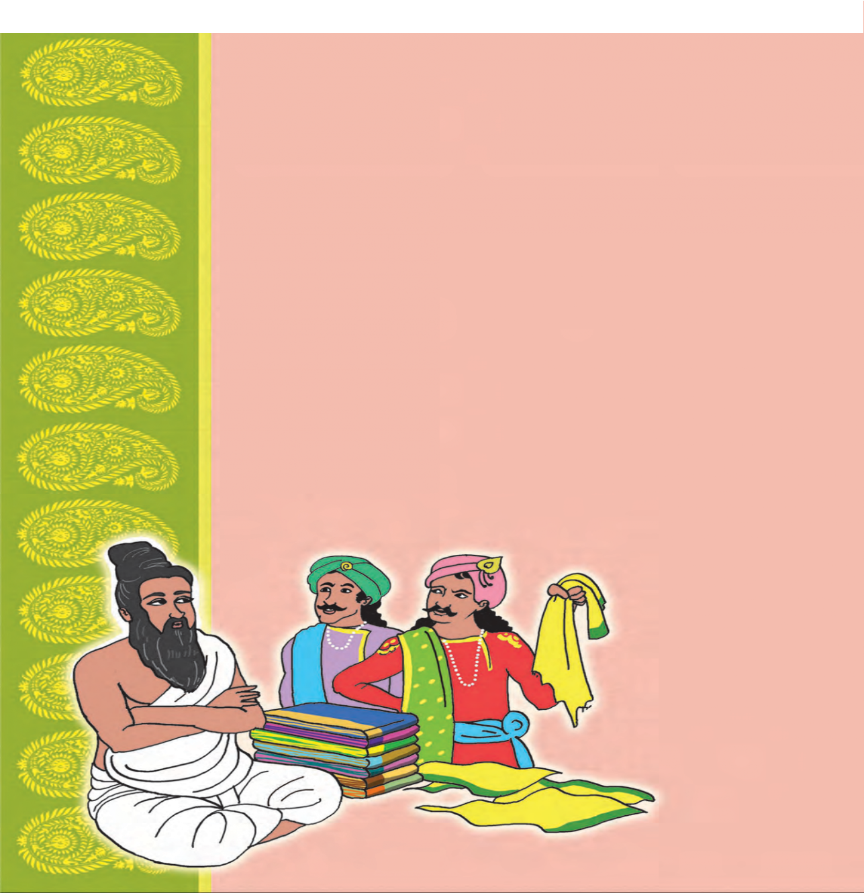

# The Worth of a Fabric

Thiruvalluvar was a great Tamil Saint-poet, who lived more than two thousand years ago. ‘Thirukkural’ is the book of his teachings. It is greatly loved and respected even today.

Thiruvalluvar was a textile weaver. He wove beautiful fabrics and saris and sold them in the market. People said that he never got angry, never used bad words, never shouted at anyone.

In the same town, there lived a rich young man. He wasted most of his time roaming around with his friends. They often made fun of other people.

“I don’t believe what people say about this Valluvar,” said the young man one day. “I’m sure I can make him angry. Come on, let’s have some fun today!”

So the arrogant young man approached Thiruvalluvar in the market and picked up a beautiful piece of fabric.

“How much does this whole fabric cost ?” he asked. “Eight coins,” the saint named the price.

The young man unfolded the fabric and tore it into two. “What’s the price of this piece, now ?”

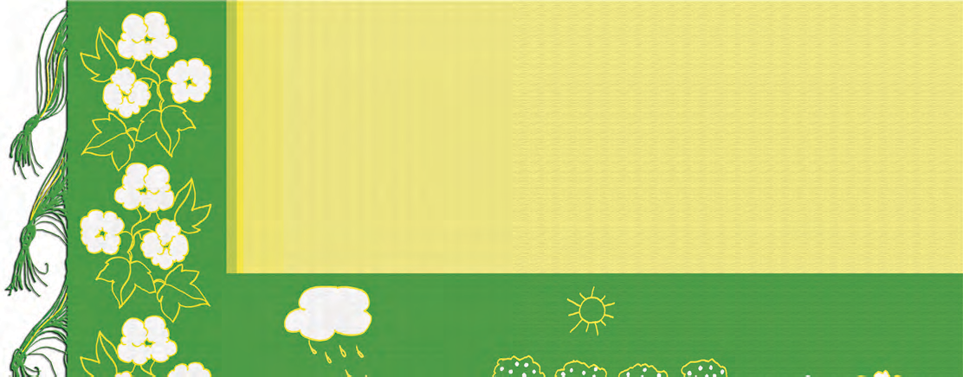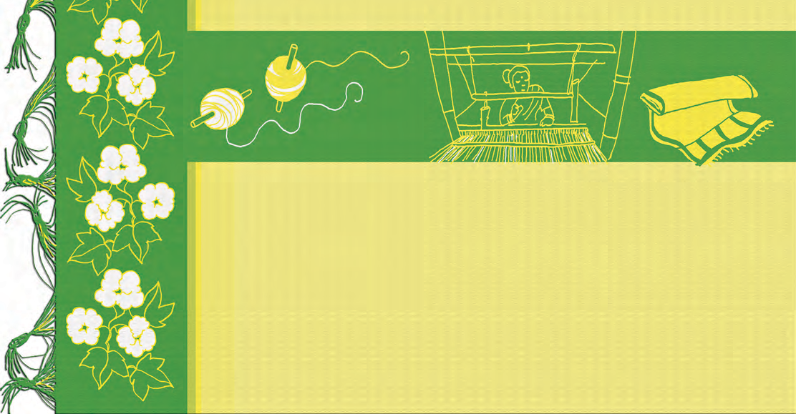

“Four coins,” the Saint answered politely.

The youth was taken aback. ‘Why doesn’t the man get angry ?’ he thought. He then tore the half pieces into half again.

“And now ?”

“Two coins!” was the answer.

Now it was the young man who became impatient and agitated. He tore the pieces into half again and again, saying, “And now? What’s the price now ?”

Thiruvalluvar calmly went on reducing the price to half every time.

At last, the fabric was reduced to rags. So, Thiruvalluvar said in a quiet tone, “Now this fabric has become worthless. I will not name any price for these rags.”

The young man did not know what to say. But he was proud of his riches. So he offered to pay eight coins to the Saint. For the first time, Thiruvalluvar smiled but he refused to take the money.

“Young man, now this fabric is of no use. It has become worthless. Why ? Because no one will be able to wear it now.”

“Do you know, the fabric was not made in a day. Many people have toiled to make it. The farmer who grew cotton in his field worked hard for months through sun and rain. He picked cotton from each boll and gave it for spinning. Then someone else carded the cotton and spun it into long, uniform threads. The threads were dyed carefully so that they took on these lovely colours. My wife and I wove the threads together, putting in beautiful designs. We thought, some day, someone will like this fabric, will be happy to

wear it. Then all our work would have been rewarded. When you destroyed the fabric, you destroyed all the love and labour that went into its making. Money cannot bring it back.”

The softly spoken words touched the young man’s heart. Now he was really ashamed of himself.

“And do you know,” Thiruvalluvar went on to say, “I can weave another fabric like this, but our life is also like this fabric. If you tear it apart with hasty, thoughtless actions, it will be destroyed. And you will not get it back again.”

Thiruvalluvar’s words opened the young man’s eyes. There and then he decided to give up his idleness and bad habits.

* **boll :** pod of the cotton plant
* **spinning :** process of making yarn or thread out of cotton wool
* **carded :** cleaned and combed cotton to remove seeds
* **spun :** drew out and twisted cotton (to make yarn or thread)
* **rewarded :** when one is rewarded, one gets what he has worked for
* **idleness :** laziness



**POINTERS**

* 1. Form pairs. Present in the class, the conversation between Thiruvalluvar and the young man.
  2. Describe the following with the help of the story.
     + Thiruvalluvar  The rich young man  The fabric woven by Thiruvalluvar
  3. Read aloud the speech in which Thiruvalluvar explains how the fabric was made. Present the process in the form of a chart. Draw pictures for the chart and label them.
  4. Classify the words in (a) and (b) into ‘positive’ and ‘negative’ words.

1. great, beautiful, arrogant, impatient, quiet, worthless, proud, happy, thoughtless, hasty
2. shouted at, wasted, answered, offered, smiled, refused, toiled, grew, dyed, rewarded, destroyed.
   1. Write the antonyms of the following words :
      * politely  ..........  calmly  ..........  softly  ..........  carefully  ..........
   2. Find the following adverbs in the story. What verbs do they tell us more about ? Write down the pairs of verbs and adverbs.
      * ago  greatly  today  politely  calmly  hard
   3. Use the following phrases in your own words.

* roam around  again and again  bring something back  there and then
  1. Discuss in groups and think about it.
     1. List a few occasions on which you had become angry. What do you do when you are angry?
     2. Mention three occasions on which you have made someone else angry. What made that person angry? Can you avoid such things in future?
  2. Choose any one of the objects we use daily and find out how it is made. Present the information in the form of a chart.
  3. Visit a library : Read the biographies of other Indian Saints. Share at least one story from their life with your friends. What message does it contain ?
  4. Form groups and display the quotes and messages from different saints in your classroom.



## A Project : Fabrics

1. Find out the synonyms for the word ‘fabric’ from a dictionary.
2. How are fabrics used in our daily life? List all the things that are made up of fabrics in your home. (At least 25)
3. How many of them are personal articles? How many of them are used for beautification of your home? How many of them are meant for utility (to fulfil a useful function in the household)?
4. List at least ten articles which use fabrics in their making. (Umbrella, school bag, tents, shamianas, stage curtains, canvas, chairs, etc.)
5. Can you name different types of fabrics? Which is the most expensive fabric you know? Talk to your parents or to a textile shop assistant. Collect samples of as many types as you can and paste them in your scrapbook. Name each type.
6. Find out the different processes by which fabrics are made. Find illustrations and write a few lines on each process.
7. Name the type of fabric closely associated with Mahatma Gandhi, the Father of the Nation. Why did Gandhiji want all of us to use this fabric?
8. India is famous for its handloom fabrics. Write the story of a handloom kurta in your own words.



**2.3**

**A Wall Magazine for your Class !**

Students of VI A bubbled with enthusiasm all the time -

be it sports, hobbies or studies. This year they surprised the rest of the school by bringing out a wall magazine. The idea became so popular that soon there were unique wall magazines in almost every class in the school. This is what Class VI A did to plan and prepare their wall magazine.

First, the students and class teacher of VI A brought several children’s magazines and pages of children’s sections in periodicals and newspapers to the classroom.

They studied the contents to see what all was included in the magazines. There was a tremendous variety - stories, poems, puzzles, riddles, craft ideas, informative articles, interesting tidbits of informotion, jokes, board games, book reviews, quizzes, study tips, health tips and even recipes ! There were also columns about students’ achievements, doubts and problems. These columns were run with the help of teachers or parents.

After studying all the material, a discussion was held in the class to choose sections for their own magazine. It was decided that :

There would be at least four issues of the magazine. There would be a separate team for each issue. The team would have an editor, one or two

|  |  |
| --- | --- |
|  | **For the teacher :** Please |
| Are you tempted to do something similar for your own class ? What are you waiting for ? Go ahead !  On the next few pages, you will find some specimens from the wall magazine of VI A. We are sure you can create even more interesting pages, if you use your own ideas and talents ! | use the procedure outlined  here to bring out Wall Magazines prepared by your students. Give them freedom to choose regular features or columns. Please see that every child contributes something to the magazine or shares some of the work. |
|  | |

sub-editors, illustrators (artists) and writers (those who actually copied or typed the issue in beautiful letters.)

Anyone in the class could send contributions to the issue. The editors would select the articles to be included and their decision would be final.

Thus, there would be four different teams to work on the four issues.

The columns (regular features in all four issues) were planned with the help of the class teacher. Apart from the editorial teams, more groups were made to run columns like Craft Ideas, Recipes, ‘I need help !’, Science Corner, etc. It was the job of these groups to collect material for their respective columns.

With the teacher’s help, a prominent place was fixed to display the magazine in the classroom.

A long discussion was held to choose a good name for the magazine.

*Teacher : Wally, why are you la/e?*

*Wally : The /rain had*

a Áa/ /yna.

Why did the teacher wear sunglasses?

Because his students were so bright.

Fun with words

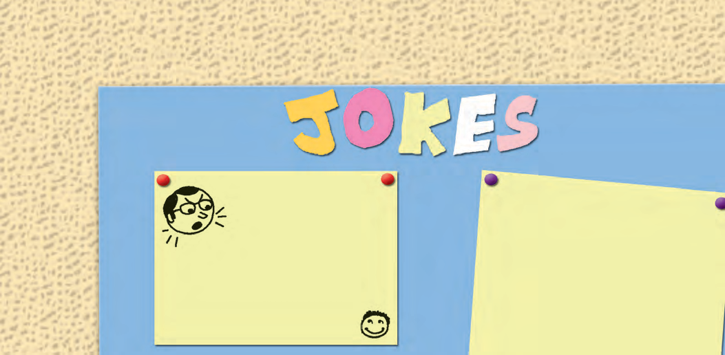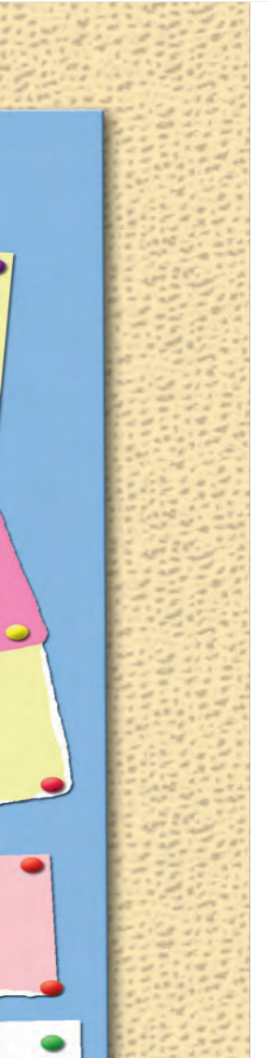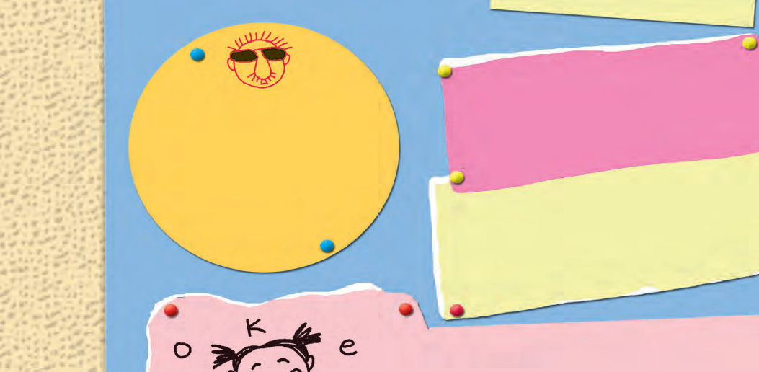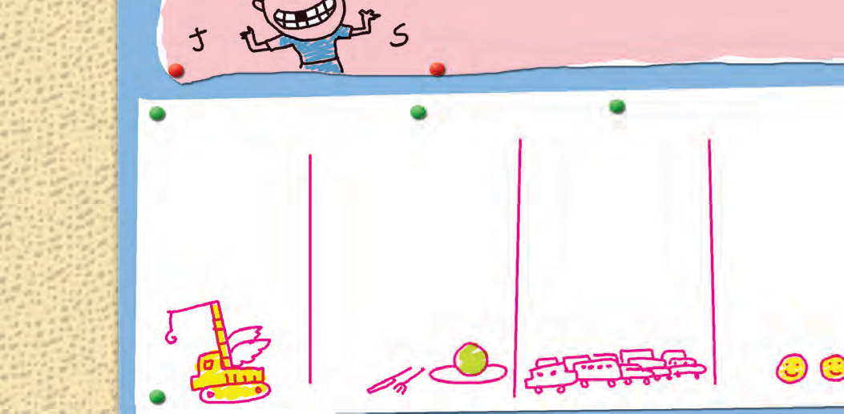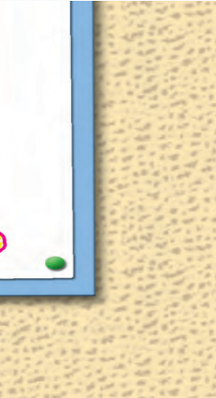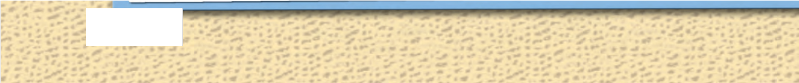

What’s the difference between a hungry person and a greedy person?

One longs to eat, and the other eats too long.

30

**C**

**Science Corner**

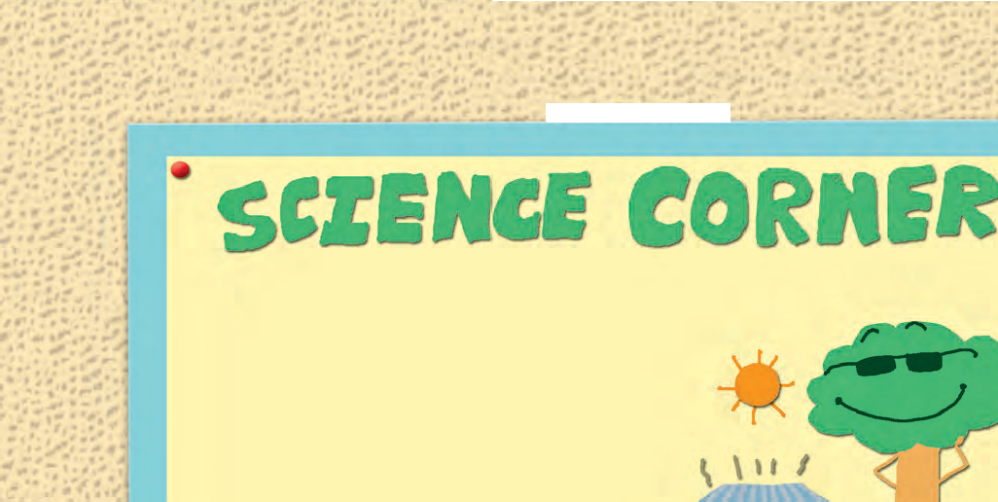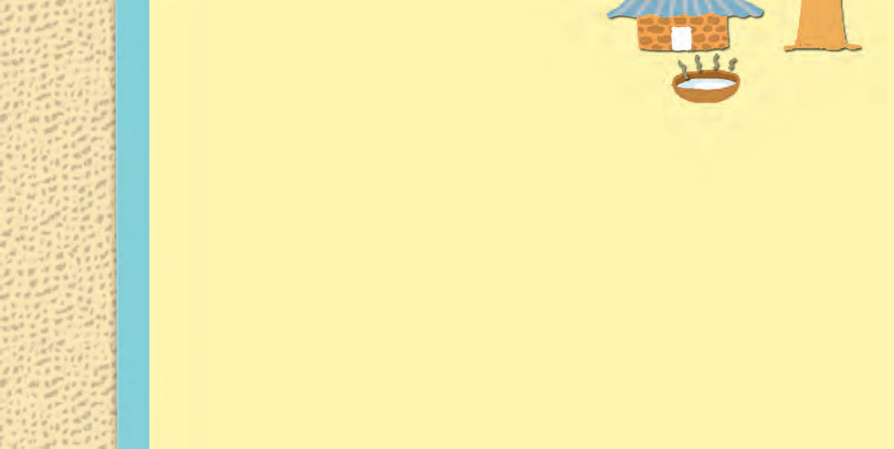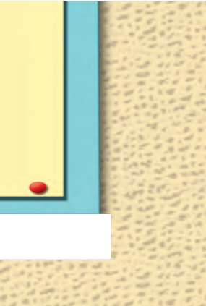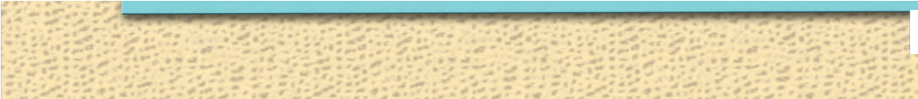

## Why do water, tin sheets become hot in the sun, but not a tree?

Water and tin sheets are non- living. When they receive heat, they get heated according to their properties and may even change the state in which they are. Water

turns into vapour, and even tin sheets melt at very high temperatures. They do not make any attempts to cool themselves.

But you know that bodies of living things carry out different processes that help them to survive or to adapt to their surroundings. Plants carry out a process called transpiration. In this process, water is absorbed by the roots and is sent up through the stems, up to the leaves. On the underside of leaves, there are pores (or holes) called ‘stomata’. Plants use up some of the water they absorb and the rest is given out through these stomata. This process helps plants to cool themselves.

(Humans also use a similar process to cool themselves. Can you guess what it is ? Yes, sweating !)

Also, you know that big trees have trunks. The trunks consist of wood. Wood is not a good conductor of heat.

You may relate this information with what is given in your science textbook (Responsiveness to stimuli, Heat, States of Matter, etc.)

Some questions for the next issue :

* Why do the sun and moon change their size?
* How can we see many channels on the same TV set ?
* Why do we see one image when we have two eyes ?

31

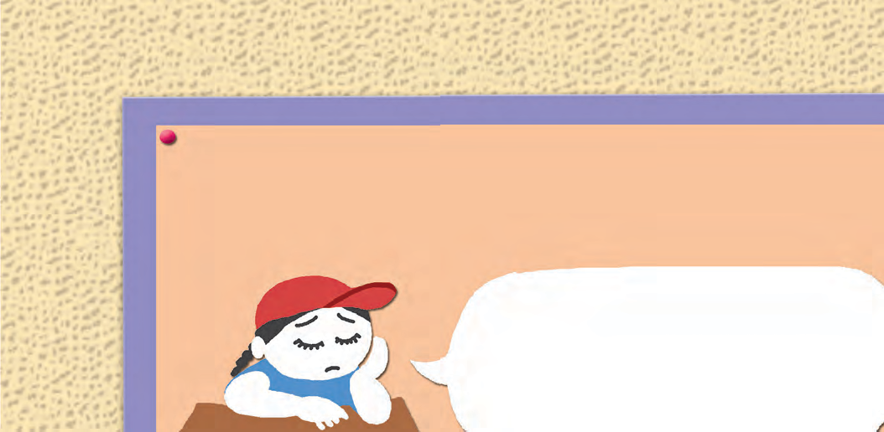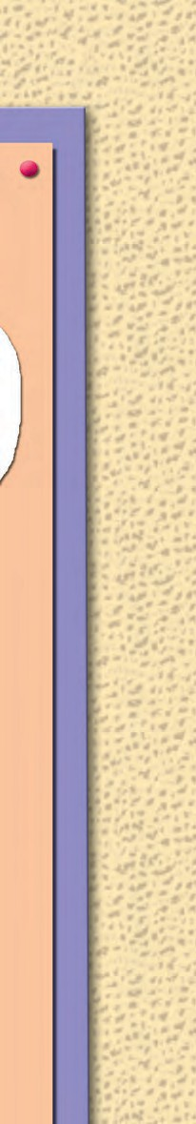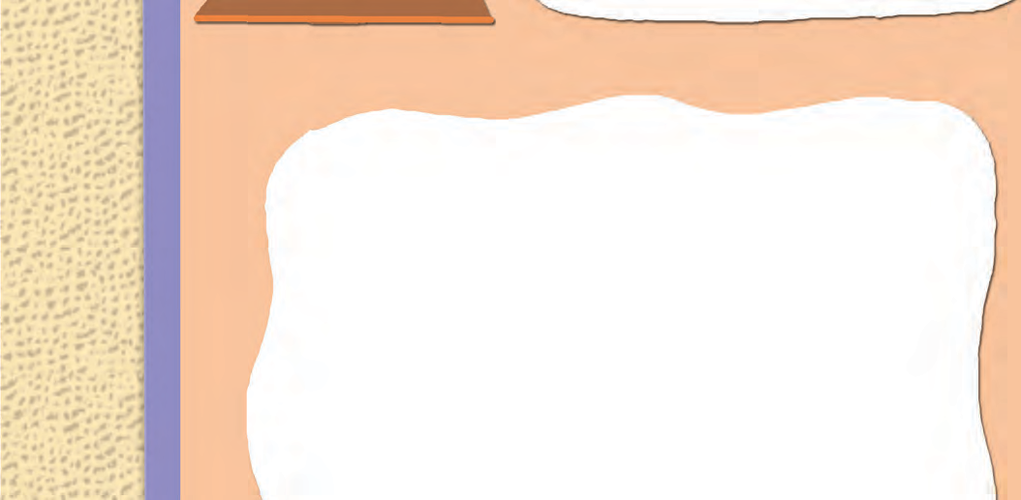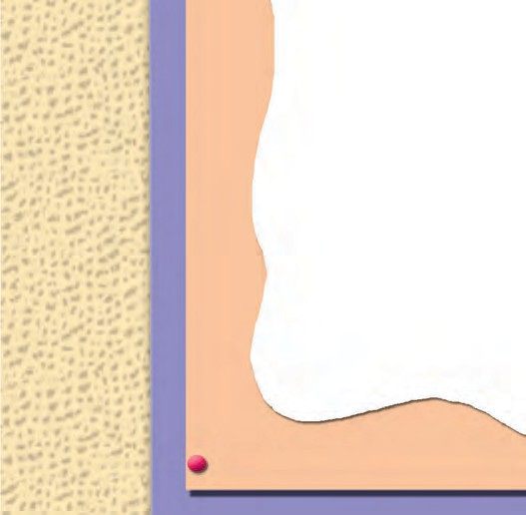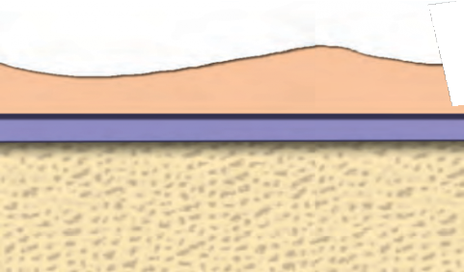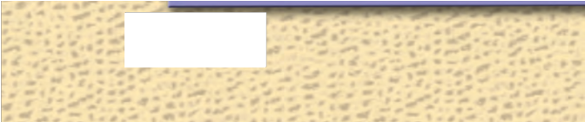

My best friend is ignoring me this year : I feel angry and unhappy about it, but I still think of her as my best friend. Why is she doing this to me ?

I am confused. Please help !

## Expert advice from senior friends !

Hmmm ! Don’t we all feel this some time or other ? Don’t worry. Let’s see what we can do. First, please think about it without getting upset. Is she really ignoring you ? What are the things that you used to do together, but don’t do any more ? For example : sitting on the same bench, having your tiffin together, coming to school or going back home together and so on. If you still do most of these things together, you may be wrong in thinking that she is ignoring you. You can talk to her about it. Find out if you have hurt her in some way, if there is a misunderstanding and that is why she is not as warm towards you as she was before. If that is so, you can simply say sorry and she will immediately be friends with you again.

Has she made new friends ? Is that what is making you feel a little jealous and sad ? Well, you can always be friends with her new friends ! Your friend may appreciate it.

If your last year’s best friend has really started ignoring you without any reason, do not keep brooding about it. You can make friends with others. Maybe after a few days, your old friend will also be close to you, once again.

3

32

## The Little Rose Tree

Every rose on the little tree

Is making a different face at me!

Rhyme and Rhythm

Some look surprised when I pass by, And others droop - but they are shy. These two whose heads together press

Tell secrets I could never guess.

Some have their heads thrown back to sing, And all the buds are listening.

I wonder if the gardener knows, Or if he calls each just a rose?

a flying horse

You can use these funny phrases in place of ‘horse fly’ or ‘pen stand’. Enjoy the puns (different meanings) !

*- Rachel Field*

## Lyrics

Did you ever see a horse fly, a horse fly, a horse fly?

Did you ever see a horse fly, a horse fly, fly, fly?

Did you ever see a pen stand, a pen stand, a pen stand?

Did you ever see a pen stand, a pen stand, stand, stand?

shoe lace, hair pin, tooth pick, eye drop, neck tie, eye lash, yard stick, ear drum

a horsefly

## One Bright Day ...

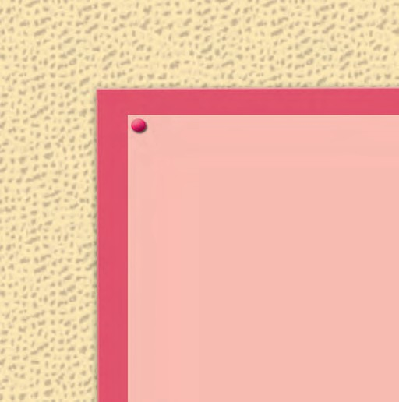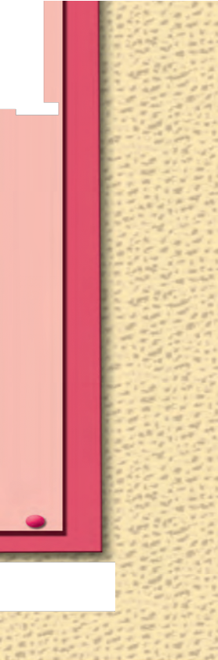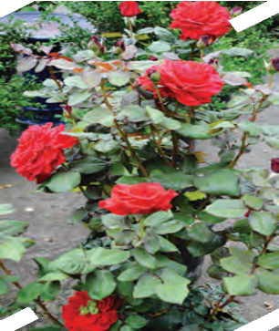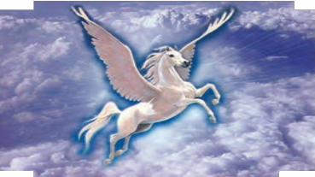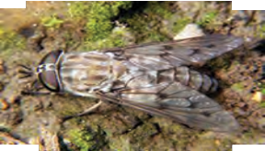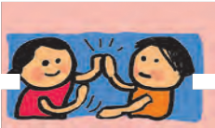

(A Hand-clapping Rhyme)

One bright day in the middle of the night, Two dead soldiers got up to fight.

Back to back they faced each other, Drew their swords and shot each other.

A deaf policeman heard the noise And ran to save the two dead boys.

If you don’t believe this lie is true, Ask the blind man, he saw it too.

33

# 2.4 Anak Krakatoa

Krakatoa is an island in the Sunda Strait between Java and Sumatra in Indonesia. It is known for its volcano which erupts regularly.

What is a volcano ? A volcano is a crack or opening in the earth’s crust. There is hot molten rock near the earth’s centre. Sometimes, it rises to the surface of the earth through such a crack or opening and flows out. When this happens, we say that the volcano has erupted.

A volcanic eruption happens on a tremendous scale. Thick, dark clouds of smoke rise high from the opening

and spread in the sky.

Big, glowing, burning chunks of rock and red hot lava are thrown out of the crack in the earth. Very hot mud and ash are also thrown out. A great volcanic eruption can change the landforms in an area.

Volcanoes are popularly classified into three categories:

1. **Active volcanoes :** Active volcanoes erupt regularly.
2. **Dormant volcanoes :** Dormant means temporarily inactive or in a deep sleep. We find information about the eruptions of these volcanoes in history, but now they are quiet.

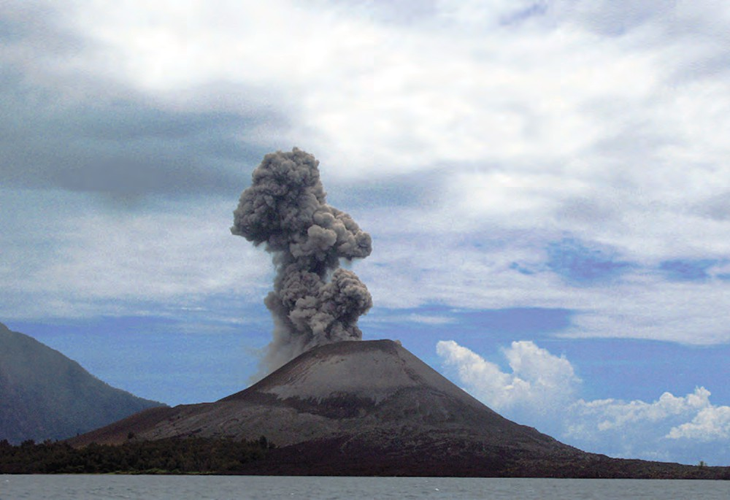

34

1. **Extinct volcanoes :** Geographers can guess (by looking at the rock formation) that they used to erupt long, long ago, but there is no record of it in history. An extinct volcano is unlikely to erupt again.

Krakatoa is an active volcano. It has erupted many times causing great disasters. The worst of the eruptions took place in August 1883. The volcano erupted with such a loud boom that it was heard more than 3500 km away in Australia. It is believed to be the loudest sound that man has ever heard. The island, which was a volcanic mountain, collapsed on itself. The dust that was thrown up in the eruption rose to about 80 km in the sky. It spread in the sky around the world and later settled in different parts of the world thousands of kilometres away.

The eruption caused giant waves or tsunamis in the sea near the island. About 165 villages and towns were destroyed due to the eruption and the tsunamis. The eruption destroyed two thirds of the island of Krakatoa. It collapsed beneath the surface of the sea, creating a huge underwater volcanic crater or hole. The hole was more than 6 km wide.

Then, in 1927, a plume of smoke rose out of the water on the crater. It was followed by another eruption. A few days later, a new island volcano broke water. How did it happen?

When the underwater volcano threw up ash and rock, it was quickly taken

away by the sea water. But then the lava started flowing out of the crater faster. This volcanic material was not all taken away by the waves, and a new mountain began to grow. It kept growing and was soon seen above the water. Thus, a new island grew from the old island of Krakatoa. It was named ‘Anak Krakatoa’ or the ‘Child of Krakatoa’.

Anak Krakatoa is still an active volcano. Eruptions have begun again since 1994. It lies quiet for a few days and then again there are eruptions. With more lava flowing out, the island is still growing bigger. Since 1950, the island has grown at an average rate of five inches per week!

A part of the old island known as Rakata is still visible in the sea, a little away from the new arrival - Anak Krakatoa.

After Krakatoa’s eruption in 1883, all the surrounding islands and coasts were covered with hot ash. No life remained. When a scientist visited it in 1884, he found just one spider there.

But the living world on Rakata was not lost and gone forever. The wind and the sea brought seeds of plants to the island. Some seeds came with the birds who flew over the island. Plants and animals that live in the sea came to the coasts again. Small land animals like ants, termites or even rats and lizards travelled to the island on plants floating in the sea. One edge of the island was



35

soon teeming with plants and animals.

It was like a laboratory where scientists can see how living things slowly develop in an area. Today, scientists

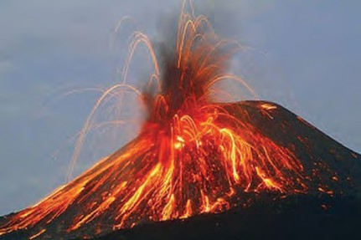

can observe this also in a part of Anak Krakatoa, which does not get covered with volcanic ash.

The western coast of Java was greatly affected by Krakatoa’s eruption. Very few human beings were left there. But the wild animals and plants in that area grew in number again. In fact, the wildlife grew naturally since there were no human beings to interfere with it - there was no one there to cut the trees or kill the animals. So, this region became rich in wildlife.



**POINTERS**

1. Draw a diagram to show a volcanic eruption from its description given in this passage. Label the diagram. Show the following in it : Volcano; earth’s crust; crack in the earth’s crust; hot molten rock; red, hot lava; smoke; ash; burning chunks of rock.
2. Show the three categories of volcanoes using the following tree diagram structure.

Write a very short description of each category below the box.

1. Show the stages in the process in which Krakatoa collapsed and then Anak Krakatoa formed in the course of volcanic eruptions. Use the flowchart given below.

→  →  → ...

1. Draw a diagram to show how life returned to the island. Label the diagram.

(Use the technique of drawing diagrams when you study science, geography, etc.)

1. Write short notes on the following :

(1) The 1883 eruption (2) The living world on Rakata

1. Find the pronunciation of the following words from a good dictionary. strait, eruption, tremendous, dormant, extinct, tsunami, crater, plume.



36

There are other verbs like can, could, may, might, will, would, shall, should, must, used to, etc. which show whether something is possible, allowed, necessary, etc. They are known as modal auxiliaries or modal verbs or helping verbs. We will look at their examples later on.

1. Read aloud with the leader : Form groups of five. Read the passage aloud in groups. The leader begins every sentence and stops after a few words. The other members complete the sentence, reading it aloud in chorus.
2. Look at the following words carefully for one minute. Now close your book and try to write down as many of the words as you can remember.

**crust tremendous lava crater volcanic tsunami island extinct**

**disaster dormant eruption plume inland molten active coast**

1. Read the passage and find the verbs used with the following nouns and phrases :
   * volcano  molten rock  volcanic mountain  dust
   * 165 village and towns  the wind and the sea  seeds  birds

The verbs **be**, **have** and **do** are also used with the main verbs in a sentence to show certain things. Then, they are called **auxiliary** or **helping** verbs.

* ‘Do’ is used with the main verb -

1. To form questions :

*Do* you *know* the answer?

*Did* you *see* the bird ? What *do* you *want* ?

What *did* the queen *tell* them ? What *did* they *do*?

1. To form negative sentences : We *did not* go back.
   * ‘Be’ and ‘have’ auxiliaries can also form questions and negatives.

‘Do’ is not needed when these are used.

Examples :

1. Questions : *Are you writing* a story ?

*Is* it necessary?

*Have* you *written* this ? Why *have* you *come* back ?

1. Negatives : I *was not* feeling well. She *had not seen* the book.

In the fifth standard, you have learnt to identify verbs like rise, flow, happen, etc. that are used in a sentence.

The verbs **be, have,** and **do** can be used as main verbs in a sentence.

be : am/are, is/are, was/were, being, been.

have : has/have, having, had do : does/do, doing, did, done Examples :

**be** : I *am* twelve years old.

They *were* ready.

**have** : I *have* a brother.

The dinosaur *had* a long tail.

**do** : *Do* it ! She *did* some work.

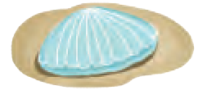

37



**2.5**

**The Silver House**

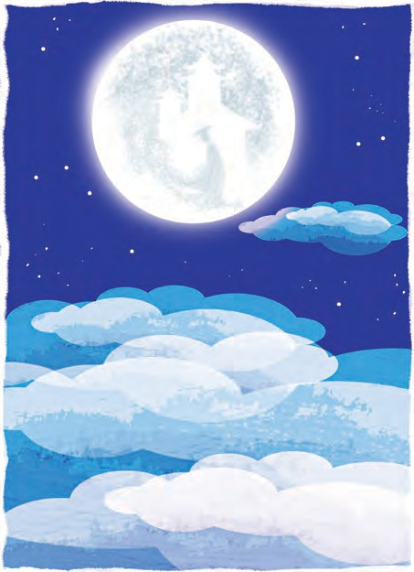There’s a silver house in the lovely sky, As round as a silver crown;

It takes two weeks to build it up, And two to pull it down.

There’s a man who lives in the silver house, In a lonely sort of way;

But what his name is no one knows, Or no one likes to say.

Yet when you go to bed tonight, Just draw the window blind, And peep out at the silver moon, This lonely man to find.

But if his house is taken down, And all the sky is bare,

Then go to bed, because, of course, The poor man won’t be there.

*- John Lea*

* **crown :** a silver coin that was used in England in the past.
* **window blind :** a protective covering for the window. A window blind keeps out light.
* **taken down :** pulled down, dismantled



**POINTERS**

1. What do the following words in the poem mean ?

(a) crown (b) round (c) draw (d) blind

Do these words have other meanings ? List them.

1. Find four pairs of rhyming words from the poem.
2. In each of the following line, spot the sound that is used repeatedly -
   * There’s a silver house in the lovely sky.
   * As round as a silver crown
   * It takes two weeks to build it up. And two to pull it down.
3. What is implied in the following phrases or lines?
4. A silver house in the lovely sky
5. It takes two weeks to build it up
6. And two to pull it down.
7. Make a ‘pair presentation’ of the poem, in the class.
8. The man in the moon is mentioned in many nursery rhymes and stories. When people see the spots on the surface of the moon, they imagine that it’s a human face, or the figure of a man who lives on the moon. Sometimes, other characters like rabbits are also imagined to live with the man. Here are two nursery rhymes about the man in the moon.

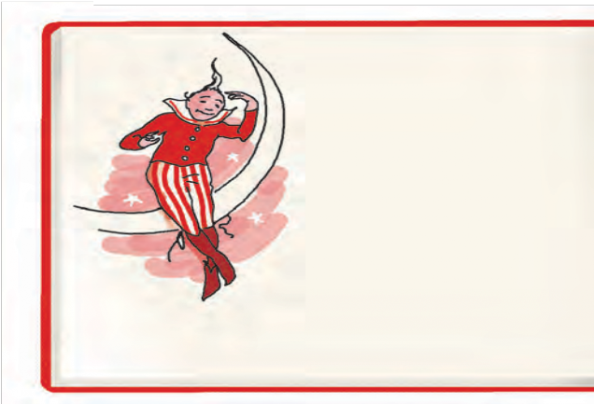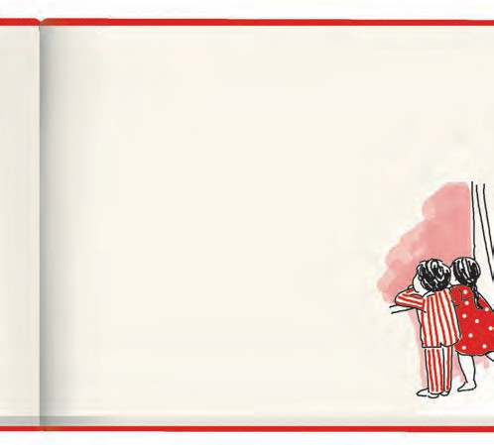

**-1- -2-**

The man in the moon Came down too soon To ask the way

to Norwich.

He went by the South And burnt his month With eating cold

pease porridge.

●  

The man in the moon Looked out of the moon, And this is what he said,

‘Tis time that

Now I am getting up, All babies went to bed.’

●  

1. Are there any stories/legends about the moon or special names for the moon in your language? Talk to your friends and family members and collect this information.
2. Do you know any poem or song about the moon in your own language ? Sing it in the class.
3. Form pairs. Write a poem with rhyming lines on at least one of the following : the moon, stars, a tree, a flower, a river/lake, rain, the wind, clouds.

***

# Ad‘wise’ Customers



You must have seen ‘ads’, that is, advertisements on TV and in many other places. Advertisements are given by owners of different companies to tell people about their products. Their aim is to make people buy those products.

Advertisements are designed in such a way that people are impressed when

***What the ad says* :**

they see them. They feel

like buying the product - that is what the owners want! But is the advice in the ads always good for you ? You must think about it carefully.

You must act like a wise customer, and decide what to buy, how much to buy and what not to buy!

*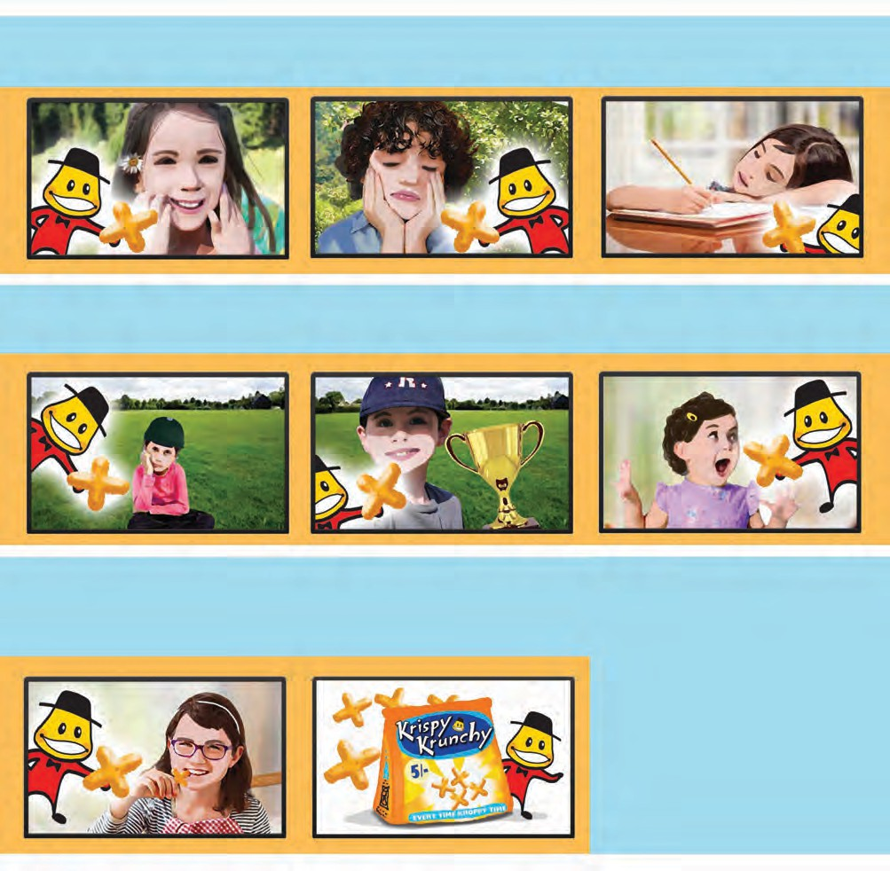Feeling happy ?*

***Krispy Krunchy !***

*Lost the match ?*

***Krispy Krunchy !***

*Now and then*

***Krispy Krunchy !***

*Feeling sad ?*

***Krispy Krunchy !***

*Won the cup ?*

***Krispy Krunchy !***

*For you and me*

***Krispy Krunchy !***

*Feeling tired?*

***Krispy Krunchy !***

*Day and night,*

***Krispy Krunchy !***

*Every time !*

***Krispy Krunchy !***

*Only for* ₹ *5!*

*Get one pack free on 5 !*

***My Teacher says :***

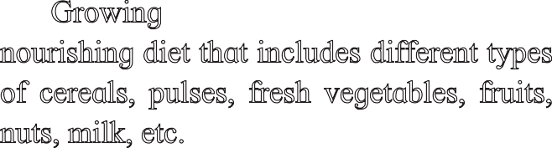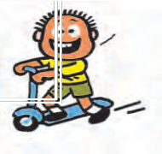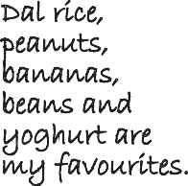

We see many types of chips, wafers and other snacks in the market. We get them in attractive packets or pouches. These snacks are usually fried foods that contain a lot of salt and spices. They are good to taste ~~-~~ but not so good for your health if you eat them all the time.

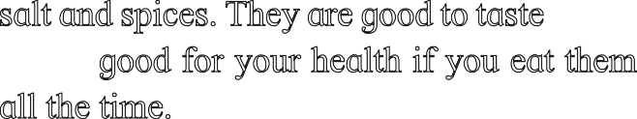

Growing children need a balanced and nourishing diet that includes different types of cereals, pulses, fresh vegetables, fruits, nuts, milk, etc.

Dal rice, peanuts, bananas, beans and yoghurt are my favourites.



**POINTERS**

* + 1. Enact the advertisement :

Seven children wait in different places, striking a suitable pose as shown in the ad. The character ‘Krispy Krunchy’ comes in dancing. He goes near every child, singing the words shown in the ad. He offers a Krispy Krunchy piece to every child.

The child eats it and begins to smile and clap. At the end, the character faces the class, shows a big pack of Krispy Krunchy and presents the last few lines.

* + 1. Discuss the following questions after you have seen a presentation of the ‘ad’.
       - What does the ad tell you ?
       - How many times is the name Krispy Krunchy repeated in the ad ? Why ?
       - What would happen if you never ate Krispy Krunchy ?
       - What would happen if you ate proper meals like rice and dal or dal-roti ?
       - What would happen if you never ate fruits and vegetables ?
    2. Present the information in the box ‘My Teacher says’. Translate the box ‘My Teacher says’ into your mother tongue.
    3. Watch the advertisements on TV. Choose any one of them for group discussion and analysis. Write your report on the advertisement.

***What the ad says :***

*Didi, Didi, Look at this! My new dress for the party. Where’s yours ?*

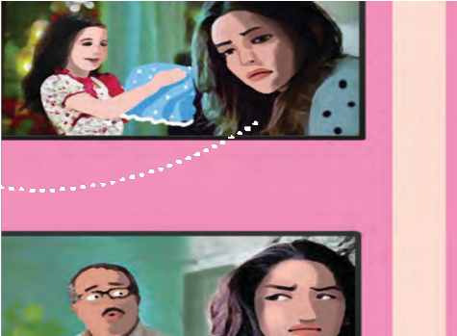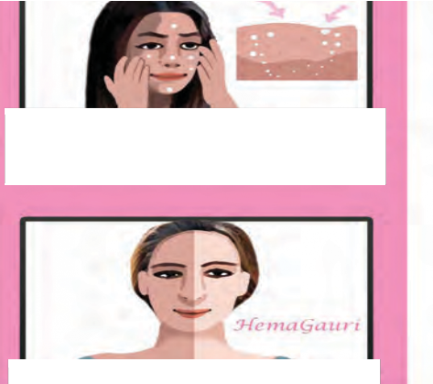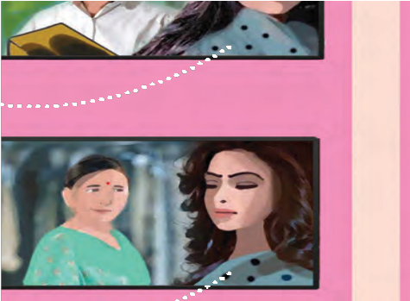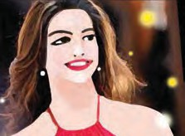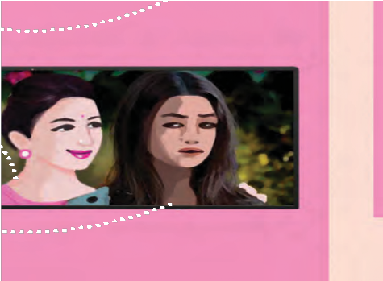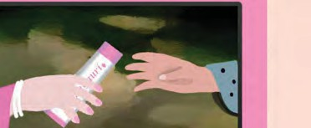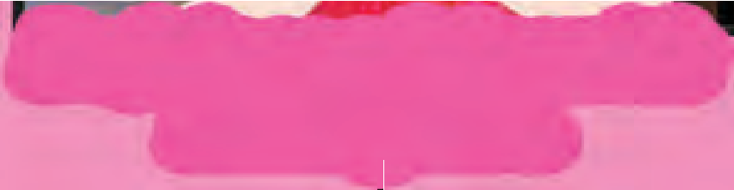

*No party for me!*

***Five days to fairness!***

*Bitia Rani, Tap, tap, tap! My new shoes for the party.*

*Where are yours ?*

*No party for me!*

***Hemagauri will make your skin shine!***

*Bitia Rani, Ting, ting, ting.*

*Choose new bangles for the party.*

*No party for me!*

***Be fair as a fairy with Hemagauri.***

*What’s the matter ? Why are you sad ?*

*My skin is so dark. I feel so bad.*

*No party for me!*

*Is that all ? Don’t worry.*

*Solve your problem with* ***Hemagauri****.*

₹ *10 off*

*on every 100 gm tube or bottle -*

*Hurry! Offer closes on 1 April.*

**



and drink enough water to get glowing skin. Never feel bad

colour of your skin or your



natural looks.



careful



when



try



fairness



creams. They may have side effects.

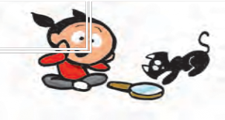

***My Teacher says :***

Who says black is not beautiful ? The colour of your skin has nothing to do with your beauty. It’s more important to be healthy, neat and tidy if you want people to like your looks.

You should eat well, exercise well, sleep well

a healthy, about the

Be

you

My fur coat is always clean and

shiny.

Mia, let’s go out and exercise to get a glowing skin.



**POINTERS**

1. Enact the ad by playing the roles of Didi and her relatives. One more child acts as

the salesman of ‘Hemagauri’ and presents the text given in white letters in pink bubbles.

1. Discuss the following questions after you have seen a presentation of the ‘ad’.
   * Why does Didi say ‘No party for me!’ ?
   * Can you become fair in five days ?

How long will the effect of the cream last ?

* + Will you love your brother or sister only if she’s fair ?
  + Think of the people you like.

Do you like them because they have a fair (white) skin or because of some other qualities ? List those qualities.

1. Who do you think benefits most from commercial advertisements ?
2. Have you seen non-commercial advertisements - those that are not ‘selling’ anything but are only giving people useful information ?
3. Write a useful ‘ad’ for : importance of games, drinking enough water, your own school.

# Yonamine and Bushi

Yonamine Chiru was the most admired girl in Okinawa. She was intelligent, tall,

strong, big and beautiful; and most important of all, she was so well trained in Karate that no one could beat her.

When it was time to get her married, her father, who was a rich merchant, began to worry. He loved his daughter and wanted her to be happy and well cared for. She was beautiful and she would inherit a fortune from him. But where, oh where, could he find a young man who would come forward to marry a woman who was stronger than him?

Yonamine had her own ideas about marriage. She declared firmly: “ I will only marry a man who can beat me in a fair fight!”

44

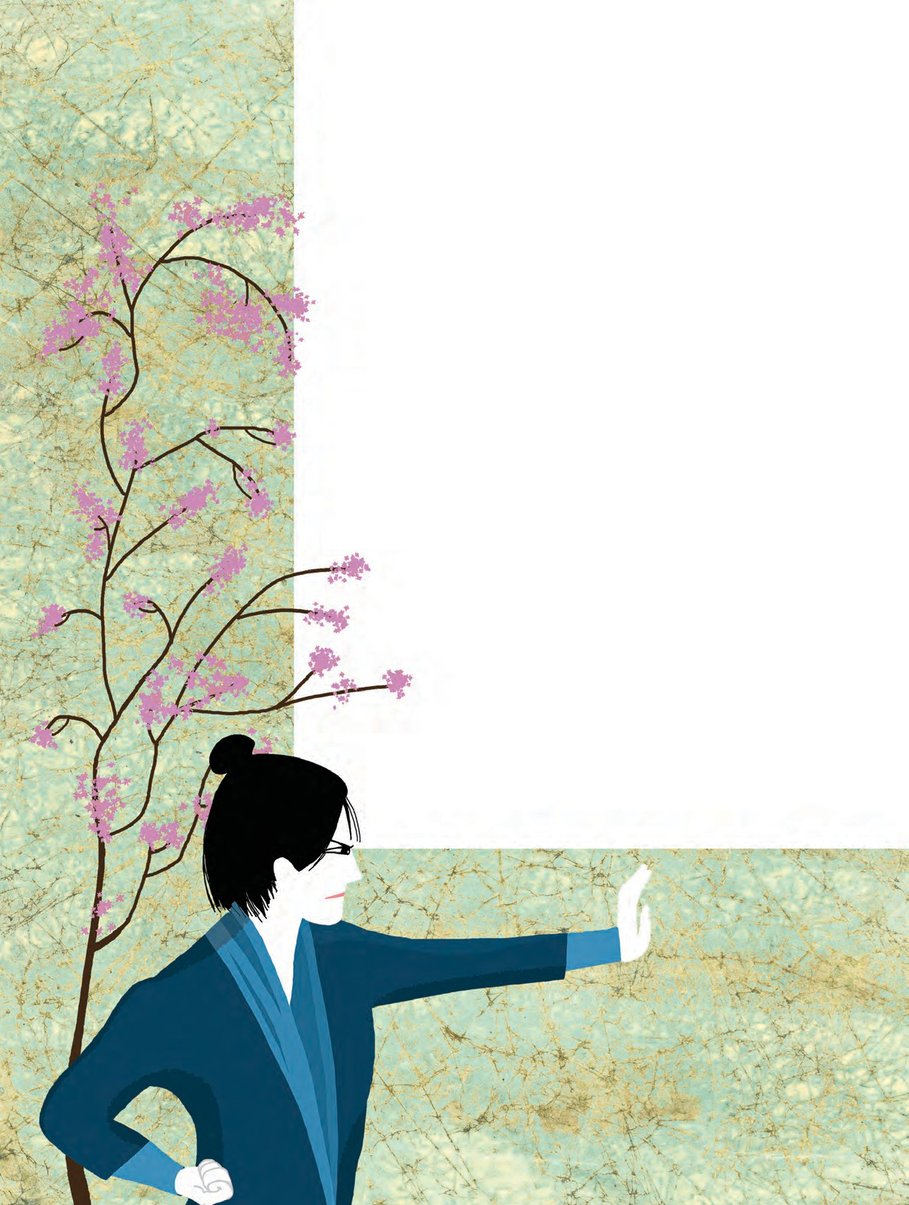

Surprisingly, many young men picked up the challenge and came forward to fight her. After all, she was a beautiful girl with a fortune! Many wrestlers were eager to win her in a contest of martial arts.

One of the first to ask for her hand was Kojo, who was actually bigger and stronger than Yonamine. He was so tall and well built that his hands were like shovels, and his legs resembled tree trunks. But he played foul! Even as Yonamine was bowing to him, in the customary sign of respect

45

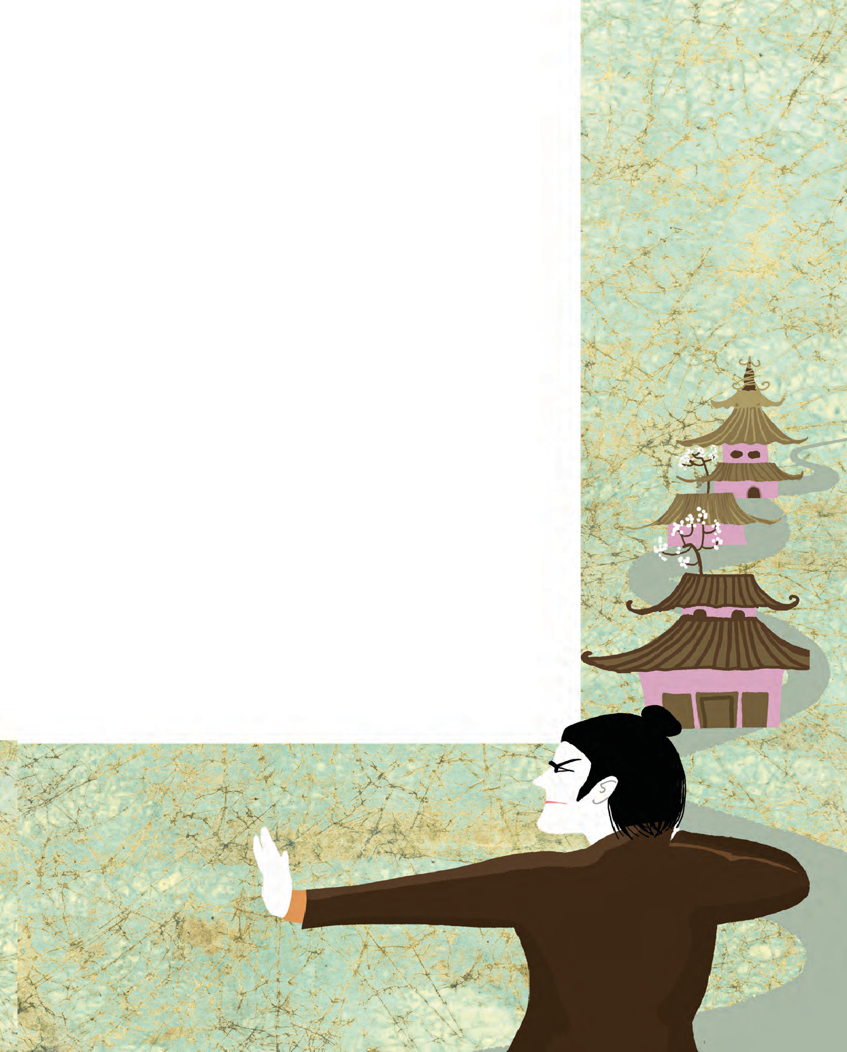

to one’s opponent, he threw a punch at her, breaking the rules of the game. Yonamine was angry. She caught hold of his arm and twisted it so powerfully that the unsportive Kojo fell down in a heap and had to limp away, defeated.

Many promising young wrestlers tried their hand, but Yonamine defeated them all. Her father was in despair. Young men wanted to marry girls who would cook and wash and make tea for their husbands. Who would marry a girl who enjoyed wrestling?

Bushi Kiyo was just such a man! He had trained under the Karate master Sakugawa. He proved to be such an expert that he was recruited by ShoKo, the King of Okinawa, to be his personal guard.

His friends said to Bushi, “You should take on the challenge of this girl, Yonamine. She may be big; but you are stronger and smarter than her.” Bushi too was keen to marry a girl like Yonamine. He did not want a delicate, fragile girl for a wife.“I shall fight with her and win over her,” he decided.

Yonamine was impressed at the sight of her new challenger. She had heard that he was one of King Shoko’s personal warriors. He was tall and slim; he stood firmly on his feet and seemed unshakeable. Above all, he had dark piercing eyes, which looked straight at the opponent, and showed that he was fearless and straightforward.

The wrestling match began. Yonamine and Bushi bowed to each other, and then began to attack each other

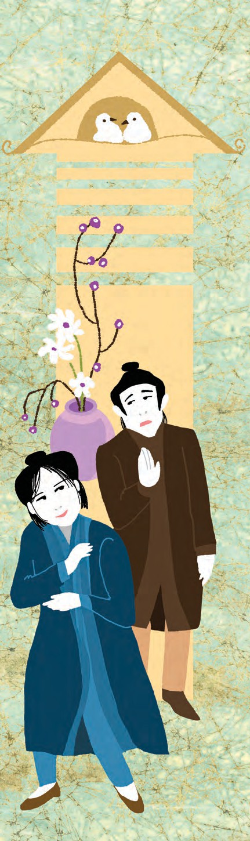

in earnest. They punched, kicked and twisted, using their best techniques. It looked as if the match was going to be a tie… nobody winning, nobody losing…

But, at a crucial moment in the fight, Yonamine paused, ever so briefly. Bushi took advantage of the moment, and brought her down with a swift punch.

Yonamine’s father was a very happy man! Bushi and Yonamine were married in a splendid ceremony.

It was a happy marriage. Yonamine was kind and loving; she cooked and cleaned and kept the house spick and span. One day, when she was sweeping the kitchen, Bushi saw her lift a huge bag of rice with her left hand, as she swept beneath the bag with her right hand. He grew thoughtful, “Is she really so strong? And yet I brought her down with one punch…”

One day, Yonamine announced that she would like to visit her parents. “I will leave in the evening, and return the next day, in time to cook your dinner,” she said to her husband.

“You really should not travel during the night,” Bushi said to her firmly. “There are bandits about; it is just not safe for a woman to go out alone after it is dark.”

“My dear husband, you forget that you married a trained wrestler,” Yonamine said to him with a smile.

“Don’t forget that I threw you down, flat on the ground,” said Bushi. “You are not unbeatable.”

“Don’t worry,” said Yonamine. “Bandits

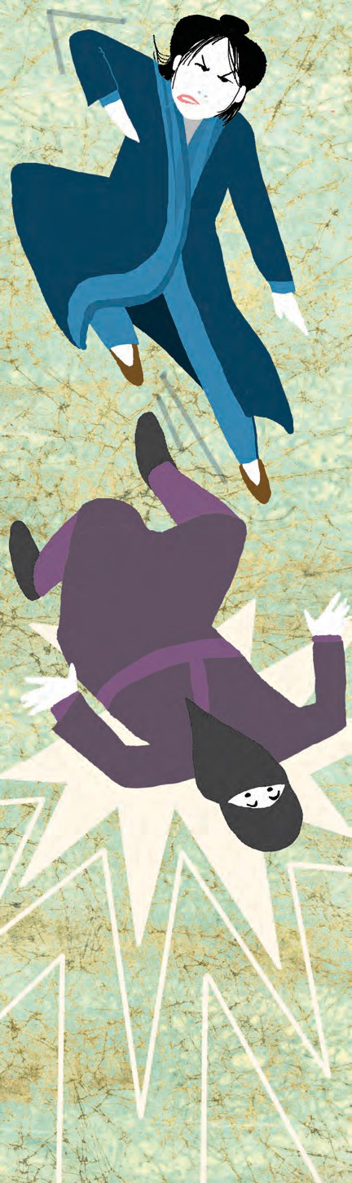

47

are not as skilled as you are. I can take care of myself.”

Bushi was not pleased. “She is overconfident,” he thought to himself. “She must be taught a lesson…for her own good!’’

That evening, Yonamine left to walk to her father’s home. As soon as she departed, Bushi disguised himself as a bandit, wearing shabby clothes, smearing dark colours over his hands and covering his face with a scarf. He ran as fast as he could to hide behind a clump of trees at a fork on the road.

Darkness fell and he saw Yonamine approaching the fork, from where she would take a left turn to reach her father’s house. When she crossed the clump of trees, Bushi jumped out from behind the trees and tried to attack her.

Yonamine was swift and sharp in her reaction to the attack. She held her attacker by the hand and kicked him with such force that the attacker fell to the ground, unconscious. Yonamine dragged him and tied him to a tree with her sash. She adjusted her backpack and set off round the corner for her father’s home.

The next day, as she was returning home in the afternoon, she saw her ‘bandit’ still tied to the tree, as she had left him the previous night. “Shall I untie you now, or leave you here?” she asked him.

“Please untie me,” mumbled the bandit. “I beg you to forgive me. I shan’t ever do this again.”

Swiftly she untied him and walked away quickly. She was in a hurry. She had to reach

home in time to cook her husband’s evening meal! Little did she realise that she had just released her husband from his captivity!

That evening, quite a while after she had set the dinner ready, Bushi walked in looking tired and dull. She helped him wash and set out fresh clothes for him to wear. She invited him to have a hot meal.

As Bushi sat down to dinner, he brought out a white sash from his pocket and gave it to his wife. “This is yours, if

**POINTERS**



I am not mistaken,” he said, looking into her eyes.

“Oh, Bushi, was it you? I am so sorry!” exclaimed Yonamine.

“You don’t have to be sorry,” said Bushi. “You taught me a lesson that I won’t forget all my life. And that is, don’t underestimate anybody!”

“Not even a woman?” asked Yonamine playfully.

“Especially not a woman,” said Bushi. And they burst out laughing, together.

1. Read the story and write about the following in short.

(a) Yonamine Chiru of Okinawa (b) Kojo (c) Bushi Kiyo

1. Discuss and write 1-2 lines about the following,
2. Yonamine’s ideas about marriage.
3. How Bushi defeated Yonamine in the wrestling match.
4. Why Bushi told Yonamine not to travel at night.
5. Yonamine’s fight with Bushi (disguised as a bandit).
6. The lesson that Bushi learnt.
7. Divide the story into different sections to show the different events and time periods in it. Give a suitable title to each section. Examples :

Finding a suitable man for Yonamine

Kojo comes forward and is defeated.

1. Write a short monologue using one of the following ideas. Write down the monologue and present it in the class.
2. Yonamine’s father worrying about getting her married.
3. Bushi disguised as a bandit.
4. Form groups and hold debates on the following topics. Make bulleted lists of points in favour of the topic (pros) and those against it (cons). (3-6 points each)
5. Boys cannot cook or do any housework.
6. Girls cannot do everything that boys do.
7. You should never lose a match.
8. You should admit your mistakes.
9. Visit a library : Read more stories from Japan, China and Korea.

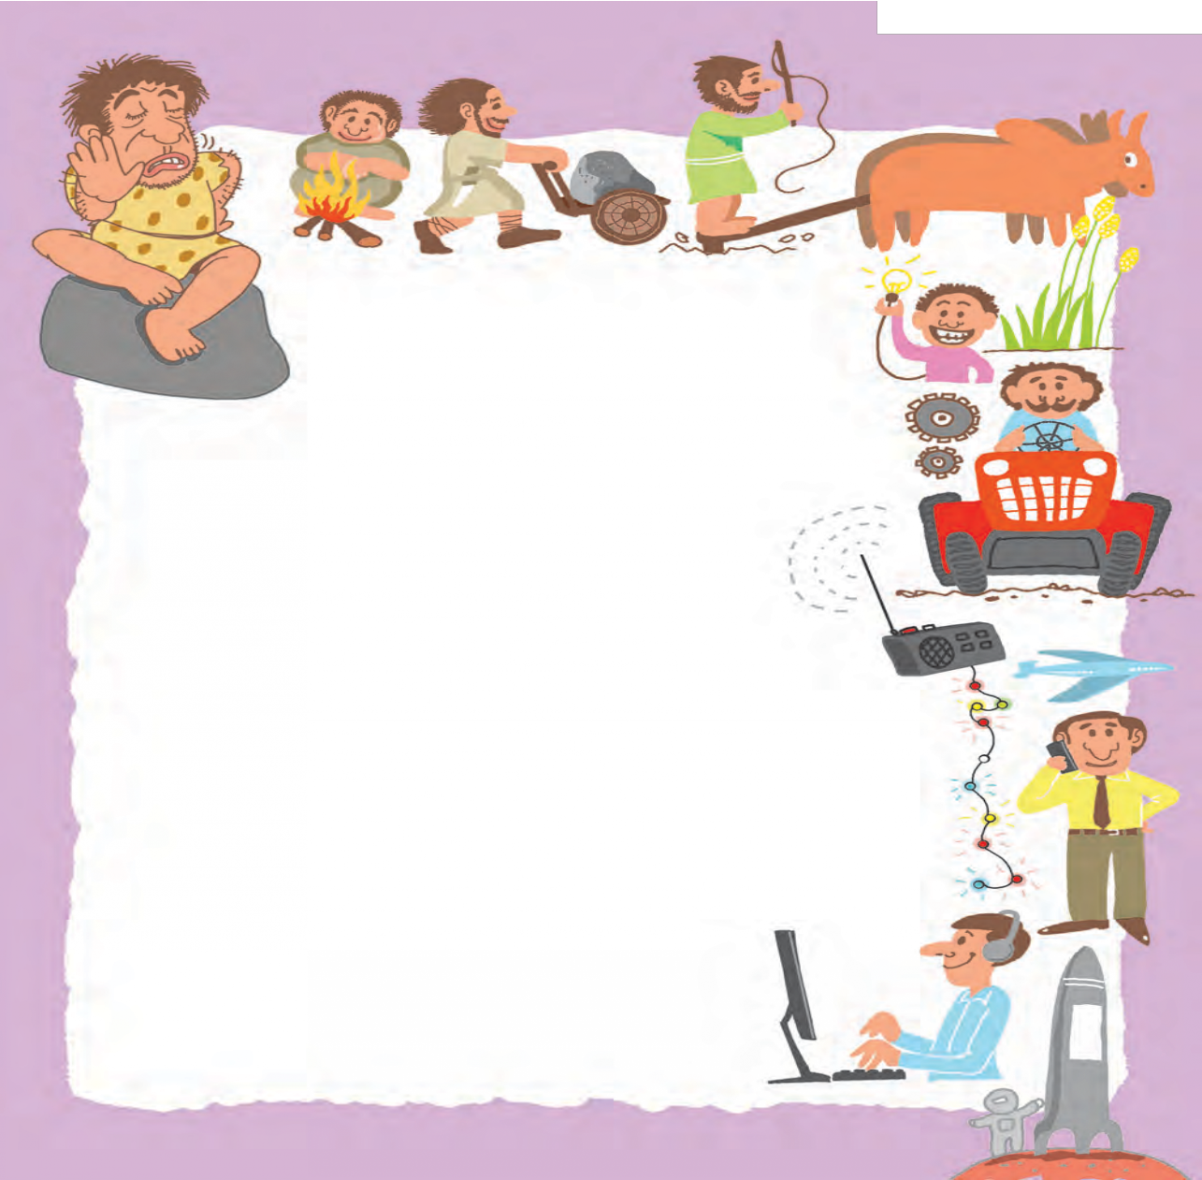

# It Can Be Done

The man who misses all the fun, Is he who says, “It can’t be done.”

In solemn pride he stands aloof

And greets each venture with reproof.

Had he the power he’d efface The history of the human race;

We’d have no radio or motor cars, No streets lit by electric stars;

No telegraph nor telephone, We’d linger in the Age of Stone.

The world would sleep if things were run By men who say “It can't be done.’’

-*Anonymous*

* **In solemn pride :** Here, it means ‘looking very serious, grand and important’.
* **aloof :** separately, without getting involved in anything
* **venture :** adventure, a dangerous or risky task
* **reproof :** criticism, negative comments
* **efface :** wipe out, remove

50



**POINTERS**

1. Answer the following questions in one sentence each.
   1. Who misses all the fun ?
   2. What does the title of the poem say ?
   3. What does the man who misses all the fun do ?
   4. Why does he ‘miss all the fun’ ?
   5. What would he do if he had the power to do it ?
   6. What examples of man’s progress have been given in the poem ?
   7. What should human beings do in order to make progress ?
2. Form groups. List a few articles of everyday use. Discuss how they can be improved.
3. Form pairs. Discuss and prepare a list of things which can be and will be done in future. (5 things) Spot the modal verbs in your answer. (See page 37.)
4. Complete the following sentences using your ideas. :



(a) I can ......................... (b) They can ......................... (c) We can .......................

0

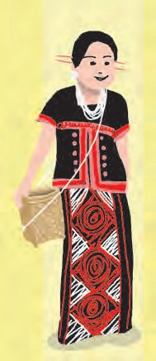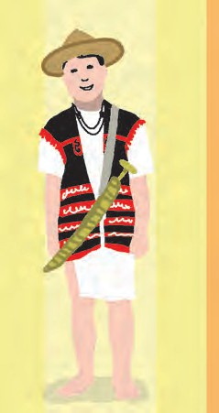

# Seven Sisters

Hello, everyone! Have you guessed who we are? We are the Seven Sisters of Northeast India, still unexplored, isolated territories to most of you and to the rest of the world. Our sister Sikkim lies to the north, but we seven sisters are contiguous to each other. We are famous for our natural beauty, lush forests and wild animals as well as our colourful costumes, traditional jewellery, exotic flowers and our own unique dance and music. Nature lovers have designated our whole area as one of the world’s biodiversity hotspots.

Now we will introduce ourselves one by one.

#### Arunachal Pradesh

Hi, they call me the Land of the Rising Sun - the Land of the Dawn Lit Sun! I am Arunachal Pradesh. My people are simple and hospitable. They belong to many tribes speaking their own languages.

Their diet is largely made up of rice with fish, meat and many green vegetables; and a popular dish is *momos* – steamed buns with meat or vegetable stuffing.

I am a nature lovers’ heaven. My land is spotted with monasteries, lush green forests, lakes, waterfalls and deep river valleys. In my limestone caves (known as *tapenuru*) and forest reserves, you will find a great variety of wild life.

You must make it a point to visit the 400 year old Buddhist monastery at Tawang and enjoy cultural festivals at Ziro. Don’t miss the Namdapha tiger project. You are also welcome to the many wild life sanctuaries and national parks where you may see rare animals, birds and plants. I am also home to India’s first orchid sanctuary.

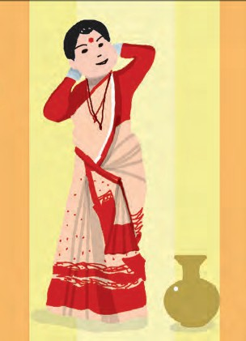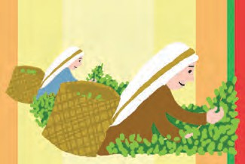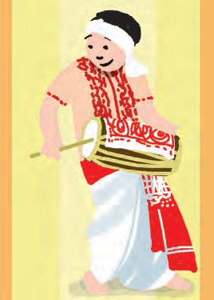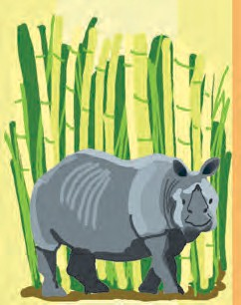

#### Assam

Friends! I am Assam, also known as Ahom. You will find my land between the beautiful valleys of the Brahmaputra and Barak rivers. They call me the gateway to the seven sisters.

My people are very hospitable. If you come here you can enjoy the cuisine which has its own distinctive aromas and flavours. I am known for my artistic heritage, exotic dance forms and elegant temples.

The rivers ensure that my territory is lush and fertile, with wetlands, orchards, tea estates, and scenic forests and parks. Kaziranga National Park and Manas National Park are World Heritage Sites. My picturesque landscape of golden-green rice fields and landscaped tea estates is awesome to behold! And you know, Assam tea is world famous!

The Brahmaputra is Assam’s lifeline. The land is also rich in petroleum, natural gas, coal, limestone and other minor minerals.

My hand woven silks are exquisite, with natural colours and designs. They say our women weave fairy tales on their looms! Assam’s silk fabrics ‘Eri’, ‘Muga’ and ‘Pat’ are the most sought after silks in the world of fashion.

I am known as the land of fairs and festivals. The major festival of Assam is Bihu.

Cane and bamboo are the inseparable parts of my life. As souvenirs you can take the *Jappi* (traditional sunshade) and masks. Don’t forget to visit the Ahom palaces.

#### Meghalaya

Hello friends, I am the abode of clouds, Meghalaya. My capital city Shillong is called ‘Scotland of the East’ because of its highlands, fog and scenery. My people speak English,

Words to remember and use :  distinctive  exotic  elegant  scenic

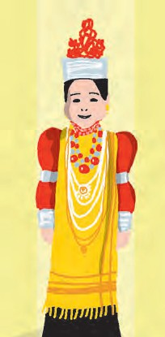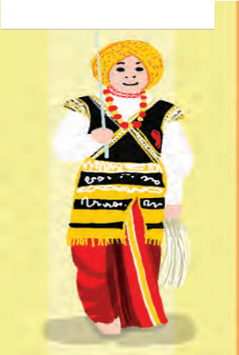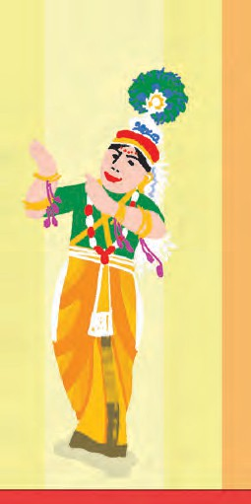

Khasi, Pnar and Garo. I am overwhelmingly beautiful, and everything here is impossibly green and alive. The rolling mists in the valleys, the undulating hills, numerous lakes, waterfalls, caves, sacred forests and exotic flora and fauna are fascinating.

Here, Jhum or shifting cultivation is practised even today. I have lovely mountains, with stretches of valley and highland plateaus. The rock formations here contain rich deposits of valuable minerals like coal, limestone, uranium and sillimanite. I have many rivers.

Please come to see Cherrapunji/Mausinram - the wettest places on earth. You can enjoy the forests and ‘sacred groves’ here.

I boast of several National Parks and Wildlife Sanctuaries. Friends, you would be amazed to see the Krem Liat Prah which is the longest cave, and Synrang Pamiang which is the deepest cave. You can enjoy the panoramic view of Bangladesh from here. Do come to this pine- fresh mountain state during the Wangala festival in autumn.

#### Manipur

Hey! I am the fourth sister, Manipur, the Jewelled Land. (I am proud to be the jewel of my mother India). I am also known by my nick names Kangleipak or Sanaleibak.

My capital is Imphal where you can see the cyclists’ velodrome. Many of my people belong to the Meetei ethnic group and speak Meetei/Manipuri language. I have the credit of introducing polo to the Europeans.

My people’s staple diet consists of rice, fish, large varieties of leafy vegetables ( both aquatic and terrestrial). But our cuisine is so different from the rest of India, due to the use of various

* picturesque  awesome  exquisite  overwhelmingly  impossibly

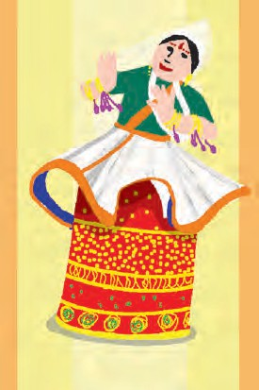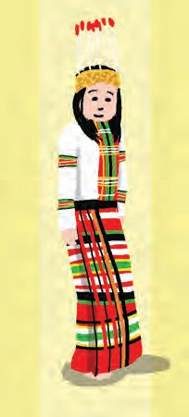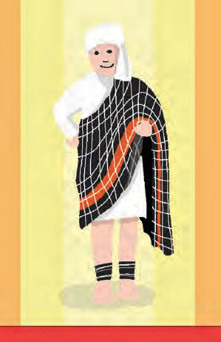

aromatic herbs and roots that are peculiar to my state.

Blessed with an amazing variety of flora and fauna, I am home to a host of rare endemic plant and animal life here. A treat for the eyes is the Keibul Lamjao National Park, an abode of the rare and endangered species of brow antlered deer. This ecosystem contains 17 rare species of mammals. It is the only floating national park of the world. You should come to see the Loktak Lake and Floating Islands.

Our Manipuri dance is one of the most acclaimed classical dances of India. The folk dances of tribal people captivate the beholders with their exotic costumes and simple but graceful rhythm. You should not fail to witness the Manipuri Martial Arts - ‘Thang Ta’ and ‘Sarit Sarak’.

#### Mizoram

Hello! I am Mizoram. Mizoram implies ‘land of the hill people’ referred to as the Kukis. I invite you to see my land of lush hills, sheer cliffs, serene lakes and waterfalls. Rolling hills stretch across hundreds of miles, and the plains and valleys are covered with lush forests and thick bamboo groves, green paddy fields, vine yards, teeming with diverse wild life. My regret is that not many of you come to visit me! Well, travelling in Mizoram is a little difficult, but it has its own rewards. The natural beauty here is exquisite and must be seen to be believed!

My capital is Aizawl, and from its scenic location, you can get a captivating view of lush emerald Tlawng river valley in the west and the Tuirial river valley in the east. The museum in the heart of the city, Zarkawt, portrays the culture of Mizoram with a splendid collection of costumes, artefacts and historical relics.

* fascinating  lovely  panoramic  aromatic  amazing  rare

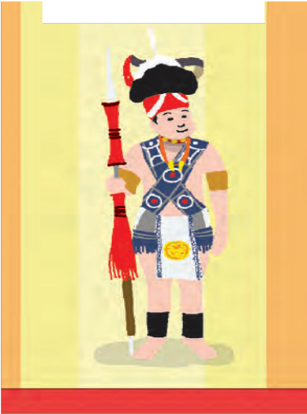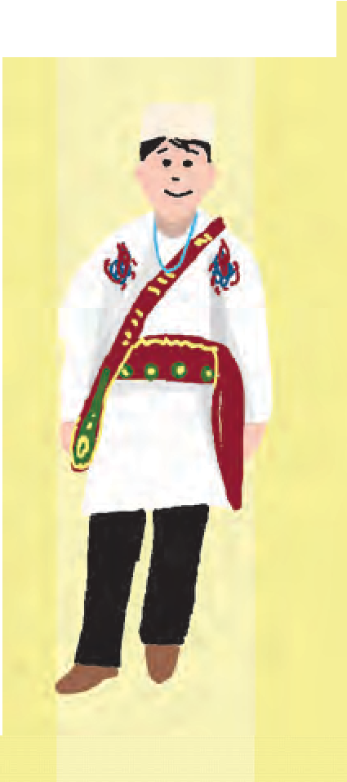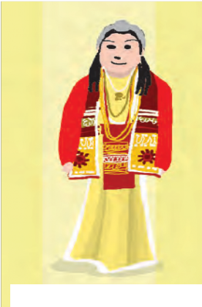

The Palak lake is the biggest in Mizoram and covers 30 hectares (74 acres). Do you know that it is believed that the lake was created as a result of an earthquake or a flood ? Champhai, with its fertile vineyards, is known as ‘the fruit bowl’ of Mizoram. I am also host to numerous species of birds, wildlife and flora. You can visit the two national parks and six wildlife sanctuaries here.

Mizo is the official language and the most widely used language.

#### Nagaland

Hello! I am Nagaland, one of the smallest States of India, called the Switzerland of the East. Here, we have a land of folklore passed down through generations, with music as an integral part of our life. The exquisitely picturesque landscapes, the vibrantly colourful sunrise and sunset, lush and verdant flora make my land unimaginably beautiful.

The State capital is Kohima. The State is mostly mountainous. Mount Saramati is the highest peak with a height of about 3,840 metres and its range forms a natural barrier between Nagaland and Burma.

There are over 16 tribes and sub-tribes that inhabit my exotic hill State, each with its own unique colourful and intricately designed costumes, jewellery and beads that adorn them. Today, many of my young people have ventured into fashion designing, creating fabrics that blend our traditional motifs with modern appeal. So much so, I have become a paradise for those who are into fashion designing. People refer to me as an affluent fashion station of the East.

My land is an ideal place for trekking, rock climbing, jungle camping and offers limitless exploration possibilities in its lush and verdant

* acclaimed  graceful  serene  splendid  vibrantly

55

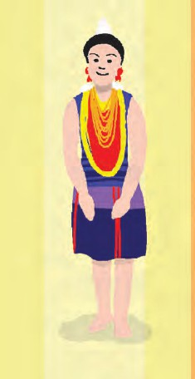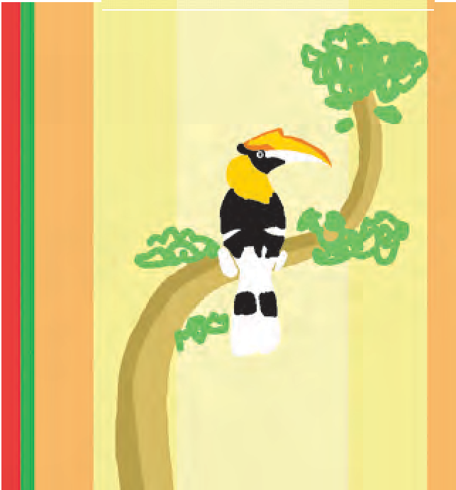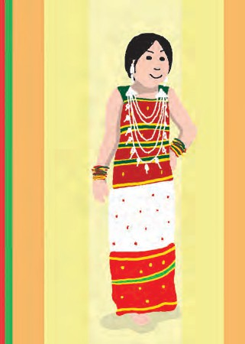

sub-tropical rain forests. Here we have an abundance of medicinal herbs too.

I am known as the ‘Falcon capital of the world.’ The great Indian hornbill is one of the most famous birds found here.

Nagas, by nature, are lovers of fun and frolic and here, life is one long festival. Dance and songs are a part and parcel of all our festivities. Most of our dances are performed with a robust rhythm. If you love a colourful life and appreciate ethnic customs and traditions with their unique songs, dances and festivals, you must come to our Naga Heritage Village, which showcases our cultural heritage. Do come and participate in our Great Hornbill Festival!

#### Tripura

Hello, I am Tripura, the third smallest State in the country, bordered by Bangladesh to the north, south, and west,

*Tripura* meaning ‘three cities’ ‘Tripura’ also means ‘near water’. Some scholars also believe that the land was ruled in ancient times by a King named Tripur, from whom my name emerged.

My land has three distinct geographical zones: 1. The hill ranges which run from North to South; 2. The undulating plateau land and

3. The low-lying alluvial plains. Many rivers nourish my land and sustain the activities of my people. Chief among them are the Gumti, the Muhuri and the Feni. Rice, cotton, jute, tea, tobacco and oilseeds are grown here.

The Kokborok speaking Tripuri people are the major group among the many tribes and subtribes. Bengali and Manipuri people have co-existed in peaceful harmony with the people of Tripura for generations.

* unimaginably  verdant  robust  peaceful  gorgeous

I am rather difficult for you to access because only one major road or National Highway connects my land with the rest of the country. Agartala is my capital city. People come to visit me for ecotourism and archaeological tourism. My lush tea gardens and wild life sanctuaries and my specially set up eco-parks are a great attraction; as are the famous rock carvings at Deotamura. The Neermahal is a gorgeous red-and-white water palace, empty but shimmering on its own island in the lake of Rudrasagar.

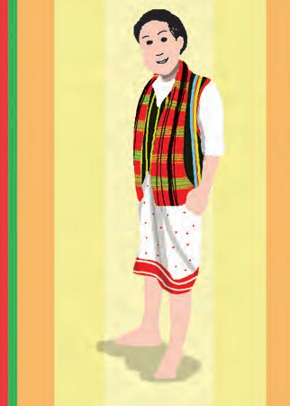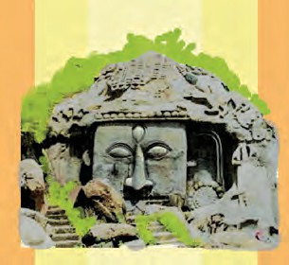

People of all communities and tribes participate in State festivals like Garia, Durga Puja, Buddha Purnima, Kharchi, Pous Sankranti, Bijhu or Christmas.

Come and visit me; you will be fascinated by my rich cultural heritage, beautiful palaces, wild life sanctuaries, historical temples, palaces and museums. My folk dances will enthrall you, and my people will welcome you with warmth and courtesy!



**POINTERS**

1. Present any one of the speeches given above.
2. Choose any one of the seven States. Find more information about it and prepare a leaflet or brochure to invite people to visit it.
3. From the passage, find and write any two examples of the following :
   1. Use of the verb ‘be’ (am, is, are, etc) as the main verb.
   2. Sentences containing  ‘must’  ‘can’.
   3. Sentences beginning with ‘Don’t’.
4. Write a short speech for the State of Maharashtra.



**3.3**

**Stone Soup**

*(A village. A few small cottages standing close by. They belong to Motiram, Sonabai, Hirabai and Rupabai. It’s evening. They are chatting outside Motiram’s house.)*

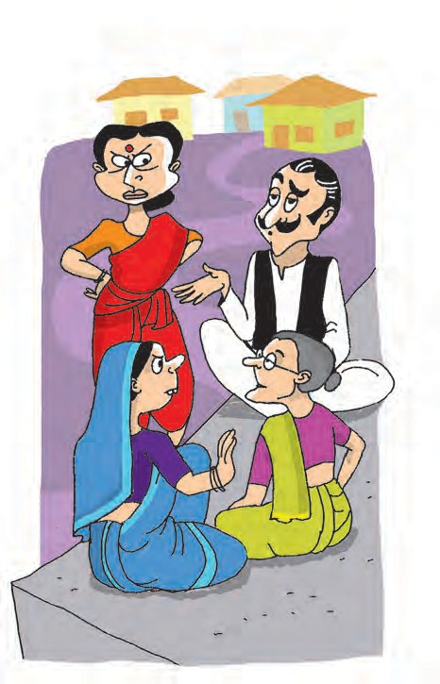**Motiram :** Your farm produce was really good this year, I’m told.

**Sonabai :** So was yours, I hear.

**Motiram :** I don’t want to advertise it, though. It might attract guests.

*(Traveller enters from a corner. The villagers don’t see him.)*

**Hirabai :** You are right. Guests can be a nuisance.

**Sonabai :** I agree. Especially uninvited guests.

**Motiram :** Uninvited guests are pests.

*(Traveller becomes nervous. Doesn’t come forward.)*

**Hirabai :** True. I never waste good food and money on others.

**Rupabai :** Do you think that is right ? How can we refuse them ?

**Hirabai :** Just find some polite excuses.

That’s all.

**Sonabai :** You are right. I can always cook up some excuse.

**Motiram :** Me, too. For me, ‘Charity begins at home’ and stays at home. Anyway, I must attend to my work now. See you.

**All neighbours :** See you later.

*(They enter their homes. Traveller comes forward.)*

**Traveller :** What hard luck ! I’m a poor, footsore traveller. And I’m so hungry ! But this bunch of villagers looks tough. I don’t think they’ll offer me food or rest, but let me try.

*(He knocks on Motiram’s door. Motiram opens the door.)*

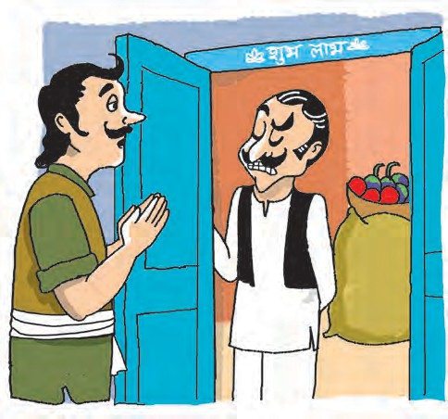**Motiram :** Yes ? Who are you and what

do you want ?

**Traveller :** I am a traveller. I am very

hungry and tired. Can I please have some food and a place to rest for the night ?

**Motiram :** Dinner is over. There is nothing

left. Try elsewhere.

*(Shuts the door with a bang.)*

**Traveller :** How rude ! Hmm... ! Let me try

the next door.

*(Knocks on Sonabai’s door. She comes out.)*

Good evening, kind lady. I am a traveller. Can I have some food and a corner to rest for tonight ?

**Sonabai :** *(putting her hand behind her ear)* What did you say ?

**Traveller :** *(aloud)* Can I have some food ?

**Sonabai :** Wood ? Why, there is plenty in the forest. Find a fallen tree and chop all the wood that you need.

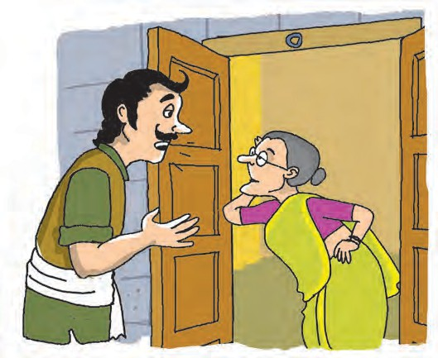**Traveller :** I said ‘food’. I’m hungry.

**Sonabai :** You agree ! Fine, then go

and chop the wood ! *(Goes back into the house.)*

**Traveller :** Well, well, that was a clever

excuse. She pretended to be hard of hearing. Let me try elsewhere.

*(Knocks on Hirabai’s door.)*

Anyone at home ? Any food for a hungry traveller ?

*(Hirabai comes out.)*

Good evening. Ma’m ! I

wonder if I could get something to eat and a place to rest for the night ?

**Hirabai :** *(pretending not to understand his language)* Og yawa. On doof dna on tser rof enoyna ereh.

**Traveller :** I don’t understand you.

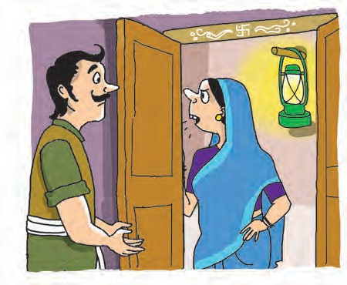**Hirabai :** *(shaking her hand)* Doog. I od

ton tnaw uoy ot. Og erehwesle.

*(Goes back inside leaving the traveller bewildered.)*

**Traveller :** So that was her trick. Talking

gibberish. I’m not defeated.

*(Knocks on Rupabai’s door. She comes out.)*

**Rupabai :** Yes ? Who are you, young

man ? I have not seen you around.

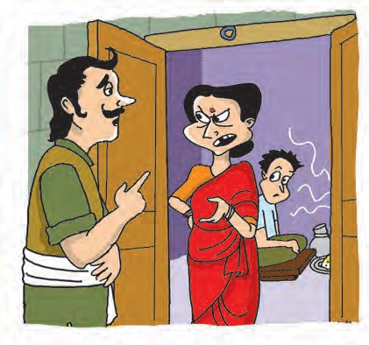**Traveller :** I am a traveller and I wondered if I could get some food as well as a corner to rest for this night.

**Rupabai :** *(thinks)* Alas. My larder is empty. I am so hungry myself but I have nothing left in the house.

**Traveller :** I am sorry to hear that.

**Rupabai :** I’m sorry too. But I can’t help it.

Sorry ! *(Turns to leave.)*

**Traveller :** *(aloud)* Wait, Madam. If you are also hungry, I can make us both some soup.

**Rupabai :** But I told you my larder’s empty.

I can’t offer you anything.

**Traveller :** All I need is a cooking pot, a spoon and some water. I have a magic stone in my bag. When you boil it in water, it makes a delicious, nourishing soup.

**Rupabai :** Really ? A magic stone ? And all you need is a pot of water ? I think I can manage that much.

**Traveller :** Yes. Just a pot of water. Only, a big one.

*(Rupabai goes back to her cottage. Traveller collects wood and makes a fire in one corner. Other neighbours peep out from their door/windows and watch quietly but curiously. Rupabai comes out with a very big pot.)*

**Rupabai :** Here’s your pot of water.

**Traveller :** Thank you. Now just wait and watch.

*(Puts the pot on the fire. Takes out a stone from his pocket and drops it in the pot.)*

*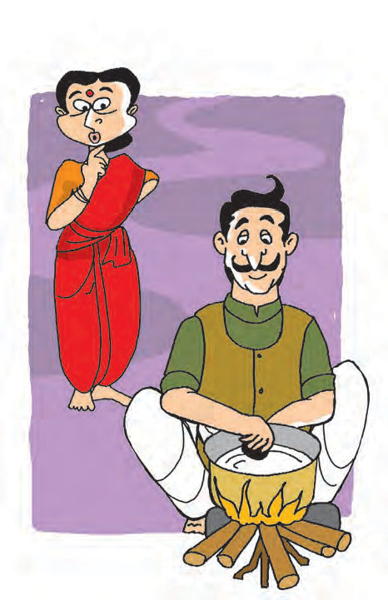***Rupabai :** A magic stone that makes soup ? I can hardly believe this. *(Sits down to watch.)*

**Traveller :** *(sniffing and pretending to enjoy the aroma)* Aah ! Lovely ! It’s going to be really delicious. *(To Rupabai)* If only we had one or two potatoes to add! It tastes heavenly with potatoes. But alas ! We don’t have any.

**Rupabai :** Ummm, one or two, you said ? Let me see if I have just one or two left somewhere. *(Brings a few peeled potatoes.)* Here! Luckily, I had just a few left. I’ve even peeled them for you.

**Traveller :** Wonderful !

*(Puts the potatoes in the pot, stirs for some time and sinffs again.)*

What with the potatoes you’ve given, the soup will now be terrific. *(Sniffs)* Carrots and tomatoes would give it a tempting colour, wouldn’t they ? But that would be too much to hope for ...

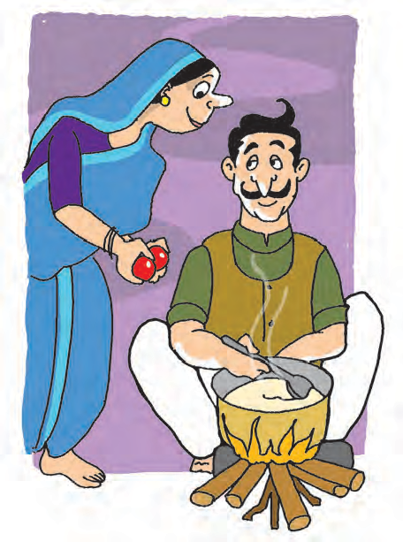**Rupabai :** Um ... I don’t know ...

*(Sonabai comes out with some tomatoes.)*

**Sonabai :** Hello, hello, maybe I can be of some help. I had reserved these tomatoes for tomorrow. But I’m always willing to help, you know. And I know that Hirabai has plenty of carrots, but I’m not sure if she’ll share a few with us.

**Hirabai :** *(enters with a few carrots)* I don’t have plenty. In fact, I, too, was reserving these for tomorrow. But never mind, if Sonabai can spare her tomatoes, I, too, can spare these. After all, you don’t get to see a magic stone making a magic soup every day.

**Traveller :** *(bows to the women)* I’m really speechless, you noble ladies. This is going to be a famous soup. *(Adds the vegetables, stirs, and sniffs.)*

It reminds me of the soup I had made some time ago. I had added just a few beans, onions ... and I think a little piece of ginger, and what flavour it had ! Those are the only little things missing now, but what we have is also good enough. You can’t always have the best ! *(Enter Motiram.)*

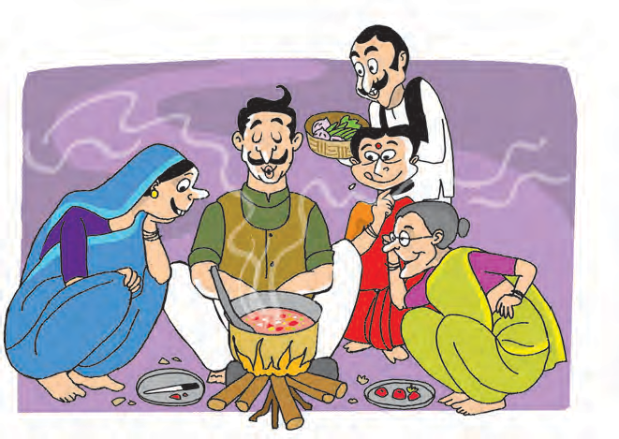**Motiram :** Why not ? If you

can have the best, why miss the golden chance ? Here. Take these. When help is needed, old Motiram doesn’t lag behind.

*(Offers vegetables.)*

**Traveller :** *(bows)* How can

I ever forget your generosity ? *(Adds all the*

*vegetables, stirs and sniffs.)* ... Aha ! ... Absolutely mouthwatering ... what flavour ... what aroma ... what taste ... *(takes a sip)* ... marvellous

... if only I could add a pinch of salt, it would be perfect !

**Rupabai :** I’ll get some salt and bowls for all of us.

**Traveller :** Thank you. I was about to suggest that. *(Exit Rupabai.)* You are all being so kind and helpful. It’s an unforgettable experience.

*(Rupabai returns with the salt, pepper and bowls. Traveller adds the salt, stirs and serves the soup to everyone.)*

**Rupabai :** Ah ! Wonderful ! You can taste the goodness of fresh vegetables!

**Sonabai :** Yes. Unbelievable. No one would think that this soup was made with a stone !

**Motiram :** You’ve said it. Such delicious vegetable soup and made with a stone !

**Hirabai :** I wonder what happens to the stone ? Does it melt away ?

**Traveller :** Oh, no ! It remains the same. *(Takes out the stone from the pot.)* Take a look. This was the stone that made the soup. *(Aside, to the audience)* Have you guessed the secret of the stone soup ? *(Smiles)* You can make it even without the stone !

*(Curtain as everyone enjoys the soup.)*



**POINTERS**

1. Answer the following questions :
   1. Where does the story take place ?
   2. List the characters in the play and write one or two lines about each.
   3. How do the following avoid giving anything to the traveller ?
      * Motiram  Sonabai  Hirabai  Rupabai (Answer in one or two lines each.)
   4. Find what Hirabai tells the traveller by reading her words from right to left.
   5. Apart from the stone, how many things go into the soup ?
   6. Does the traveller really have a magic stone ?
2. On any one page, note against the speech of every character, what feelings it should show to bring out the meaning best. For example, joy, fear, anger, nervousness, friendliness, dislike, surprise, wonder, excitement, politeness, rudeness, cunning, curiosity.
3. Read aloud / Enact the play.
4. Write a recipe for the stone soup.
5. Form pairs. Write at least one short dialogue for each of the following expressions.

(a) I agree. (b) True ! (c) You are right.

1. Why not ? (To mean that something can be done.) (e) Thank you.

For example :

Amit : I think all schools should have big playgrounds. Sumit : I agree !

1. Find the meaning of ‘Charity begins at home’. Find other sayings which have a similar meaning.
2. List five questions from the play which can be answered with ‘yes’ or ‘no’.
3. ‘Smart Answers’ : Form a large group. Each person asks the next one a question to get him to say ‘yes’ or ‘no’. He/She can use appropriate statements, requests or even other questions as a response. But if he/she says ‘yes’ or ‘no’, he/she is out. Otherwise he/she continues the game. Questions cannot be repeated.
4. Visit a library : Find stories about hosts and guests. Share them with the class. Classify the stories into funny and serious stories.

***

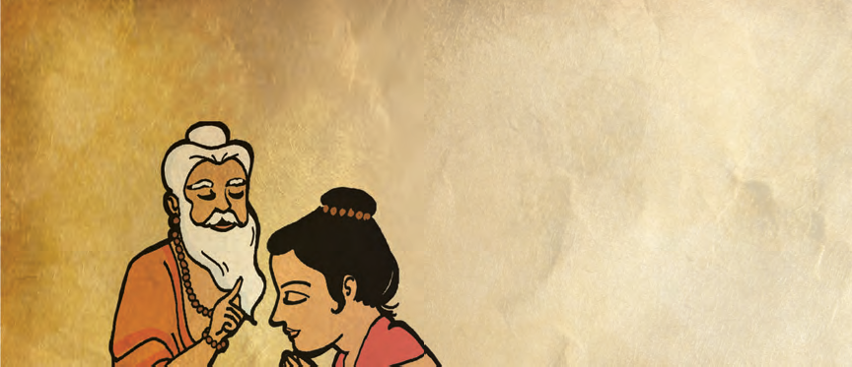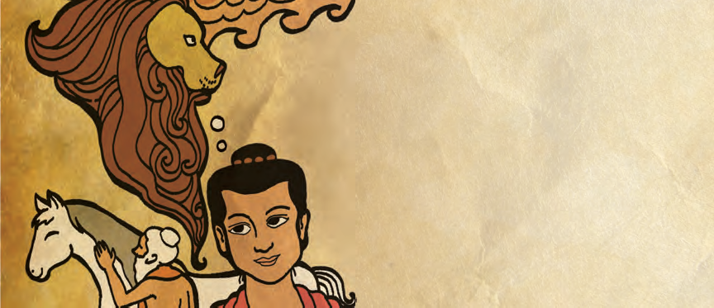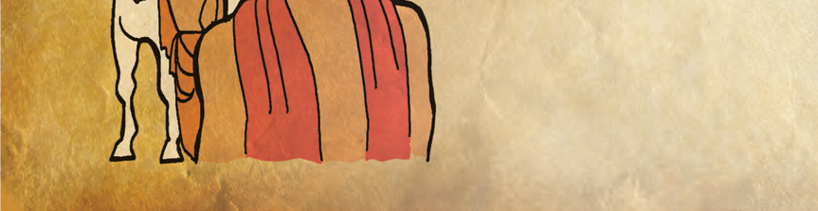

# Sushruta

#### (A Peep into the Past)

**Part 1**

Sushruta was an Indian Ayurvedic physician widely regarded as the ‘Father of Indian Medicine’ or ‘Father of Surgery’ and ‘Father of Plastic Surgery’. He wrote one of the world’s earliest works on medicine and surgery. Sushruta was known as the main author of the treatise ‘The Compendium of Susruta’ (Susruta Samhita).

During those days, physicians treating human beings were also trained in the care of the animals. The principles of animal surgery are effectively the same as that of human surgery. Indian medical treatises like Charaka, Susruta and Harita Samhitas contain chapters or references about care of the diseased as well as the healthy animals.

There were, however, physicians who specialized only in the care of the animals or even in one class of animals; the greatest of them all was Shalihotra, the ‘Father of Veterinary Sciences’.

Though Shalihotra gained all the knowledge of Surgery from Sushruta and implemented it in animal health care, once he asked Sushruta what all he would need to perform a surgery on a wonderful horse. Sushruta, very quickly listed down all the instruments and the medicines that would be needed.

“Three things are missing.’’ Shalihotra said.

Confused, Sushruta looked at him.

“I will give you a week to find them.’’ Shalihotra consoled.

64

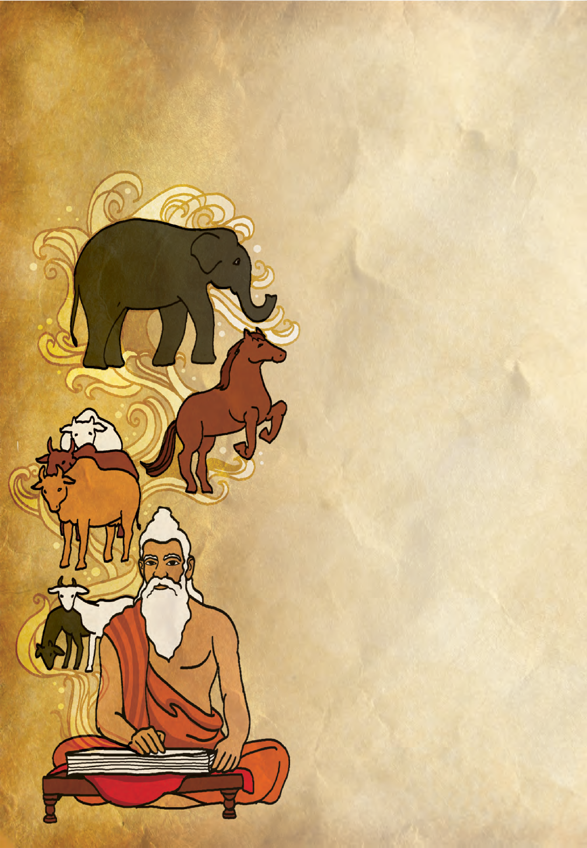

Curious to find out what those three things were, Sushruta observed his teacher carefully for the next one week.

Before operating the horse, Shalihotra observed every part of the horse. And then Sushruta found the first missing thing!

‘A good veterinarian should have an eagle’s eye.’

Then Shalihotra treated the animal as if it were his own; balancing science and compassion equally. And lo! Sushruta found his second rule. ‘A good veterinarian should have a lion’s heart.’

Shalihotra helped the horse recover after the surgery. Sushruta came to know that ‘A good veterinarian should have a mother’s touch too.’

#### Part 2

A tradition of veterinary therapy developed very early in India and this has survived to the present time. Based on the Ayurveda, Indian veterinary medicine is known for its specialized literature, which provides information on ancient methods of preventing and treating diseases of animals. Some of these treatments, little known outside India, are still practised today.

The oldest existing veterinary text from India is a treatise entitled ‘Asvayurveda Siddhanta’ (Complete Ayurvedic system for horses) attributed to Shalihotra (around 2350 BCE), the founder of veterinary medicine. Subsequently, various treatises on horses and diseases of horses were

65

composed. Nakula, one of the five Pandavas, was a horse specialist himself. Among the best known works of animal literature is ‘Asva chikitsa’ (Therapeutics of horses), written by Nakula!

Later, during the reign of Chandra Gupta Maurya (around 300 BC), veterinarians started accompanying armies, to treat horses, elephants as well as cattle.

The great Emperor Ashoka erected the first known veterinary hospitals of the world. He arranged cultivation of herbal medicines for men and animals in his empire and adjoining kingdoms.

Giving the animals general tonics and stimulants was practised in order to ensure good mental and physical health.

Prevention of the occurrence of diseases was also given importance.



**POINTERS**

Cleanliness of animals, maintenance of stalls and stables, quality of food, disadvantages of overfeeding were looked after.

Utilization of animal by-products was also done wisely by our ancestors! Conversion of milk into butter, ghee, curd, *khoa*, etc. was a common practice and still is. Chicken was utilized for its meat while sheep was utilized for its wool.

Although India has always had immense knowledge in the field of veterinary sciences, it is not chosen as a career by many due to a lack of awareness. Being an agriculture based country, today, India needs more veterinarians who empathize with animals and give their cent percent to the profession.

*- Dr. Chirantana Mathkari*

1. Answer the following questions :
   1. Who was Sushruta ?
   2. Who was Shalihotra ?
   3. What question did Shalihotra ask Sushruta ?
   4. How long a period did Shalihotra allow to find the missing things ?
   5. How did Sushruta find the missing things ? Select the appropriate answer.
      1. By reading several books
      2. By consulting his friends
      3. By observing his teacher carefully and thinking about what he did
      4. By meditating
   6. Who erected the first known veterinary hospitals of the world ?
2. What were the three things that Sushruta discovered ?
3. Explain the meaning of the following phrases :

(a) An eagle’s eye (b) A lion’s heart (c) A mother’s touch.

1. Narrate the story of Sushruta in your own words.



66

1. Write short notes on the following :

6.

* 1. Veterinary Science in Ancient India.
  2. Care of animals in the regime of Emperor Ashoka.
  3. Utilization of animal by-products in the ancient world.

1. Form pairs. Complete the following table through discussions.

|  |  |  |
| --- | --- | --- |
| **Occupation** | **Necessary Qualities** | **Reasons** |
| Student |  |  |
| Teacher |  |  |
| Housewife |  |  |
| Sportsman |  |  |
| Artist |  |  |
| Singer |  |  |
| Author |  |  |
| Umpire |  |  |
| Actor |  |  |
| Scientist |  |  |

1. Note these pairs of words :  care-carefully  equal-equally.

Here we see that the letters ‘-ly’ are added at the end of the word to make another word. A letter or group of letters added at the end of a word to make another word is called a suffix.

* 1. Use the suffix ‘-ly’ to make other words from the following :
* subsequent  frequent  wise  immense  beautiful
  1. Find two examples each, of the words made by using the following suffixes.
* -ness  -er  -let  -ful  -tion/sion  -y

1. Frame questions beginning with the following words, based on the above passage.

* Who  What  Where  When  How  Why (One question each)

1. Visit a library : Find more information/stories about scholars of the ancient world - Aryabhatta, Bhaskaracharya, Varahamihira, Charaka, Nagarjuna, Jeevaka.

***



67

# The Donkey



I saw a donkey one day old.

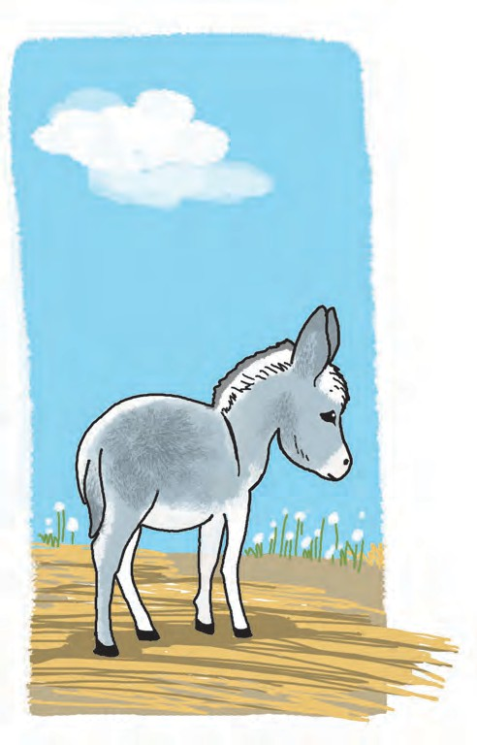His head was too big for his neck to hold; His legs were shaky and long and loose,

They rocketed and staggered and weren’t much use.

He tried to gambol and frisk a bit,

but he wasn’t quite sure of the trick of it.

His queer little coat was soft and grey and curled at his neck in a lovely way.

His face was wistful and left no doubt

that he felt life needed some thinking about. So he blundered round in venturesome quest,

and then lay flat on the ground to rest.

He looked so little and weak and slim,

I prayed the world might be good to him.

*- Anonymous*

* + - **rocketed :** moved suddenly
    - **staggered :** tottered, moved unsteadily
    - **gambol :** leap, move playfully
* **wistful :** full of hope, longing for something
* **venturesome :** daring, adventerous
* **quest :** search, the act of looking for something



68



**POINTERS**

* 1. Rewrite the poem in the form of a prose passage.
  2. List the pairs of rhyming words from the poem.
  3. What does the poet pray for ? Why ?
  4. Have you seen a newborn young one of an animal ?
  5. Talk to your parents and family members and write what you could do when -
     + you were a day old  you were one month old
     + you were six months old  you were one year old.
  6. Form groups and hold debates on the following topics. Make bulleted lists of points in favour (pros) and those against (cons) the given statement. Let the whole class vote on who won the debate.

1. Man should use animals for his own needs.
2. Contact with man has helped animals to survive.
   1. Find what the young ones of the following animals are called :
      * donkey -  sheep -  owl -
      * horse -  lamb -  swan -
      * lion -  cow -  eagle -
      * tiger -  pig -  duck -
      * elephant -  whale -  peacock -
   2. Complete the following using your own ideas :
3. His head was **too big to** hold his neck.
4. He was **too shy to** ............................ .
5. She was **too proud to** ............................ .
6. They were **too tired to** ............................ .
7. We are **too busy to** ............................ .
8. He was **too lazy to** ............................ .
   1. Write a conversation between :

(a) A donkey and a dog (b) A donkey and a horse (c) A donkey and a school boy.

* 1. If you saw someone abusing an animal, what would you do ? Write about it in 5 lines.
  2. Visit a library : Find poems about animals. Copy them and recite them to your friends.

***

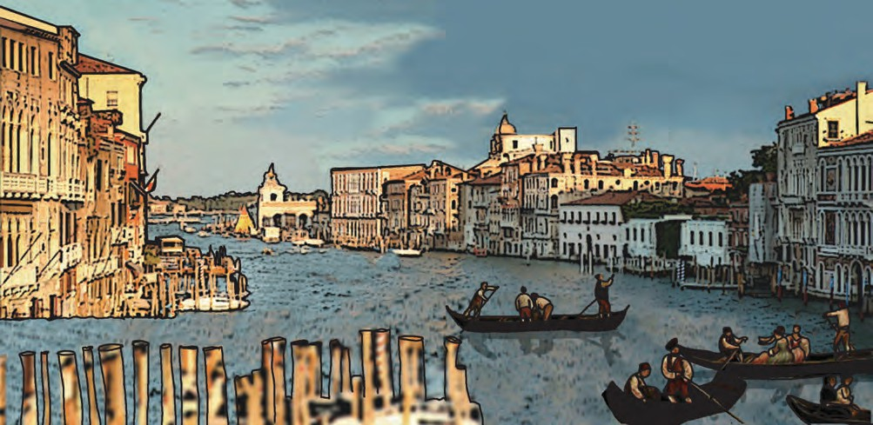

**3.6**

**The Merchant of Venice**

Antonio was a merchant who lived in Venice, a prosperous city in Italy. In those days, that is, about five hundred years ago, sea voyages were dangerous.

And yet, some adventurous merchants

best friend was Bassanio. Bassanio was a young and handsome nobleman but unfortunately, he had no money.

Bassanio wanted to marry Portia.

travelled across the seas. spent a lot of money in sen to faraway countries. Thes

Some others

ding ships

e ships

She was t

a very

fathe

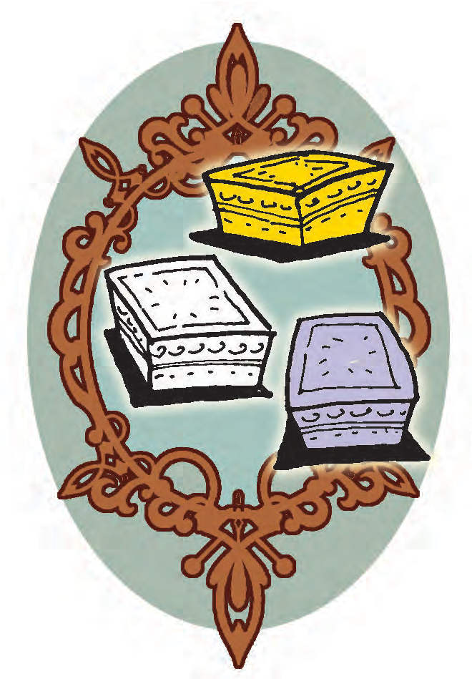

ome o ers ing ships ships

Portia was beautiful and intelligent. She was the only daughter of a very wealthy man. Her

brought back spices and other

ther

father had died, leaving

treasures from India and ot er countries. The mercha ts sold these things in Europ .

her

nts

e.

They made a lot of profit in this business.

At the time when the story begins, Antonio was waiting for his ships to return with merchandise. He had put almost all his mon y in the ships.

ey

Antonio was a kind m

an.

He had many friends, but his

ut his

her a large estate.

In his will, ortia’s father had written how Portia’s husband should be

her

P

selected. He had set a test for her suitors. They had to choose between three caskets - one

t

t

of gold, one of silver and one of lead.

of

and



70

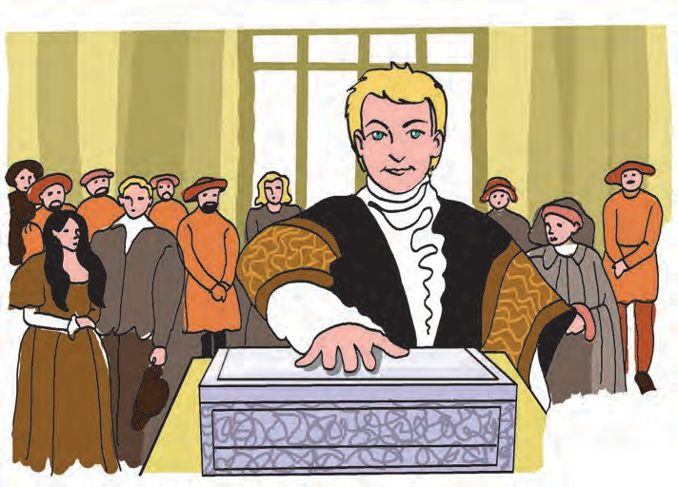

Each casket had something written on it. On the gold casket, it was written ‘Whoever chooses me shall gain what many men desire’; on the silver casket, ‘Whoever chooses me, shall get as much as he deserves’; on the casket of lead, ‘Whoever chooses me must give and hazard all he has’.

One of Portia’s suitors was the Prince of Morocco. He chose the gold casket. But when he opened the casket, the message inside said that it was not the right casket. ‘All that glitters is not gold !’

Another suitor, the Prince of Arragon, chose the silver casket. But that too was not the right casket.

Bassanio wanted to try his luck with the caskets. To do that, he had to travel to Belmont where Portia lived on her estate. He needed money for that. When Antonio came to know this, he wanted to help. He told Bassanio to borrow money in his (Antonio’s) name. They went to

Shylock, the Jewish moneylender, and asked him for the money.

Shylock had a lot of money, but he was not at all generous. Money was all that he cared for. He did not like Antonio, because Antonio sometimes lent people money without charging any interest for it.

So, Shylock decided to take advantage of this situation. He gave them the money on a strange condition. If Antonio failed to return the money within three months, Shylock would cut off a pound of Antonio’s flesh. Antonio agreed to this, and borrowed the money for Bassanio.

Bassanio went to Belmont. When he saw the caskets, he chose the lead one. That was the right casket, and Bassanio won Portia’s hand by choosing it. Portia, too, was glad to marry Bassanio.

In the meanwhile, Shylock heard that Antonio had lost his ships. He was very happy that Antonio would not be able to pay the money. He took Antonio

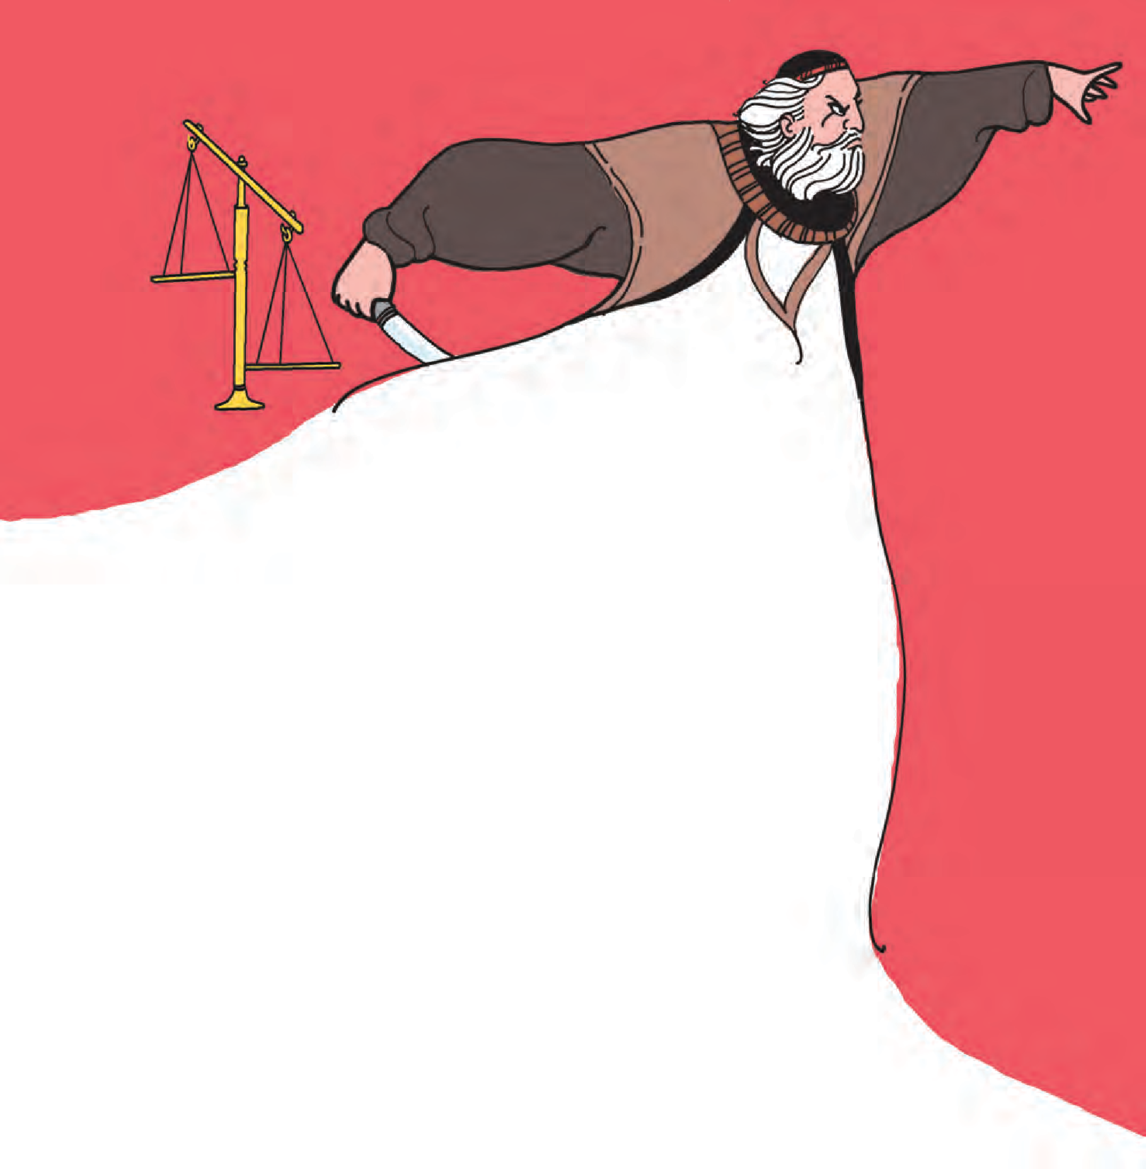to court and demanded that he

fulfil the strange and cruel condition. The Duke liked Antonio and was sorry for him. But what could he do ? Antonio had written a bond to Shylock and according to the law, Shylock was right.

When Bassanio and Portia heard all this, they rushed back to Venice. Portia told Bassanio to pay Shylock twice the amount to save Antonio. But Shylock was adamant. He demanded only a pound of Antonio’s flesh.

Everyone in the court, including the Duke, felt that Shylock’s demand was inhuman. The Duke asked Shylock to show mercy towards Antonio but Shylock was not ready to do so. He felt that Antonio and others had treated him badly before, and he wanted revenge.

Just then, a young lawyer entered the court. He said that he would fight Antonio’s case. He asked Antonio whether he had agreed to Shylock’s condition. Antonio said that he had agreed.

Then the young lawyer requested Shylock to show mercy, though the law was on Shylock’s side. The lawyer pleaded that mercy is a quality of God himself. When a person shows mercy to someone else, they are both blessed. Mercy was

more valuable than a king’s crown. But

all this had no effect on Shylock.

The young lawer then said that the law allowed Shylock to take a pound of flesh, and he could do that. At the same time, the lawyer warned that while cutting off the flesh, Shylock should not shed even one drop of Antonio’s blood. Also, he should cut exactly one pound of flesh - nothing less, nothing more. That would not be allowed by the law.



Shylock realised that he could not do what the young lawyer asked him to do, and he accepted his defeat. Antonio’s life was saved.

Who was the young lawyer ? Bassanio and Antonio found out later that it was none other than Portia herself, dressed as a young man.

Later, it was learnt that Antonio’s ships were safe, and so he had not in fact lost his money. Thus, the story which could have ended in a tragic manner ended happily.

**POINTERS**

1. Say whether the following statements are true or false.
   1. The merchant ships brought spices and other treasures from India and other countries to Italy.
   2. Antonio had gone on a long voyage.
   3. Bassanio was very rich.
   4. Portia had many brothers and sisters.
   5. Portia’s suitors chose the gold and silver caskets.
   6. Bassanio borrowed money from Shylock in Antonio’s name.
   7. Shylock was not at all generous.
   8. Shylock demanded a pound of Antonio’s flesh.
   9. Portia saved Antonio in the court of law.
   10. Antonio’s ships were lost at sea.
2. Write a few lines about each character.
3. Write the following in short :
4. The story of the three caskets.
5. What the young lawyer pleaded.
6. The events at the court.
7. Write the conditions that Portia put down to warn Shylock.
8. Find four words ending with ‘-ous’ from the story.

Can you add three more words ending with ‘-ous’ to this list ?

1. Read the following words. Write the words that are combined to make these words.

* faraway  nobleman  whoever  moneylender  sometimes

Add ten more words to the list on your own. Each of the component words must be meaningful.

1. Read the following chains of words :

* fortune - fortunate - fortunately - unfortunately
* know - knowing - knowingly - unknowingly
* amaze - amazing - amazingly
* possible - impossible - impossibly

1. A letter or group of letters added to the front of a word to change its meaning and make a new word is called a prefix.

Examples : fortunately - **un**fortunately, agree - **dis**agree, possible - **im**possible, human - **in**human, legal - **il**legal

Add proper prefixes to the following words to make new words.

* kind  intelligent  advantage  happy  allow  safe

1. Find at least three sentences in the story which have modal verbs.
2. Visit a library : Read other tales from Shakespeare, for example, Julius Caesar, As You Like It, Macbeth and The Tempest.
3. Hold a mock trial for any one of the following offences. There should be a complainant, a defendant and lawyers to argue the case on behalf of them. The whole class can vote to pass the judgement. On what occasions will you plead for justice ? What punishment will you suggest ? When will you plead for mercy ?
   1. A very poor and honest servant has broken a vase while cleaning it. The vase was valuable and the employer liked it very much.
   2. A poor man stole some ornaments from a rich girl.
   3. A young man was injured in a road accident due to another man’s careless driving.

***



**3.7**

**At the Science Fair**

The Science Fair at Vidya Vardhini School was always an exciting affair. There were a number of stalls (never less than 50), entertainment booths and of course refreshments ! There were two basic rules. One, everything should be handled by students and two, everything - even the entertainment booths and refreshment stalls - had to have a scientific base !

Preparations for the fair began at least a couple of months in advance. The first step was brainstorming. The Principal invited ideas for the event from students, teachers and even parents ! A host of ideas poured in. Luckily, many parents not only contributed ideas but also volunteered to help with the planning and implementation of the big event ! So a committee of parents and teachers was set up to look after all the work of the fair. Some student representatives were also taken on the committee to give them a first hand experience of managing big programmes like this.

The committee identified certain themes for the fair. They were - Plants, Animals, Properties of Substances, Energy (forms of energy and energy resources), Science in our Everyday Life, Latest News from the World of Science,

and Food and Nutrition. Considering the area of the school playground and the estimated turnout, it was decided to allow 56 stalls in the Fair. The stalls were allotted to as many groups of children. Each group selected a topic/idea from the chosen themes. (The committee had to make sure that the topics were not repeated.)

PLANTS

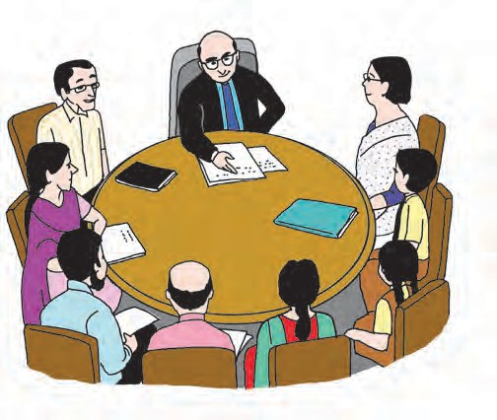

PROPERTIES OF SUBSTANCES

LATEST NEWS FROM THE WORLD OF SCIENCE



SCIENCE IN OUR EVERYDAY LIFE

FOOD AND NUTRITION



ANIMALS

ENERGY

(FORMS OF ENERGY

AND ENERGY RESOURCES)

75

The young scientists began their work in earnest. They began by collecting a lot of information about their topic using their science textbook, their school library and also the internet. They shared and discussed this information in their groups. The next step was to decide the exact activity for their stall - whether they would build and display a model, or give a demonstration, or present their project through posters or simply exhibit a collection.

The Principal announced that the language, appearance and content of the presentations were all important. The language teachers helped the young stall holders to make their graphic and oral presentations more effective.



**GƌĂƉŚiĐ WƌĞƐĞŶƚĂƟŽŶƐ**

* If you have used any text, pictures, diagrams, etc. from elsewhere,

acknowledge the source.

* hƐĞ ĚiffĞƌĞŶƚ cŽůŽƵƌƐ ƚŽ ŚiŐŚůiŐŚƚ iŵƉŽƌƚaŶƚ ĨĞaƚƵƌĞƐ͕ ďƵƚ ƵƐĞ ƚŚĞŵ jƵĚiciŽƵƐůǇ͘
* Don’t forget to check your spellings, sentences or other errors in the ‘mini-copy’ itself.
* DaŬĞ a ƌŽƵŐŚ ͚ŵiŶi−cŽƉǇ͛ ďĞĨŽƌĞ ǇŽƵ ďĞŐiŶ ǁŽƌŬ ŽŶ ƚŚĞ ďiŐ͕ fiŶaů ƉŽƐƚĞƌ Žƌ cŚaƌƚ͘
* Plan all your posters, charts properly before you start making them.
* Use pictograms, graphs, pie-charts etc. to show numerical data.
* Use pictures and diagrams and label them.
* Make use of bullet points or bulleted lists.
* Write to the point so that a visitor may read a chart or poster at a glance.

**KƌĂů WƌĞƐĞŶƚĂƟŽŶƐ**

* The oral presentations or speeches should be short and to the point - 2 to 3 minutes at the most.
* They should be directly related to the model, demonstration or specimens exhibited in the stall.
* Be confident when you make a presentation.
* Rehearse the speech well.
* Be ready to answer relevant questions. Practise doing that with your friends.
  + 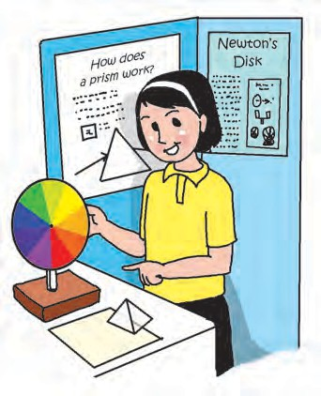Make use of the visuals or graphics in the stall. Point to the relevant parts when you speak.
  + Wear clean and tidy clothes, but do not ‘dress up’ to show off.
  + Be polite, be pleasant when you talk to the visitors. If you don’t know the answer to a question, say so. But later on, try to find the answer.
  + Smile !

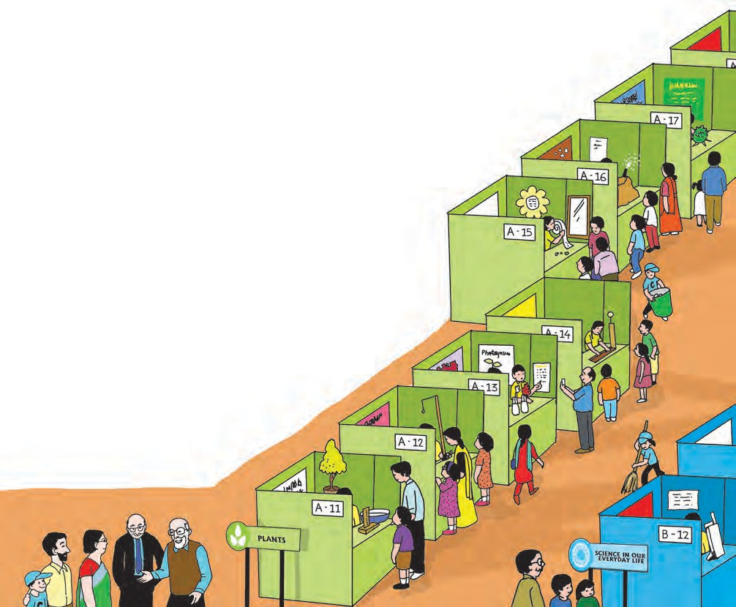At last the big day arrived ! The fair was inaugurated by the oldest science teacher, Mr Gizare. It was Mr Gizare who had come up with the idea of a ‘Science Fair’ some 25 years ago. Initially, it was meant for just one class, but the idea had become so popular that now the entire school participated in it.

Mr. Gizare explained the importance of using the scientific method to find the answers to the questions relating to the physical world around us. He was happy to see the stalls, especially the ones that showed simple methods of identifying food adulteration. He appreciated the fact that in most of the stalls, visitors could also try out the various science experiments and models. He gave a special pat on the back to the Clean Brigade. The brigade members made rounds of the Fair spreading the message of cleanliness. But

that was not all. They had vowed to keep the school

premises spick and span during the Fair, though they expected more than a thousand visitors and half as many stall holders - they were a disciplined lot, but what with so many activities and experiments going on, it was bound to create a lot of litter ! They were well- equipped with garbage cans,

scoops, brooms and wipes.

Let us also take a round of the fair to see some of the highlights. The sixth standard children were handling the following stalls:

# hƐĞ ŽĨ ŬiŶĞƟĐ ĞŶĞƌŐǇ

The stall

displayed the model of a watermill.

# Sound

**hƐĞ ŽĨ WŽƚĞŶƟĂů EŶĞƌŐǇ**

- **A ƉůĂƐƟĐ ďŽƩůĞ**

**ŵŽƚŽƌďŽĂƚ͘**

# EůĞĐƚƌŽƐƚĂƟĐ EŶĞƌŐǇ

Everyone enjoyed making simple string telephones at this stall and then using them.

This stall was so popular, that additional help was needed to blow balloons as quickly as they were used up.

**Food**

**AĚƵůƚĞƌĂƟŽŶ**

**Fun with**

**ŵĂŐŶĞƚƐ**

Even the parents learnt something at this stall !

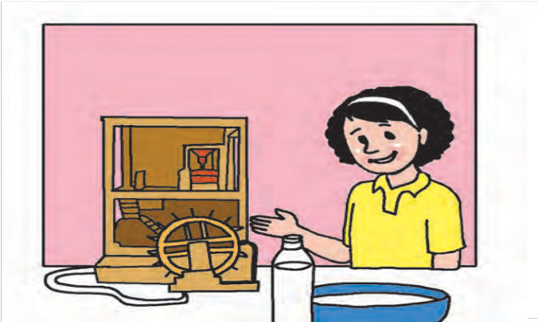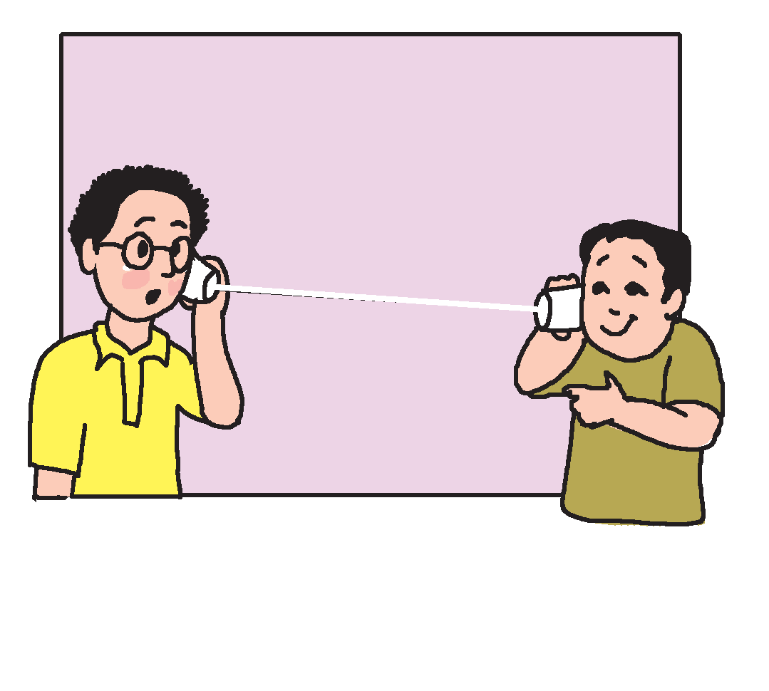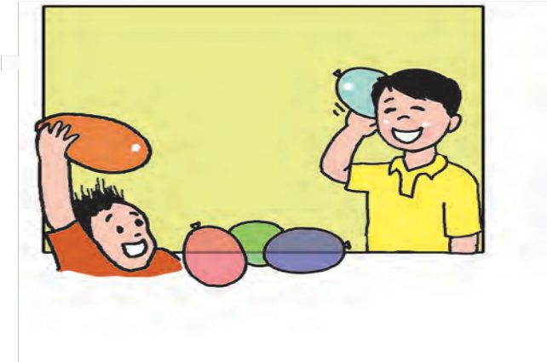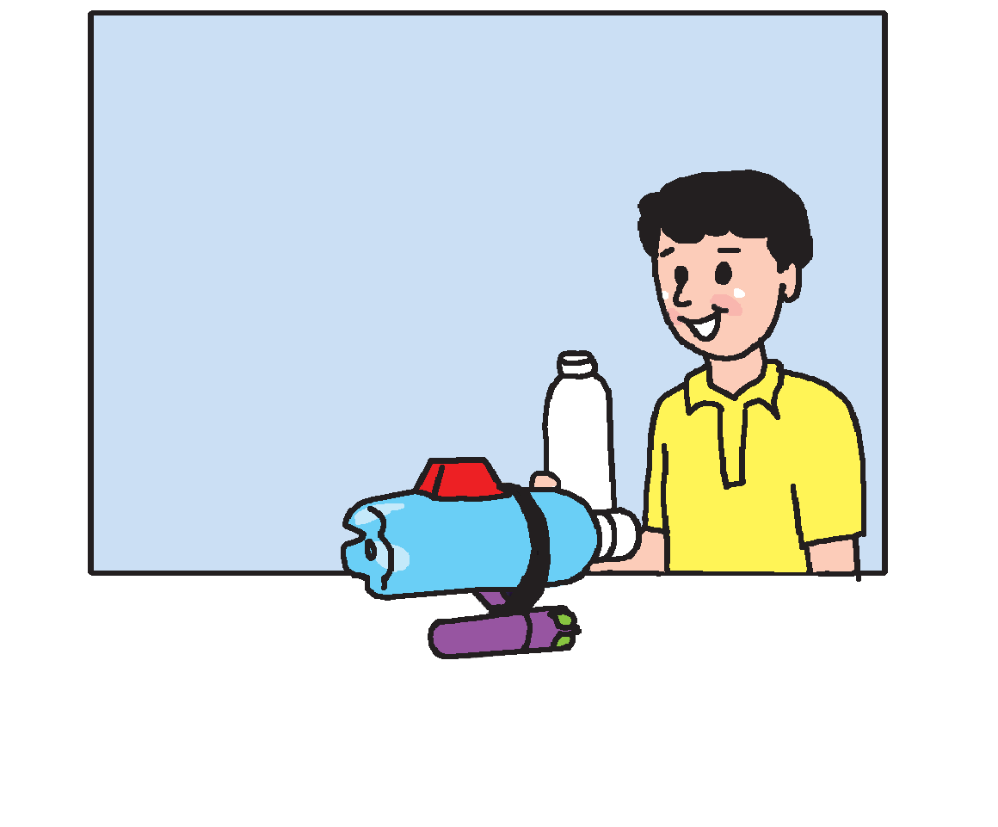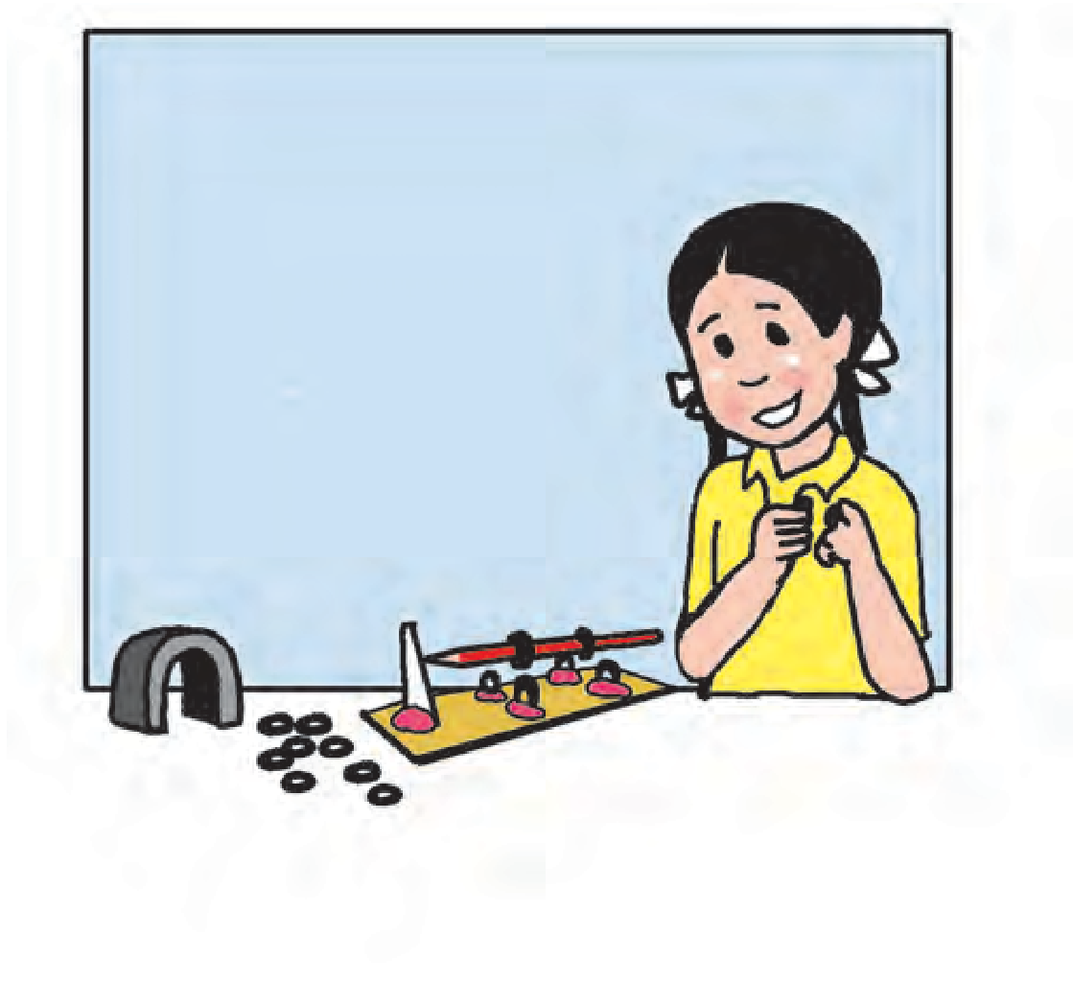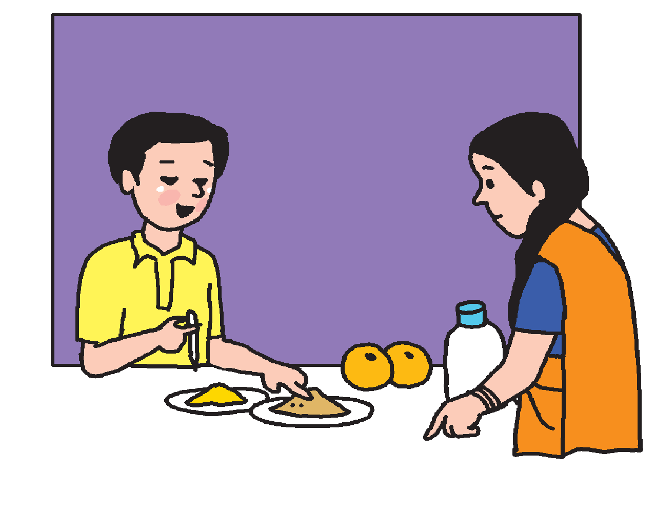

Visitors queued up to see the different types of magnets at work.

# DĂiŶƚĂiŶiŶŐ

**machines**

Some of the visitors made video clips of the presentation at this stall. It consisted of different children playing the roles of different machines, all crying out turn by turn, ‘Hey, we, too, need your attention ! We can serve you well only if you take care of us’.

The fair was such a huge success that the school had to run it for three days instead of two ! The Principal allowed this change in the time table only because it was a truly educational activity - not just for the children but also for their family and the entire community**.** No wonder everyone is already looking forward to the next year’s Fair !

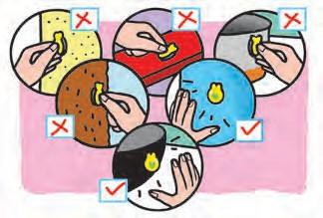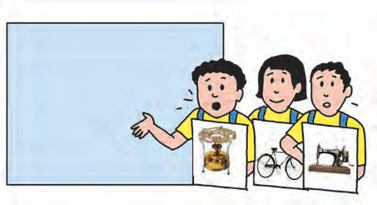

**The Scientific Method**

↓

Ask questions -

why, why not, how, etc.

Observe what is around you.

↓

Can you think of an explanation ? (This is what is called ‘hypothesis’ in the scientific method.)

↓

Set up an experiment

to try out your ‘hypothesis’.

↓

Record your observations

in detail. (This is your data.)

↓

Draw conclusions.

Do they match your hypothesis ? If yes, why ? If not, why not ?

↓

Why does a fridge magnet stick to the fridge door but not to

the kitchen platform?

↓

Maybe it has some special powers.

↓

I will try to stick it to different things

* a wall, a tile, a potato, a wooden table, pots and pans, a plastic bottle, a cup.

The magnet sticks to some surfaces but not to others.

↓

It seems as if some metal objects are attracted to the magnet.

They are made of iron or steel.

Write down your findings and share them with others.

↓

Magnet attracts iron, but not all substances - not even all metals.



**POINTERS**

* 1. Answer the following questions :
     1. What two basic rules were followed in the Science Fair ?
     2. How early did the preparations for the Science Fair begin ?
     3. How was the committee formed ?
     4. What themes did the committee identify ?
     5. How did the students prepare for their stalls/presentations ?
     6. What did Mr Gizare appreciate the most ?
     7. What did the Clean Brigade do ?
  2. Make charts to show the important points to remember while making -
     1. A graphic presentation (b) An oral presentation.
  3. Relate the themes of the Fair to your science textbook by writing the relevant chapter numbers under each theme.
  4. Find, in your science textbook, the topics of the stalls handled by students of VI A. (Write the page number.)
  5. What themes would you like to add to the themes given in this passage ?
  6. Imagine you are visiting the Science Fair. What other stalls (apart from the ones mentioned here) are you likely to find there ? Try to list at least five more stalls.
  7. Using your imagination, and information from other sources, describe any one stall in detail.
  8. Choose a ‘question’ through your own observation. Try to follow the scientific method to find the answer to that question. Take the help of your teacher/parents to set up the experiment.
  9. Visit a library : Find and read the biography of your favourite scientist.

***

Sleep, sleep, my treasure, The long day’s pleasure

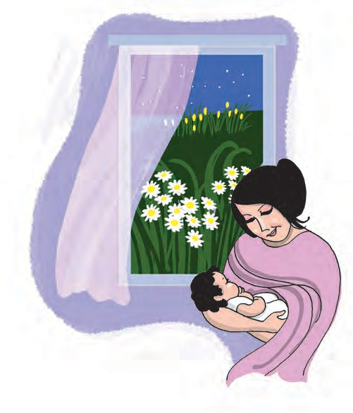

**4.1**

**Sleep, My Treasure**

**POINTERS**

Has tired the birds, to their nests they creep; The garden still is

Alight with lilies,

But all the daisies are fast asleep.

Sleep, sleep, my darling, Dawn wakes the starling,

The sparrow stirs when he sees day break; But all the meadow

Is wrapped in shadow,

And you must sleep till the daisies wake!

*- E. Nesbit*

1. Answer the following questions :
   1. Who is the speaker in the poem ?
   2. To whom is the poem addressed ?
   3. What time is being described in the poem ?
   4. Name the white and bright things mentioned in the poem.
2. Guess the meaning of the following from the context.
   1. The garden still is alight with lilies.
   2. Dawn wakes the starling.
   3. The meadow is wrapped in shadow.
3. What is your favourite time of the day ? Describe it in detail.
4. Visit a library : Find and read stories and poems written by Edith Nesbit.
5. Draw word webs for the following. Begin with the given word and go on writing as many other words associated with it, as you can. Use these words to write other related words to form a word web.

dream

bed

sleep

day

rest

night

bird

garden

meadow

1. An activity : Speak fast, think faster !

Form groups of 4-6. Discuss each of the following topics. Then each person in the group should choose a topic and speak about it for one minute. Try to say as many sentences as you can in that time.

* 1. What may happen ...

‘I may study ... A bird may fly into the classroom. The Principal may call me ... It may rain ... A dog may chase a cat ... A king may lose his kingdom ... My friend may give me a story book to read ... Mother may make idlis today ...’ etc.

* 1. What is not likely to happen or will never happen ...

‘It won’t rain in the classroom ... I won’t ever see a live dinosaur ... The sun will never set in the east ...’ etc.

* 1. Imagine you are watching a scene. For example, someone learning to ride a bicycle; or a cricket match. Give a running commentary on what you see.

‘Monu is sitting on the bicycle. It has side wheels. Monu tries to push the pedal down - No - he stops. His uncle holds the seat in one hand and the handle in the other hand. He says, ‘Come on, Monu’ ... etc.

**For the Teacher :** Allow students to speak on their own, using their own ideas. The objective here is fluency, good speed and giving scope to the students’ creative thinking.

Later on, draw their attention to modal verbs like ‘may’, ‘will’, ‘should’, etc.



# The Story of Gautama’s Quest

G autama the Buddha was born over two thousand five hundred years ago, as Prince Siddharth. He was the son of a king - Raja Shuddhodana. He was born on the sacred day of Vaishakh Purnima at Lumbini, situated near the city of Kapilavastu. Seven days after his birth, his mother Mayadevi passed away. It was prophesied at his birth that the infant would grow to be either a great *Chakravarti* (an Emperor) or a *sannyasi* (a renunciate) who would bring comfort to thousands of lost souls.

The king was determined to prevent his beloved son from renouncing the world. He surrounded the Prince with every imaginable luxury and comfort. It is said that the King had three magnificent palaces, one for each season of the year, and in the beautiful atmosphere of these royal mansions, Prince Siddharth lived his secluded, protected life.

In good time, the prince was married to one of the most beautiful girls of the realm - Princess Yashodhara, the daughter of the Koliyan king. Soon, a son, Rahul was born to them. At the age of twenty-nine, Siddharth went out to see his kingdom and to meet his subjects. He beheld what the Buddhist books call the ‘four signs’ - witnesses to the impermanence of the world. He saw an old man, a diseased man, a dead man, and a monk. And there entered into his heart a vision of *dukkha*, the world-sorrow. “What is the way out of the world-sorrow?’’ he asked himself, repeatedly. The unanswerable question led him to renounce worldly life, leave his wife and son and set out in quest of the Truth of life.

83

The story of Gautama’s quest that ends in illumination and attainment of *nirvana*, is one of the most moving tales of our times. For six years did Gautama practise intense asceticism. For several days in succession, he ate barely a grain of rice. His strong, athletic body was reduced to a bag of bones. But it served no purpose ! The Buddha

then scattered a handful of grass on the ground beneath the Bodhi tree and formed a seat for himself. “I care not if my skin and nerves and bones decay !’’ he thought. “I care not if my life-blood dries, I shall not give up until I attain to enlightenment.’’

What divine will-power in these words ! And what may not a man achieve if he would wake up his will-power !

It is said that he saw a vision which contained a message for him: it acted as a spiritual stimulant to him. The

words were:

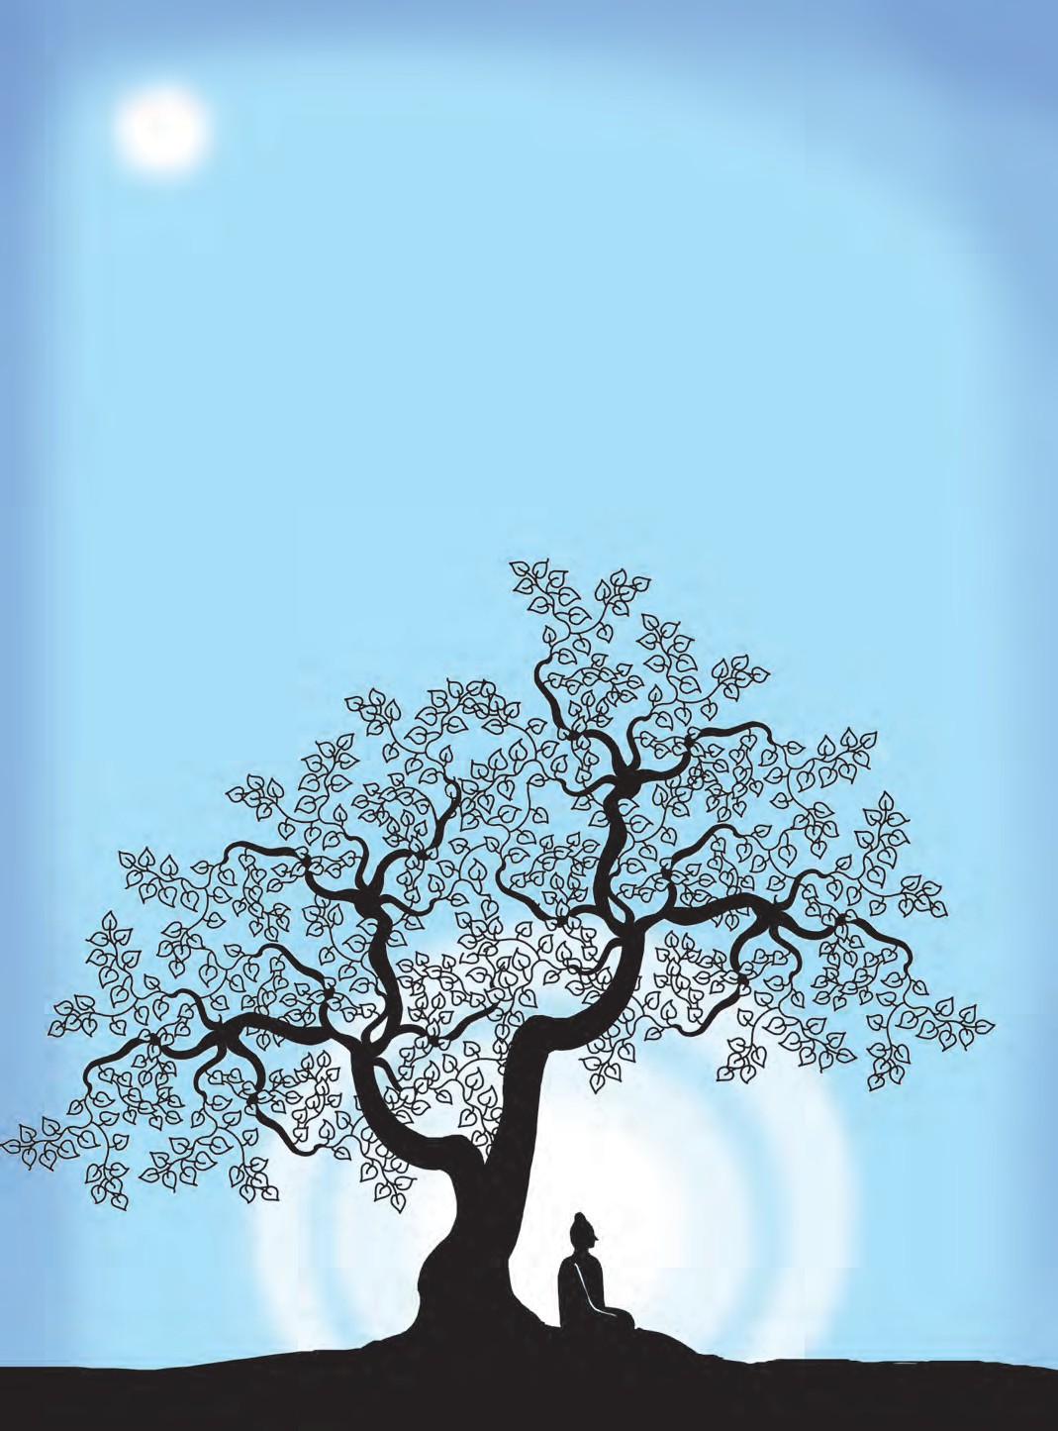

Tune the sitar neither low nor high, The string overstretched breaks and the music dies.

The string overslack is dumb and the music dies.

He thought to himself, ‘I too, have tortured my body to starvation. I have taken to extremes. Let me follow the middle path’.

When he tried to get up to take a bath in the river, he found that he had become so weak that he could not rise. Just then, a beautiful girl named Sujata appeared before him, carrying a golden bowl filled with sweetened milk and rice.

When she saw the weakened ascetic, she offered the bowl at his feet. “Lord,

please accept my offering of milk and rice.’’ Buddha accepted her offering. This was his first meal after many days of starvation. It refreshed him and infused a new strength in him. He realized that making the body suffer was not the way to enlightenment and truth.

Gautama had longed for enlightenment. That night, he found the answer to his query. What is the cause of sorrow ? The cause of sorrow is desire. The cure for sorrow is to give up all desires and adopt Right Living.

Born under a tree, the Buddha received illumination also, under a tree. To this day, we venerate this tree as the Bodhi Tree.



**POINTERS**

1. Complete the following sentences with reference to the passage :
   1. Gautama, the Buddha, was born over two thousand five hundred years ago, as ................ .
   2. The king was determined to prevent his beloved son from ................ .
   3. For six years did Gautama practise ................ .
   4. He realised that making the body suffer was not ................ .
   5. To this day, we venerate this tree as ................ .
2. Write short notes on the following :
   1. Prince Siddharth’s protected life.
   2. The ‘four signs’ that Prince Siddharth beheld.
   3. The message in the vision.
   4. Sujata’s offering
3. Read aloud a paragraph of your choice from the passage.
4. Visit a library : Read stories about Gautama Buddha. Relate one story in the class.

# Mr Nobody

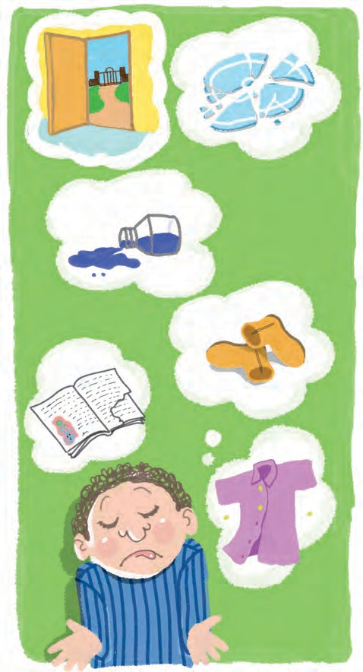

I know a funny little man, As quiet as a mouse,

Who does the mischief that is done In everybody’s house!

There’s no one ever sees his face, And yet we all agree

That every plate we break was cracked By Mr Nobody.

Tis he who always tears out books, Who leaves the door ajar,

He pulls the buttons from our shirts, And scatters pins afar;

That squeaking door will always squeak, For prithee, don’t you see,

We leave the oiling to be done By Mr Nobody.

The finger marks upon the door By none of us are made;

We never leave the blinds unclosed, To let the curtains fade.

The ink we never spill; the boots That lying round you see

Are not our boots - they all belong To Mr Nobody.

*- Author Unknown*



**POINTERS**

1. Read the poem aloud.
2. Complete the following chart of personal pronouns using words from the brackets - (him, our, we, he, her, their, it, me, your).

|  |  |  |  |  |
| --- | --- | --- | --- | --- |
| **Person** |  | **Pronouns** |  |  |
| First | I, ............ | my, ............ | . , us | mine, ours |
| Second | you | .................... | you | yours |
| Third | . she, it, they | his, ..... its, ........... | . her, them | his, hers, its, theirs |



86

* + Which of the above pronouns do you use when you talk about yourself ?
  + Suppose you are telling someone about the good/bad things they have done. What pronoun are you likely to use ?
  + Suppose you are complaining about one or more persons/things to your teacher/ mother. What pronouns will you use ?

1. Write all the instances of the mischief done by Mr Nobody.
2. What characteristics of Mr Nobody do we learn about from this poem ?
3. Imagine that there is a Mr Somebody who has to correct all the wrongs that are done by Mr Nobody. Write in the following table, what Mr Somebody will have to do.

|  |  |
| --- | --- |
| **Mr Nobody’s Actions** | **Tasks for Mr Somebody** |
| 1. The plate is broken/cracked. | Mend the plate. / Throw it away carefully. |
| 2. The book is torn. | ......................................................... |
| 3. The door is ajar. | ......................................................... |
| 4. The buttons are pulled from the shirt. | ......................................................... |
| 5. The pins are scattered. | ......................................................... |
| 6. The door is still squeaking. | ......................................................... |
| 7. There are finger marks upon the door. | ......................................................... |
| 8. The ink has spilled over. | ......................................................... |
| 9. Boots are lying around. | ......................................................... |
| 10. ........................................................ | ......................................................... |
| 11. ........................................................ | ......................................................... |

* + Add a few more things to the list in the above table, using your own ideas and experience.

1. Write about one occasion each when you have behaved like -

(a) Mr Nobody (b) Mr Somebody.

1. Listen and complete : Close your books. The teacher will dictate some lines from the poem. She will say the first half and you have to write the entire line/verse.
2. I know a funny....... ....... . As quiet as a ........

Who does the mischief that is done

. !

1. There’s no one ever sees his face, And yet we all .......

That every plate we break was ....... By ....... .......

1. Use the following expressions in your own sentences :
2. We all agree that (c) Don’t you see
3. It is he/she who (d) None of us

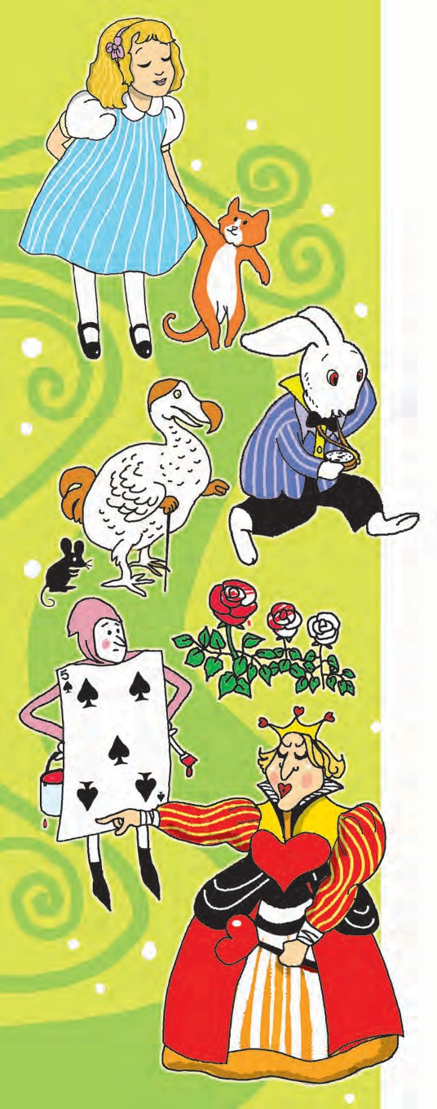

# A Mad Tea Party

*(Alice in Wonderland is a fantasy novel written by Lewis Carroll. It tells us of the adventures of a little girl called Alice who falls into a rabbit hole and finds herself in a fantasy world where funny people mingle with peculiar creatures. Here she happens to attend a tea party with three of them: the March Hare, the Mad Hatter and the Dormouse.)*

There was a table set out under a tree in front of the house, and the March Hare and the Hatter were having tea at it: a Dormouse was sitting between them, fast asleep, and the other two were using it as a cushion, resting their elbows on it, and talking over its head. ‘Very uncomfortable for the Dormouse,’ thought Alice; ‘only, as it’s asleep, I suppose it doesn’t mind’.

The table was a large one, but the three were all crowded together at one corner of it: ‘No room! No room!’ they cried out when they saw Alice coming. ‘There’s PLENTY of room!’ said Alice indignantly, and she sat down in a large arm-chair at one end of the table.

‘Have some wine,’ the March Hare said in an encouraging tone.

Alice looked all round the table, but there was nothing on it but tea. ‘I don’t see any wine,’ she remarked.

‘There isn’t any,’ said the March Hare.

88

‘Then it wasn’t very civil of you to offer it,’ said Alice angrily.

‘It wasn’t very civil of you to sit down without being invited,’ said the March Hare.

‘I didn’t know it was YOUR table,’ said Alice; ‘it’s laid for a great many more than three.’

‘Your hair wants cutting,’ said the Hatter. He had been looking at Alice for some time with great curiosity, and this was his first speech.

‘You should learn not to make personal remarks,’ Alice said with some severity; ‘it’s very rude.’

The Hatter opened his eyes very wide on hearing this; but all he said was, ‘Why is a raven like a writing-desk ?’

‘Come, we shall have some fun now!’ thought Alice. ‘I’m glad they’ve begun asking riddles – I believe I can guess that,’ she added aloud.

‘Do you mean that you think you can find out the answer to it?’ said the March Hare.

‘Exactly so,’ said Alice.

‘Then you should say what you mean,’ the March Hare went on.

‘I do,’ Alice hastily replied; ‘at least – at least I mean what I say – that’s the same thing, you know’.

‘Not the same thing a bit!’ said the Hatter. ‘You might just as well say that “I see what I eat” is the same thing as “I

eat what I see”!’

‘You might just as well say,’ added the March Hare, ‘that ‘I like what I get’ is the same thing as ‘I get what I like !’

‘You might just as well say,’ added the Dormouse, who seemed to be talking in his sleep, ‘that ‘I breathe when I sleep’ is the same thing as ‘I sleep when I breathe !’

‘It IS the same thing with you,’ said the Hatter, and here the conversation dropped, and the party sat silent for a minute, while Alice thought over all she could remember about ravens and writing-desks, which wasn’t much.

‘Have you guessed the riddle … yet?’ the Hatter said, turning to Alice again.

‘No, I give it up,’ Alice replied: ‘what’s the answer?’

‘I haven’t the slightest idea,’ said the Hatter.

‘Nor I,’ said the March Hare.

Alice sighed wearily. ‘I think you might do something better with the time,’ she said, `than waste it in asking riddles that have no answers’.

‘If you knew Time as well as I do,’ said the Hatter, ‘you wouldn’t talk about wasting IT. It’s HIM.’

‘I don’t know what you mean,’ said Alice.

‘Of course you don’t!’ the Hatter said, tossing his head contemptuously. ‘I dare say you never even spoke to Time!’

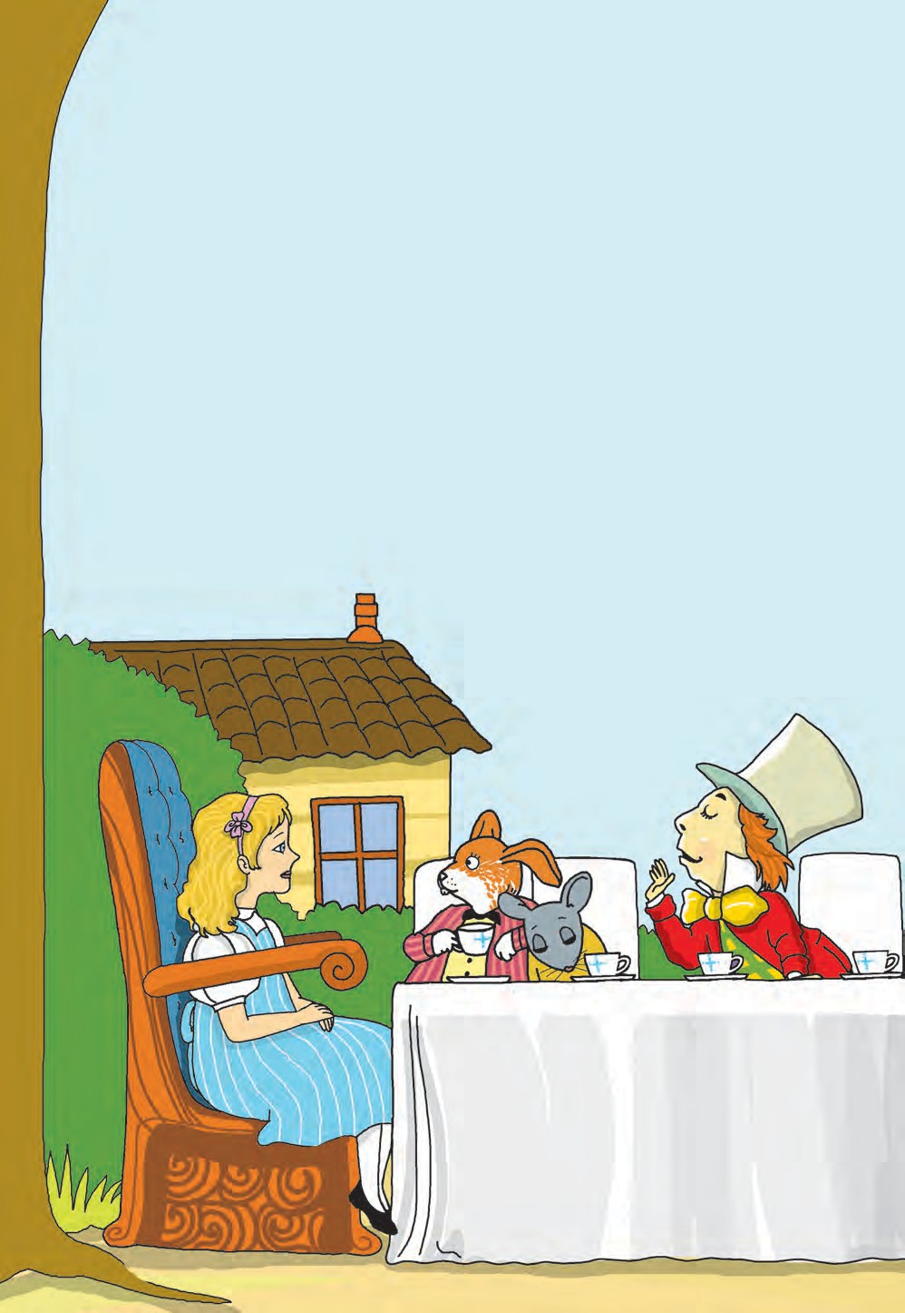

‘Perhaps not,’ Alice cautiously replied: ‘but I know I have to beat time when I learn music’.

‘Ah! that accounts for it,’ said the Hatter. ‘He won’t stand beating. Now, if you only kept on good terms with him, he’d do almost anything you liked with the clock. For instance, suppose it were nine o’clock in the morning, just time to begin lessons: you’d only have to whisper a hint to Time, and round goes the clock in a twinkling! Half-past one, time for dinner!’

(‘I only wish it was,’ the March Hare said to itself in a whisper.)

‘That would be grand, certainly,’ said Alice thoughtfully: ‘but then – I shouldn’t be hungry for it, you know’.

‘Not at first, perhaps,’ said the Hatter: ‘but you could keep it to half- past one as long as you liked’.

A bright idea came into Alice’s head. ‘Is that the reason so many tea- things are put out here ?’ she asked.

90

‘Yes, that’s it,’ said the Hatter with a sigh: ‘it’s always tea-time, and we’ve no time to wash the things between whiles’.

‘Then you keep moving round, I suppose?’ said Alice.

‘Exactly so,’ said the Hatter: ‘as the things get used up.’

‘But what happens when you come to the beginning again?’ Alice ventured to ask.

‘Suppose we change the subject,’ the March Hare interrupted, yawning.

‘I’m getting tired of this. I vote the young lady tells us a story.’

‘I’m afraid I don’t know one,’ said Alice, rather alarmed at the proposal.

‘Then the Dormouse shall !’ they both cried. ‘Wake up, Dormouse!’ And they pinched it on both sides at once.

The Dormouse slowly opened his eyes. ‘I wasn’t asleep,’ he said in a hoarse, feeble voice: ‘I heard every word you fellows were saying’.

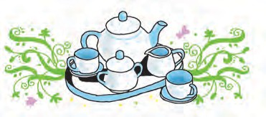

* **indignantly :** angrily, the anger caused by something wrong, unjust or mean
* **civil :** polite, well-mannered
* **wearily :** in a tired manner
* **between whiles :** between two occasions or two short periods
* **hoarse :** rough, grating (This adjective is used to describe human voice or sound.)



**POINTERS**

* 1. Read the passage aloud playing the roles of the different characters.
  2. Write any three of the silly remarks made by the characters other than Alice. Write why you think the remark is silly.
  3. Read the following.
     + I mean what I say. I say what I mean.
     + I see what I eat. I eat what I see.

Use your imagination to write a funny sentence on this pattern.

* 1. Write what you would like to do if ‘Time’ was your friend.
  2. Can you think of a similarity between a raven and a writing desk ? Write at least five differences between the two.
  3. Visit a library : Read Lewis Carroll’s book ‘Alice in Wonderland.’



91

#### Some Funny Riddles

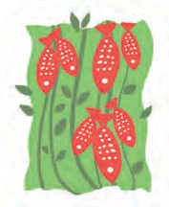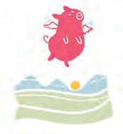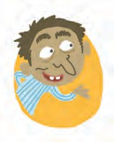

The Man in the Wilderness asked of me ‘How many blackberries grow in the sea?’ I answered him as I thought good.

‘As many red herrings as grow in the wood.’

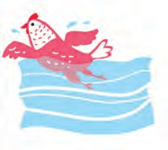The Man in the Wilderness asked me why His hen could swim, and his pig could fly. I answered him briskly as I thought best.

‘Because they were born in a cuckoo’s nest.’

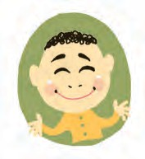The Man in the Wilderness asked me to tell The sands in the sea and I counted them well.

Says he with grin ‘And not one more?’

I answered him bravely, ‘You go and make sure.’

*- Anonymous*

* **wilderness :** a wild region, a region not occupied by people, for example, a desert or a forest

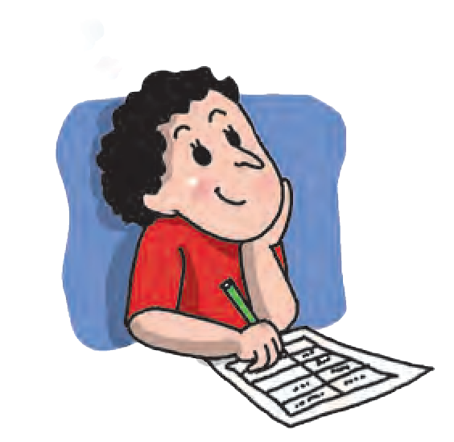

**A Project : Time Tables**

1. We all follow a class time table made by the school. Imagine for a minute what will happen if there was no time table for your class.
2. Apart from class/school, where else are you likely to find a time table useful?
3. Make a time table of your daily routine
   1. On a school day
   2. On a holiday, and
   3. During examinations.

Start at the time you normally get up and

list your activities hourly : 7 am to 8 am, and so on.

* **cuckoo’s nest :** madhouse, a home for the insane



92

# If I can stop one heart from breaking ...

If I can stop one heart from breaking, I shall not live in vain ;

If I can ease one life the aching, Or cool one pain,

Or help one fainting robin Unto his nest again,

I shall not live in vain.

*-Emily Dickinson*

* + - **I can ease one life the aching :** If I can reduce the sorrow in someone’s life
  + **cool one pain :** reduce the pain, give relief
  + **unto :** to

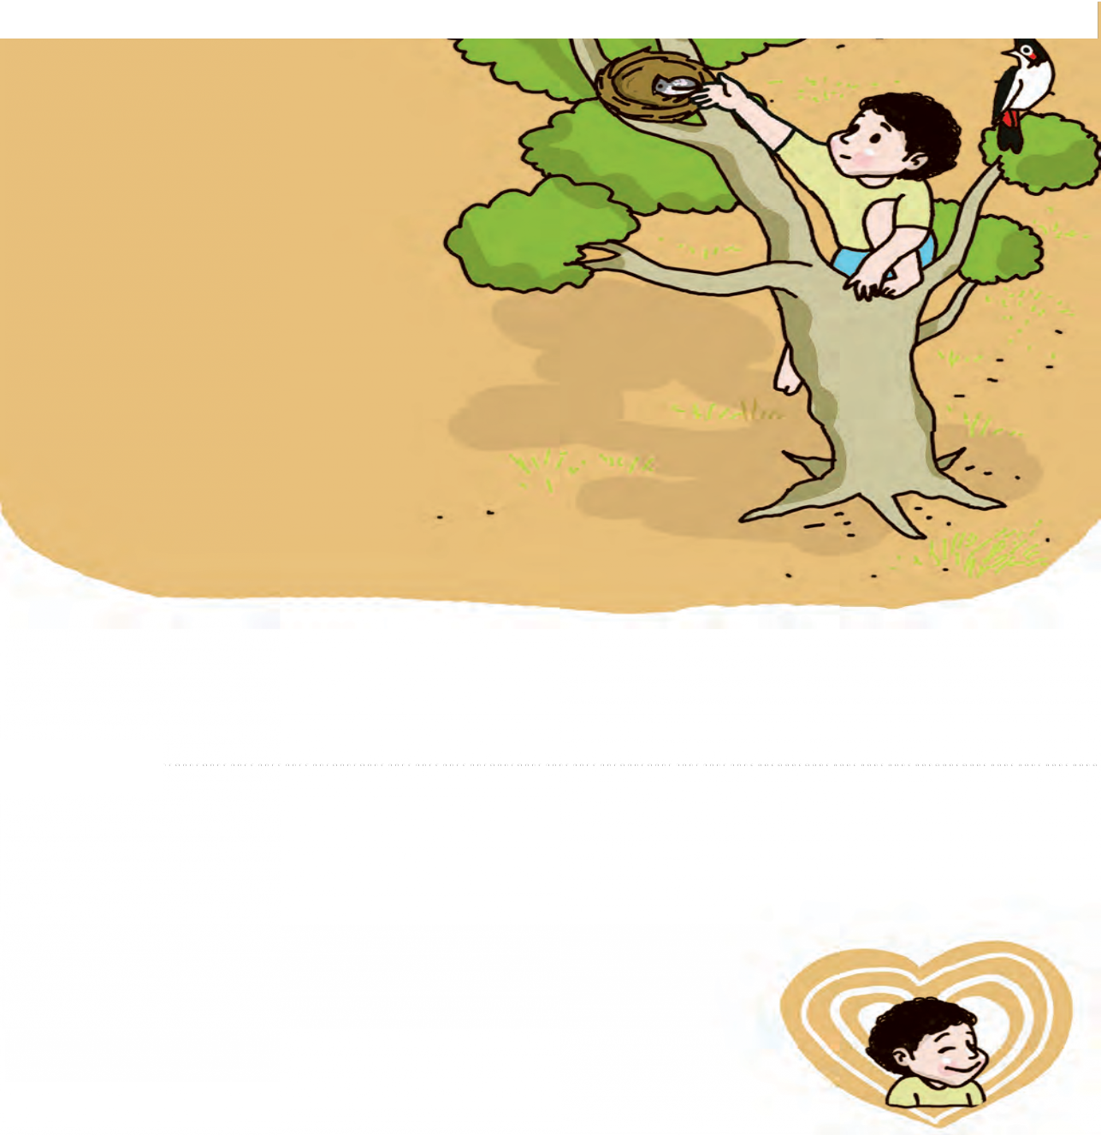

**POINTERS**

* + 1. What does the poet want to do ?
    2. Does the poet expect anything in return? What is the poet’s reward ?
    3. List the phrases that indicate sorrow or pain.
    4. Form groups of five and discuss : There are many things that seem small, minor or insignificant to some people but

the same may be the cause of great pain, suffering for others.

Can you list such things ? What can you do to provide help on those occasions ?

93

# The Phantom Tollbooth (A Book Review)



Milo was a young boy who lived in San Francisco in the States. He lacked for nothing. Being an only child, at home he was surrounded by all sorts of expensive toys. In school too, there was nothing that he could complain about. But …! But Milo was bored! Nothing really interested him. He thought of everything as a waste of time, and school as the greatest waste of time of all. Poor Milo!

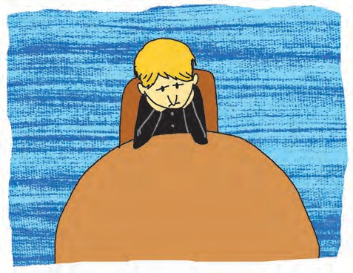

‘There’s nothing for me to do, nowhere I’d care to go, and hardly anything worth seeing,’ he thought. (You must have guessed by now that Milo belonged to an age when TV, video games and computers were not invented!)

But on one long afternoon like any other, Milo suddenly received a huge parcel with a bright blue envelope attached to one side. The envelope was addressed to him, ‘FOR MILO, WHO HAS PLENTY OF TIME’! Wouldn’t

you be surprised if something like this

happened to you? So was Milo.

‘I don’t think it’s my birthday,’ he puzzled, ‘and Christmas must be months away, and I haven’t been outstandingly good, or even good at all.’ - Milo was an honest boy, so he admitted the last bit to himself.

He couldn’t return the parcel; there was no sender’s address on it. So, just in order to be polite, Milo decided to open the envelope.

‘ONE GENUINE TURNPIKE TOLLBOOTH,’

it was written inside,

‘EASILY ASSEMBLED AT HOME, AND FOR USE BY THOSE WHO HAVE NEVER TRAVELLED IN LANDS BEYOND.’

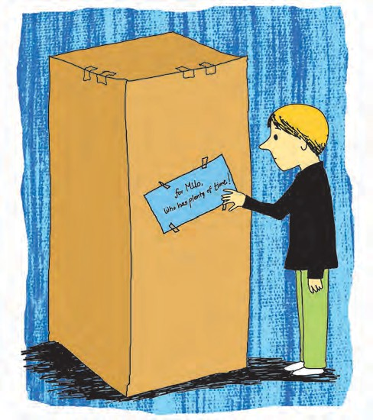Like you, Milo was also intrigued by the words, ‘lands beyond’. There



94

was also a list of the contents of the parcel. It contained -



Milo

met

the

Lethargarians when he was in the Doldrums. The Lethargarians spent all their time in daydreaming and taking naps. They dawdle and they delay, they bide their time, they linger and loiter, they put

off for tomorrow what

they they they

could

do today,

loaf and lounge, dillydally and

yet they complain that such a

leaves

no time lagging,

busy schedule them almost for brooding,

plodding,

or

procrastinating!

‘One (1) genuine turnpike toll- booth : to be erected according to directions.

Three (3) precautionary signs : to be used in a precautionary fashion.

Assorted coins : for use in paying tolls.

One (1) map : up to date and carefully drawn by master cartographers, depicting natural and man-made features.

One (1) book of rules and traffic regulations, which may not be bent or broken.’

And in smaller letters at the bottom, it concluded: ‘Results are not guaranteed, but if not perfectly satisfied, your wasted time will be refunded.’

Because Milo had nothing else to do, he followed the ‘directions’ and erected the tollbooth. It was a proper booth with windows and a roof and a coin box.

‘But what’s the use?’ thought Milo

– there was no highway attached to the booth! Nevertheless, Milo set up the precautionary signs, unfolded the map and chose a destination. He chose it at random because he had never heard of any of the places shown on the map, and so one was as good as any other!

Milo was not sure that this new game would turn out to be interesting. However, he sat in his toy car, approached the booth, paid the toll with the coins, and drove past the toll booth. But when he looked back, Oh wonder of wonders, the toll booth had disappeared along with Milo’s room and even his house! He found himself speeding down a highway into an

unknown territory! What happened next is the story of Norman Juster’s novel, ‘The Phantom Tollbooth’!

Though Milo didn’t know it then, he had begun his journey in the land of expectations. He was in the kingdom of wisdom. He had many adventures there. He had to rescue the princesses Rhyme and Reason from castles of air. Was

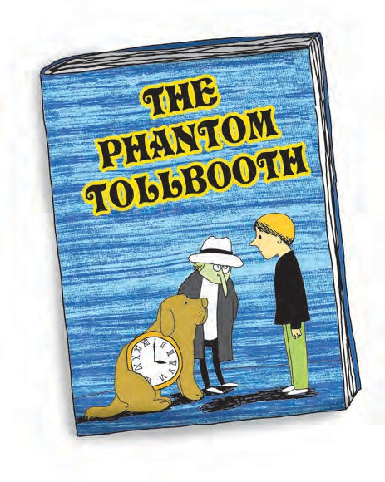Milo find his life interesting later on? You must read the novel to find it out.

The novel ‘The Phantom Tollbooth’ was written more than 50 years ago but it continues to be a classic of children’s literature. It is a fantasy but it has an important message for children all over the world. It has helped them to look at their school and studies in a new light.

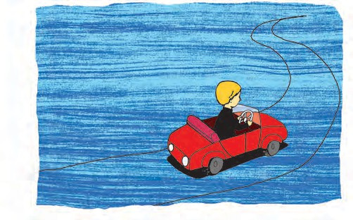

he successful in his mission? Who were the strange people and creatures he met there? What happened to the toll booth? Did Milo see it again? Did

**POINTERS**

1. Read the passage and answer the following :
   1. Which book is introduced in the passage ?
   2. Where does the story take place ?
   3. Who is the main character in the story ?
   4. Why is the tollbooth called a ‘phantom’ tollbooth ?
   5. When was the book written ?
   6. Who has written the book ?
2. List the various people and places mentioned in the passage. The places Milo visits and the people he meets have unusual names. Write the meanings of those names.
3. List the various things that the Lethargarians do or want to do. Can you sum up all of it in one word or phrase ?
4. In the novel, the Lethargarians give a whole day’s time table of their activities. Can you guess what it would be like ? Use your own ideas and prepare their time table.
5. Try to write interesting time tables for imaginary people or creatures.
6. Activity :

Start a collection of new and interesting words. Write the words in coloured ink on cards of equal size and arrange them in alphabetical order. Try to use the words in your writing or conversation from time to time.

1. Discuss what makes the following sentences funny.

* Your wasted time will be refunded.
* There was no highway attached to the booth.

1. The following boxes represent a word or phrase, through a special arrangement of letters. Guess the words.

|  |  |  |
| --- | --- | --- |
| Example :  S T  O N E  Cornerstone | S T A N D  I  .... .................... . | F A L L  .......................... |
| R E A D I N G  .......... ........... ........ | S  T  A  R  ................ .......... | .......... ...... .......... |

Try to represent the following words or phrases using such special graphic arrangements.

* fair and square  side by side  round table  breaking news  an ice cube
* once upon a time  Hurry up  cool down  as big as

1. Write a review of your favourite book. Use the following points :

* Title of the book  Author/Authors  The central idea or story
* The important characters  Some special features of the book
* Why it is your favourite book.

***



**4.7**

**The Sword in the Stone**

*(****King Arthur****, famous in legends and history as one of the bravest and noblest Kings of Britain, grew up as an orphaned youth, before Destiny intervened, in the form of his protector and guardian, Merlin the Magician, to reveal his true identity to the people of Britain.)*

In ancient Britain, at a time when the land was invaded by wild barbarians, the good and noble Lord Uther fought them bravely and drove them away from his land. The people made him king of Britain and gave him the title, Pendragon, meaning Dragon’s head. King Uther Pendragon ruled Britain wisely and well; the people were content. But very soon, the king died; it was thought that he had been poisoned by some traitors. There was no heir to the throne of Britain.

The powerful Lords and Knights who had been kept under control by King Uther, now began to demand that one of them should be crowned King of Britain. Rivalry grew amongst the Lords, and the country as a whole began to suffer. Armed robbers roamed the countryside, pillaging farms and fields. People felt unsafe and insecure in their own homes. Fear gripped the country and lawlessness prevailed over the divided kingdom.

Nearly sixteen years had passed since the death of Lord Uther. All the Lords and Knights of Britain had assembled at the Great Church of London for Christmas.

On Christmas morning, just as they were leaving the Church, a strange sight drew their attention. In the churchyard was a large stone, and on it an anvil of steel, and in the steel a naked sword was held, and about it was written in letters of gold, ‘Whoso pulleth out this sword is by right of birth King of England.’

Many of the knights could not hold themselves back. Fancying themselves as future kings, they rushed to the stone and attempted to draw the sword from its steel anvil. They pulled with all their might, but none of them could so much as move the sword.

“Obviously, the man who might draw the sword and prove himself to be our rightful king, is not amongst us this morning,” said the Archbishop. “However, every man who wishes to try his hand at drawing this sword, is free to do so, for the next few days. He who draws the sword will be crowned King. And to celebrate the appearance of this magnificent sword and prepare ourselves for the arrival of our future king, we will hold a magnificent tournament on New Year’s Day.”

On New Year’s Day, a great number of young and brave knights gathered to attend the Church Service. After that, they met in the field nearby, to participate in the Great Tournament. Dukes and Counts, Earls, Barons and Knights crowded on to the field.

Among them was Sir Ector, a noble knight. He was accompanied by his two sons, Sir Kay and young Arthur. Kay was his own son, who had been recently knighted; Arthur, whom he had brought up as a foster son, was actually an orphan whom he had raised as his own child. The good Sir Ector loved both his sons dearly.

As Sir Kay was preparing to join the tournament, he realized that he had left his sword behind, at home. Hastily he summoned his younger brother and said to him, “Arthur! You want me to win this tournament, don’t you? Then you must help me out. Take my horse and gallop home as fast as you can. Get my sword and rush back here at once.”

“I’m going,” called Arthur, rushing off at once. “You shall have your sword sooner than you think!”

As he rushed past the church, a glint of steel caught his eye - the blade of a sword, shining brightly in the morning sun. The sword was mounted on an anvil on top of a block of marble, right in the middle of the churchyard. It was the magic sword in the stone; but Arthur knew nothing about it. All he saw was a sword that was available for taking. ‘Kay shall have his sword straight away,’ Arthur said to himself. He ran up to the stone, seized the sword by the handle and drew it out effortlessly. He rushed back to his brother and handed the sword to him, breathless with excitement.

“You are back very soon,” Sir Kay said to him, “But hey, this is not my sword!”

“No, it isn’t,” smiled Arthur. “I thought it would take me too long to get home and bring your sword. I found this sword in the Churchyard. It looked good and I thought you could use it just for today. We will, of course, put it back when the Games are over.”

Sir Kay stood speechless, staring at his younger brother. He knew all about the magic sword and what it signified; but Arthur was unaware of it all ! Arthur had always been a brave and valiant boy, and he had excelled in fencing and archery, he adored his father and his half brother and his dream was to become the squire to his dashing brother ! And now, without even knowing what it implied, Arthur had drawn the magic sword from the stone! Kay’s mind was working rapidly. He actually held the Sword of the Stone in his hand; the very same sword that the strongest and best knights could not so much as grip or get hold of !

Sir Kay seized the sword and ran to their father, leaving a bewildered Arthur behind him. He said to Sir Ector, “Father, father! This is the Sword of the Stone and I have it in my hand! I am the rightful King of Britain!”

Sir Ector was a wise man. “How did you get hold of this sword, son?” he asked his eldest born.

“What does that matter? I have it in my hand. It was meant to be mine. Isn’t that enough?” Kay retorted, angrily.

“That’s not enough,” said the father, quietly. “How did you get hold of this sword?”

“ I’ve got it, and that’s what matters,” Kay replied, stubborn as ever.

“Well then, come with me,” Sir Ector said, and led his son inside the Great Church which was now empty. Taking the Holy Book from the choir, Sir Ector said to his son, “Swear on the holy book that you drew the sword from the stone.”

Sir Kay lowered his eyes. He could not face his father now.

“How did you come by the sword, son?” Sir Ector asked him, once again.

“Arthur brought it to me, father,” said Kay, still with his eyes lowered.

“Bring Arthur here, and let the three of us go to the churchyard,” Sir Ector told him. “We have to know the truth about this.”

Soon, the three of them were at the churchyard.

“Put the sword back on its anvil,” Sir Ector said to Kay. But try as he might, Kay could not put the sword back. It struck the anvil and slid off the block.

Arthur saw what was happening, and thought that his father was angry with them because he thought the sword was stolen. Sir Ector had always told his sons, “What matters most for a knight is integrity, being honest and truthful at all times, on all occasions.”

Arthur stepped forward impulsively. “Here, let me put it back,” he said. And, taking the mighty sword from his elder brother, he thrust it back on the anvil and it slipped in, neatly.

“I assure you father, I did not steal the sword. Kay needed a sword urgently, and I did not want to keep him waiting. Rather than ride all the way home, I decided to take the sword which I found in the churchyard. And see, it is back in its place now. I fully intended to put it back in place after the tournament.” And glancing at his brother, he added, “I am sure that is what Kay would have told me to do, wouldn’t you, brother?”

Sir Kay did not speak a word. “Alright Arthur, I believe you,” said

Sir Ector. “Now let me see you draw that

sword out as you did the first time. First, you, Kay.”

But try as he might, Kay could not so much as grip the handle. And he could not move the sword however hard he tried.

“Now, it is your turn Arthur,” said Sir Ector, sternly.

Arthur gripped the handle of the sword and drew the sword out, gently but firmly.

Sir Ector made him repeat the action again, and again. Each time, Arthur gripped the handle and drew the sword out, without any hesitation.

Sir Ector was overwhelmed. He fell on his knees before his young son who held the mighty sword in his hand, and bowed his head in deep devotion. Wordlessly, Kay followed his example.

Arthur jumped back in surprise. “Father, why do you kneel before me? Am I not your son?”



100

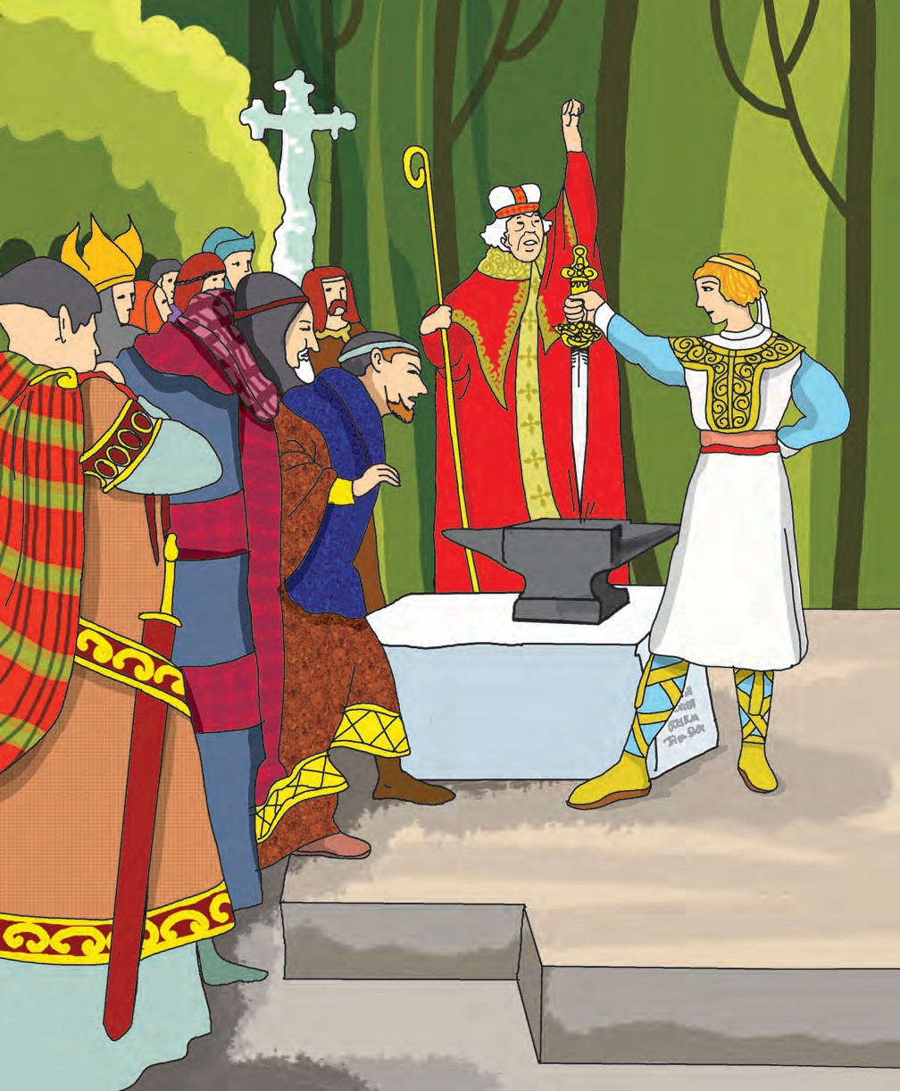

“That is what I had thought, until now,” Sir Ector replied. “But now, I know better. I know whose son you are. You are the son of the good King Uther Pendragon, and I bow to you, as you are the King of Britain now.”

“How could that be? You and I know that I was an orphan boy entrusted to your care.”

Silently, Sir Ector pointed to the inscription on the stone which Arthur

had not seen until now. ‘Whoso pulleth out this sword is by right of birth King of England.’

“But it can’t be me! Father, I am your son, and I shall always remain your son!”

There was a flash of light, and Merlin appeared before them, a hooded figure with bright, shining eyes and a bewitching smile. Lovingly, he laid his hand on Arthur’s head and said to him, “Indeed, I was the one who entrusted you to good Sir Ector, for your own safety. Your father and I knew that great danger lay ahead for the kingdom and yourself. No sooner than you were born, your father blessed you and handed you over to me, with the solemn request that you would take your rightful place on the throne of England when it was safe for you to do so.”

Turning to Sir Ector, Merlin said, “In the name of the Late King Uther, I thank you. You have done a splendid job of bringing up the heir to the British throne. Now, you must inform the Archbishop and your fellow Knights of all that has happened here. I shall await your return.”

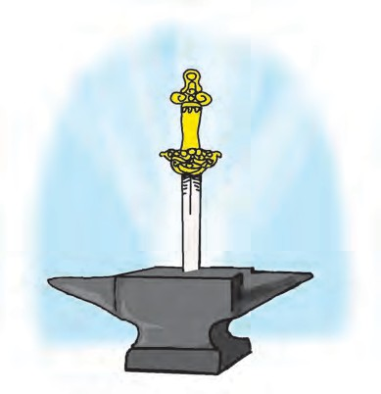Forthwith, Sir Ector called upon the Archbishop and all the Lords assembled at the Tournament. Holding Arthur by

the hand, he announced to the assembly, “Behold, the rightful King of England.”

For a moment, there was silence. And then, the crowd burst out in angry protests. “How can we believe you?” “Who is this unknown boy?” “Where did he come from?” “How is he any better than one of us?”

The Archbishop took them all to the churchyard. The entire assemblage watched in awe, as Arthur inserted the sword in the anvil and drew it out effortlessly. Some of the Lords and Knights also tried to draw the sword, but failed to do so.

Again, and yet again, Arthur drew the sword from the stone before his people. Each time, cheers went up, and each time, more and more Knights drew their swords and held them high, in a gesture of loyalty to their newfound prince. Loud cheers rose from the common people, who had surrounded the churchyard, eager to greet their new king.

Now, Merlin stepped out of the shadows and addressed the crowds, “Behold, O People of Britain, I present to you, the one and only son of King Uther Pendragon and his queen. He is your rightful king!”



102

* **Archbishop :** An Archbishop is a bishop or priest of the highest rank.
* **Merlin :** In the legends of King Arthur, Merlin is portrayed as a great wizard

who helped, advised and guided Arthur. Merlin, with the help of the Archbishop, had arranged the ‘sword in the stone’ so that Britain would get its rightful king.





**POINTERS**

1. Read the passage. Underline the new words. Guess their meaning from the context. Verify it from a good dictionary.
2. Put the following events in chronological order.
   1. The sword in the stone appeared in the churchyard.
   2. Lord Uther died.
   3. Lord Uther drove the barbarians away.
   4. The Lords and knights began to fight for the kingdom.
   5. Sir Kay left his sword behind at home.
   6. Merlin announced that Arthur was the son of Lord Uther.
   7. Arthur brought the sword from the churchyard.
   8. Ancient Britain was invaded by wild barbarians.
   9. Many knights tried to pull the sword out of the stone.
   10. Arthur grew up in Sir Ector’s house.
   11. Merlin entrusted a baby to Sir Ector.
3. What do the following events/actions tell us about the characters ? Discuss.
   1. The Archbishop announced that everyone was free to try his hand at the sword and called all the Lords to a Tournament.
   2. Arthur agreed to bring Sir Kay a sword at once.
   3. Sir Ector asked Sir Kay to show him whether he could draw the sword out of the stone.
   4. Sir Ector kneeled before Arthur.
4. Write five words each -
   1. with the suffix  -less  -ly  -ness
   2. with the prefix  un-  in-
5. Visit a library : Read the stories of King Arthur and his Knights of the Round Table.

***

# An Autumn Greeting



“Come, little leaves,’’ Said the wind one day, “Come over the meadows With me, and play;

Put on your dresses Of red and gold; Summer is gone,

And the days grow cold.’’

Soon as the leaves Heard the wind’s loud call, Down they came fluttering,

One and all; Over the meadows

They danced and flew, Singing the soft

Little songs they knew.

Dancing and flying The little leaves went; Winter had called them And they were content -

Soon fast asleep In their earthy beds,

The snow laid a soft mantle Over their heads.

*- George Cooper*

* + - Recite the poem with proper rhythm and intonation.



104

*E-learning material for the Standards I to XII*

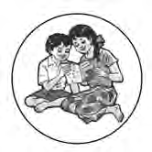

**Available in Marathi and English medium**

### ebalbharati

**Features**

* Inclusion of prescribed subjects as per subject scheme.
* Complete E- learning material based on textbook
* In the form of audio-visual
* Presentation of chapterwise content and inclusion of questions as per necessity
* Inclusion of various activities, pictures, figures/diagrams, etc.
* Use of animation for easy and simple learning
* Inclusion of exercises.

E-learning material (Audio-Visual) for the Standards One to Twelve is available through Textbook Bureau, Balbharati for the students of Marathi and English medium.

For purchasing E-learning material...

* Register your demand by scanning the Q.R. Code given above.
* Register your demand for E-learning material by using Google play store and downloading ebalbharati app.
* Visit the following websites of the Textbook Bureau. [www.ebalbharati.in](http://www.ebalbharati.in/)

[www.balbharati.in](http://www.balbharati.in/)

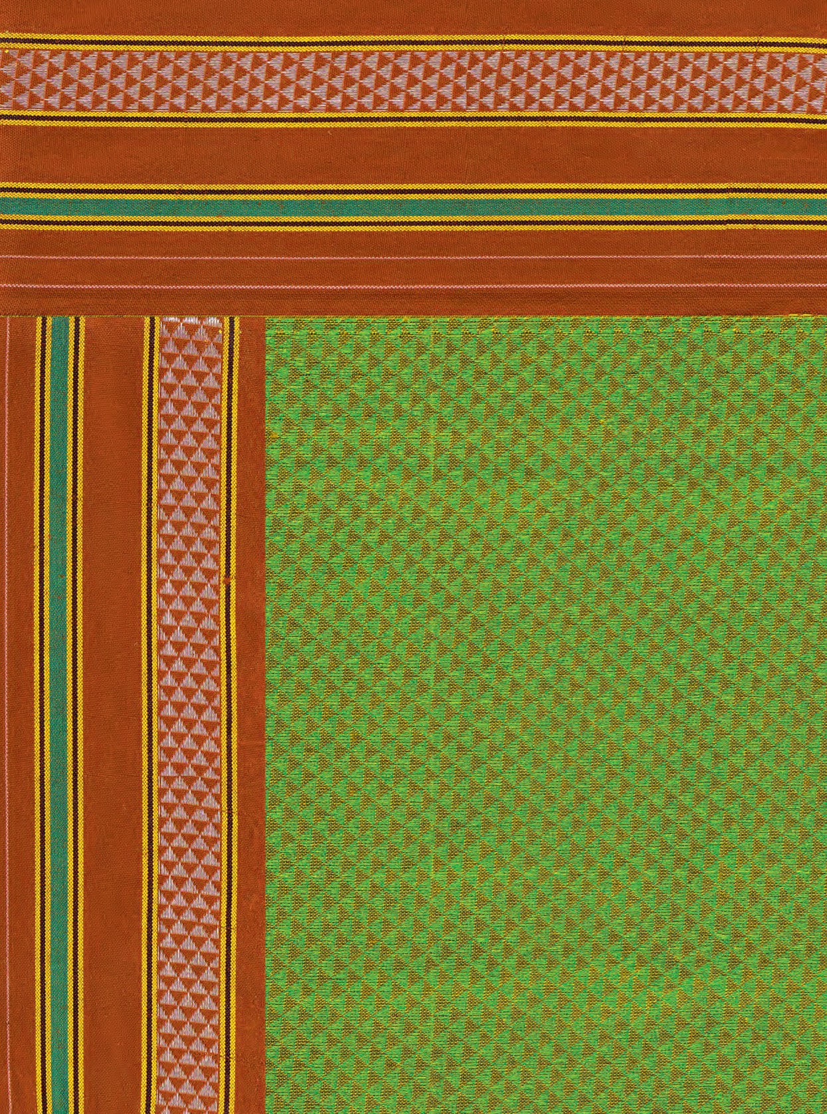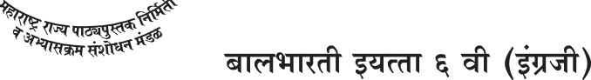

MAHARASHTRA STATE BUREAU OF TEXTBOOK PRODUCTION AND CURRICULUM RESEARCH, PUNE.

7 46.00